Gen-AI: The Art of Prompts

TABLE OF CONTENTS
- Introduction
- Exploring AI Tools

3-4

Prompts to help you Learn
- Overview of New Concepts
- Preparing Questions
- Linking New Concepts with Prior Knowledge
- Learning with analogies
- Applying Ideas to Current Events
- Creating a Study Schedule
- Engaging in Conversations for Practice
- Critical Analysis

5-6

Follow-up Questions or Additional Prompts
6

Prompts to help you Create
- Planning your Essays
- Generating Ideas
- Stuck on What to Write Next
- Searching for Literature
- Enhancing Written Communication
- Reviewing and Editing your Work
7

Prompts to help you Progress

- Finding Job Roles
- Making sense of the Job Description
- Creating your CV
- Interview Preparation
8

9
- Data Privacy and AI
- Conclusion
Introduction

When you think of AI or ChatGPT, you may think of people using it to do their assignments for them. Getting a Generative AI to do your assignment for you is academic misconduct, counts as plagiarism, and will lead you to being penalised. There are however, ways to use AI to make your assignment writing journey easier. In fact, and perhaps more significantly, you can use generative AI to your advantage across all aspects of your learning activities.
Generative AI is a type of artificial intelligence that learns from existing data and uses that to come up with new data, such as text or pictures. This is great for you as a student because it can quickly access its database of knowledge to give you the information you need. However, it’s important to note that the information given by some Generative AI models can be inaccurate, so it’s up to you to do your due diligence and make sure you include accurate information in your work. In addition, when you do use Generative AI to help you with an assignment you must be open about this, explaining how exactly you have made use of the generative AI and citing the contribution of generative AI appropriately within your assignment (please see Guidance to Students on the use of Generative AI).
Whilst bearing in mind the guidance on the use of Generative AI, the whole point of what follows is to show you the different ways you can use generative AI to help you with your learning. From helping you understand course content to creating ideas for essays and helping you prepare for life after University, Generative AI is a very useful tool for you to get to grips with.

Crafting an effective AI prompt involves following the steps below:

ChatGPT Plus from OpenAI

ChatGPT Plus (openai.com)

Requires Paid OpenAI Account

Bing Chat from Microsoft

Chat - Bing AI

Available Without Account

Bard from Google

‎
Bard AI Experiment

Free Google Account

Accessible via Uni Login

Perplexity.ai from Perplexity

Perplexity.ai

Basic functionality without an account, Paid 'pro' version with additional features

GrammarlyGO from Grammarly
GrammarlyGO
Both the free version and premium accessible via Uni Login

Access to the GPT-4 model. Improved logical thinking with fewer instances of inaccuracies.

GrammarlyGO uses GPT-3.5 to provide a variety of writing assistance features.

Perplexity AI uses GPT-4 to answer complex questions that require reasoning, inference, and knowledge.

Operates on the PaLM 2 model. Which can generate text, translate languages, write different kinds of creative content, and answer your questions in an informative way.

ChatGPT (free) from OpenAI

ChatGPT (openai.com)

Free OpenAI Account

Accessible via Uni Login

Utilises the GPT-3.5 model. Superior reasoning ability with wide-ranging capabilities.

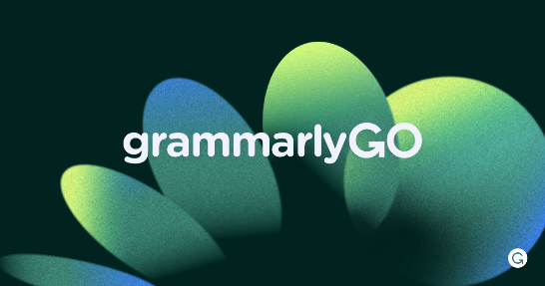
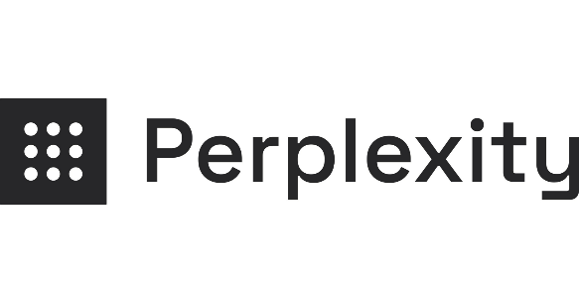
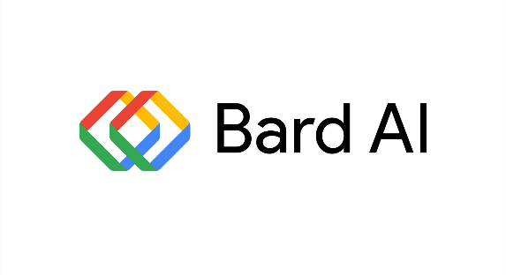

Operates the GPT-4 model with a focus on 'creative mode'. The model prioritises generating imaginative, innovative, and unconventional outputs or solutions.

Exploring Generative AI Tools
Explaining and Applying Prompts | Examples
Overview of new concepts  Objective: This prompt gives an overview of a topic. Generative AI tools aid in explaining complex concepts clearly, making them easier to understand. | You are a 2nd-year undergraduate Business Management student about to attend a Digital Business Lecture. Outline the fundamental concepts of Digital Operations. Provide a summary in paragraph form.  You are a Foundation undergraduate Marketing Student in a Project Management module. Outline the main ideas of Project Management Structures. Provide the response in a table. Write short bullet points and be concise.
Preparing questions  Objective: This prompt helps you generate questions to understand a module topic better. It encourages interactive learning for improved understanding and preparation for lectures. | You are a Postgraduate History student, preparing for a lecture on Global Conflicts. Generate questions about the ramifications of major conflicts in world history. Organise the questions on a table, prioritizing them and keeping them concise.  You are a student studying law at a postgraduate level. Brainstorm 15 questions on family law and supply the reasons for each question. Provide the questions on a table. Write in spoken English.
Learning with analogies  Objective: This prompt aims to employ generative AI to establish links between new ideas and existing knowledge. | You are a Data Science and Analytics student about to attend a lecture on sorting techniques. Explain how sorting techniques relate to searching techniques using analogies. Provide a summary in 3 200 word paragraphs, and for each point compare the two techniques.  You are a Sports Science student writing an essay on exercise physiology. Produce 3 creative analogies to explain the interplay between energy systems and cardiovascular responses to exercise.
Linking new concepts with prior knowledge  Objective: Analogies in education help learners understand complex ideas by relating them to familiar concepts. Generative AI can create relevant analogies, enhancing comprehension and promoting active learning. | You are a Master of Economics Student about to attend a lecture on Applied Econometrics. Explain the major differences between Keynesian and Monetarist economic theories. Provide a 600 word summary in paragraphs.  You are studying English Language at a postgraduate level. Explain the connection between Language Contact and Change in an essay form. Provide the response in paragraphs and highlight key concepts. Write your response in an academic style.
Applying ideas to current events  Objective: The prompts provided illustrate how AI capabilities can be used to generate perspectives related to current events. | Imagine you are a Postgraduate FinTech student. Provide a brief analysis of the potential impact of AI technology implementation in London, considering its implications for various finance sectors.  As a 3rd year politics student, provide a comprehensive assessment of the current political landscape in London, analysing key policies, public sentiment, and potential implications for upcoming elections.
Prompts to help you Learn
Studying and Practicing Prompts | Examples
Creating a study schedule  Objective: An organised study schedule is vital for academic success. It reduces stress, enhances learning, and maximises efficiency when managing multiple modules, assignments, and tests. | I have the following exams coming up: Project Management on 23/05/2024, Accounting on 3/06/2024 and, Business Ethics on 14/06/2024. I have commitments every Wednesday and Saturday post 5 pm. Create a study plan for me to study for my exam. Remember to include at least 2 60 minute breaks every day.
Engaging in conversations and questioning for practice  Objective: AI can function as an educational tutor, assisting you in applying the knowledge acquired in Lectures and seminars, while also delivering feedback and supplementary prompts to enhance your cognitive processes. | You are an expert in business ethics and a CSR student tutor. I want to prepare for the following topics:  - Understanding Ethics: Deontology vs Utilitarianism  - Stakeholder Driven Ethics  - Principles of Corporate Social Responsibility  Ask me questions that integrate ideas from these three topics. After each question that you ask, wait for my response. Then you should respond, but do not tell me the answer. Ask me questions and use the Socratic questioning approach to help me arrive at the answer myself.
Critical analysis  Objective: To hit those top marks, critical analyses are crucial. These prompts will help you come up with some points, which you can then further critically evaluate and expand on as you complete your work. | You are a 2nd-year undergraduate sociology student writing an essay on emotional labour in the workplace. List critiques or opposing views on emotional labour with detailed explanations.  Outline three supporting points, with an explanation, for the above-mentioned theory. Be concise.  You are a master’s student studying Economics. List in bullet points, the similarities, and differences between classical economics and Keynesian economics.
Follow-up questions or additional prompts
Prompts to help you Learn

Incorporating follow-up prompts can significantly improve the quality of your research with a Generative AI by obtaining better answers and acquiring additional details or examples. These prompts serve as valuable tools to enhance the depth and accuracy of your findings, ultimately leading to a more robust and comprehensive research outcome.
Examples of Follow Up Prompts you can ask:
- Can I have a few examples of this?
- I'm still uncertain. Can you describe it in a way that a 10-year-old would grasp easily?
- What makes these questions significant?
- What are some model responses to these questions?
- Provide me with more creative examples that delve deeper into the subject matter.
- Summarise everything in a paragraph of 500 words.
- Provide me with more information.

Creating Prompts | Examples
Planning your essays  Objective: This prompt can be used to develop a detailed essay plan that you can use to guide your writing. | I am a 3rd-year history student. I want to write a paper on the rise of communism in the 1940s. I want to discuss the role of Fidel Castro, the role of the USA, and the impact the spread of communism would have on the USSR. Please provide me with an essay plan to help me write the introduction, main body, and conclusion.
Generating Ideas  Objective: The following prompts are designed to serve as valuable aids in facilitating the ideation process for your assignments. By utilising these prompts, you can effectively outline and structure your tasks, leading to more comprehensive and creative ideas. | I am a 2nd year Psychology student. I want to write a paper on drug use and motivation. Suggest some ideas of what I could write about, with a short explanation of each.  You are a physics student. You have been given the task of giving a presentation on the effect of moon phases on tides and water levels. What would your presentation consist of? What would be your most important points? Be creative and give ideas that will help keep the audience’s attention.
Stuck on what to write next?  Objective: This prompt can be used to help you get over any writer’s block by providing you with an explanation for a point you may be stuck on. | I am a 3rd year history student. I am writing an essay on Britain after the Second World War, in which I am discussing the economic impact of the war on minorities. How could I develop my explanation of this to be more detailed?
Searching for literature sources  Objective: The objective of this prompt is to assist in finding literature sources related to a particular topic. | You are a Postgraduate Student in English Literature and are preparing to write a paper on the literature of London. List reliable sources you can use and summarize the paper's main ideas. Include links to the sources.
Enhancing written communication  Objective: AI acts as a writing aid, improving phrasing, style, and coherence. It offers precise vocabulary, enhances grammar, can adopt an academic tone, and ensures clarity in your writing. | Are there any other words with a similar meaning that might be more appropriate in this context?  Could you rewrite this paragraph in a more formal tone?  How do I make this paragraph more interesting for the reader?
Reviewing and editing your work  Objective: AI can assist in editing and proofreading by identifying errors, suggesting alternatives, and improving clarity | How can I reword this section more concisely?  How can I reword this to keep the reader's attention?  Please check my spelling and grammar in this text.
The University has provided premium access to GrammarlyGo, a Generative AI assistant across the digital spaces you write in most. It helps you compose, come up with ideas, rewrite and reply in a way that is tailored to your goals and writing context.
Prompts to help you Create
Prompts to help you Progress
 | Examples
Finding job roles  Objective: You can use AI to generate a list of possible job roles for you could apply for given your specific skillset. This is particularly useful if you don’t know what you want to do post-university and need some inspiration. | Find me some possible job roles for a computer science graduate in the finance sector.  What roles could I apply to as a Law graduate with 7 months of work experience as a receptionist?
Making sense of the job description  Objective: AI can summarise a job description to give you a condensed list of responsibilities. It can also rephrase the job description (or person specification) to make it easier to understand and give you more information on what some of the key aspects of the job will entail. | Summarise this job description to give me a concise list of key responsibilities.  Can you simplify and reword this job description so that it is easier to understand?  Looking at both the job description and the person specification, what would strong problem-solving skills look like in this role?
Creating your CV  Objective: This will help you to tailor your CV and cover letter for the specific job you are applying to. Employers sometimes look for specific keywords used by their candidates so by using AI you can boost your chances of those keywords being used and your application being successful. | Before using this prompt, it would be a good idea to paste your text beforehand and give it a ‘name’. This will make it easier for you to refer to the document in later prompts.  Using this job description/person specification, edit my CV so that it is better suited to this role.  Using this job description and my CV, draft a cover letter.
Interview Preparation  Objective: These prompts will help you to prepare for your interview to make sure that demonstrate your skills and put your best foot forward. | I am going to interview for the position of HR administrator at a hospital. What skills and experience should I mention?  What are some questions I could ask at the end of my job interview to demonstrate my interest and abilities?  Using the job description, act as the hiring manager at this company. Give me a numbered list of potential interview questions you would ask me. Once I respond, provide me with feedback on my answers.
Additional, more detailed support can be provided to you by the University’s Career and Employability Service.
Data Privacy and AI
When using AI, it's important for you to be aware of the type of information you are sharing. The information that is inputted into GenAI models is stored and used to help improve the quality of the responses given. It is imperative that you do not share any sensitive information when using platforms such as ChatGPT or Bard AI.
You can still make the most out of them whilst being anonymous. This means not including personal details such as your name, address, or date of birth. If you are using Gen AI to improve your CV or your cover letter, remove the names of your schools, your phone number, email etc. Although not including personal information is very important, it is equally as important to make sure that you do not input anything deemed to be confidential; be that a letter from the bank or a confidential email sent to you by your employer.
The developers of the tools mentioned on this page will have to provide a statement that gives users information on how their data is stored and handled. Before using them, you should read through their statements and make sure that you are comfortable with their policies.
Conclusion
The world of Generative AI offers a realm of possibilities to amplify your learning journey. Generative AI emerges as your creative assistant, transforming existing data into fresh content. It empowers you with quick access to knowledge, assists in grasping complex coursework, ignites essay concepts, and equips you for the road ahead.
Varied AI tools like ChatGPT, Bing Chat, Bard AI, Grammarly Go, and Perplexity.ai bring different learning, creativity, and growth dimensions to the table. Effective use of generative AI centres on crafting precise prompts. This involves introducing the AI to its task, providing context, specifying details, and exemplifying where needed. By shaping response formats and offering supplementary guidance, you fine-tune AI outputs to match your goals.
Amid our ever-evolving tech landscape, responsible AI engagement is the cornerstone. Embrace AI as a supportive ally, not just a quick fix. This stance leads to enriched understanding, honed writing skills, and readiness for the challenges ahead. So, harness the power of AI and journey towards a more empowered future.

Video Script
Hey everyone! Ever wondered how AI could supercharge your learning journey? That's where Generative AI comes in. It's like having a creative assistant who takes existing data and creates fresh content. It swiftly provides access to knowledge, aiding in understanding coursework, sparking essay ideas, and preparing for life beyond university.
Different AI tools like ChatGPT, Bing Chat, Bard AI, Grammarly Go, and Perplexity.ai offer distinct learning, creative, and growth capabilities.
Effective use of generative AI centres on crafting precise prompts. This entails introducing the AI to its role and task, clarifying context, specifying details, and even offering examples. By setting response formats and providing additional instructions, AI responses can be refined.
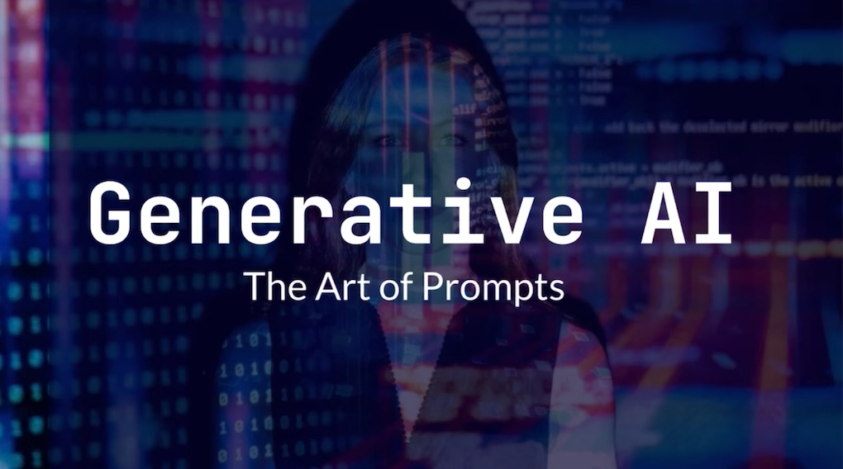
In today's rapidly evolving tech landscape, responsible AI application is key. Generative AI cannot provide the whole answer for you. You need to apply your won critical thinking and analysis to the outputs that a Generative AI provides you. Embrace AI as a supportive tool, not just a shortcut, and reap deeper understanding, improved writing, and readiness for future challenges.

