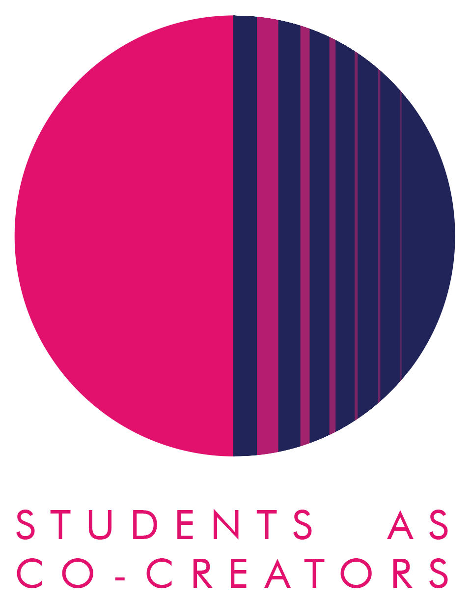

A Curriculum Design Collaboration

A Sustainably Developed Introduction to Academic Practice
Teodora Avram, Samiha Baskh and Ayush Shah
Morgan Lirette and Amy MacLatchy

Centre of Education and Teaching Innovation

Academic Year 2023-2024

A Sustainably Developed Introduction to Academic Practice report

The inspiration initially stemmed from a conversation between Morgan and me in the summer 2023, in response to the university’s commitment to UN Sustainable Development Goal 4.7 ‘Education for Sustainable Development’ (ESD). Sustainable Development is defined as ‘an aspirational ongoing process of addressing social, environmental and economic concerns to create a better world’ (QAA, 2021). We wanted to trial the inclusion of the theme sustainable development in the module Introduction to Academic Practice (IAP), on which I teach. IAP is a core Foundation module which is delivered across all seven disciplines of the Foundation programme (Arts and Media, Business, Computer Sciences, Life Sciences, Social Sciences and Humanities, Law, and Architecture). The students and staff focussed efforts of this project specifically within the Life Sciences discipline, where we are situated.

The project was further inspired after seeing the success of such partnership projects with the Foundation module Critical Thinking for Academic and Professional Development (CTAPD). As both IAP and CTAPD are core Foundation modules and focus on aspects of social justice and draw upon these links through partnership. We appreciated the positive impact this had and were inspired to embed student partnership work within the design and development of the curriculum. As we required feedback on the integration of SD in IAP it seemed logical to do this in partnership with students as they are the ones the content is intended. Therefore, this ensures that our work remains relevant, engaging, and innovative. Whilst providing opportunities for students to participate in ways that encourage meaningful interactions within ESD and beyond (Ho et al, 2023).

The aim of the project was to review and enhance the integration of sustainable development within the module Introduction to Academic Practice (IAP). A further aim of the project is to address the drop in attendance and engagement we observe after about week 3-4. We want to explore, through partnership, how to engage students further, which activities and materials they have enjoyed and how we can co-create the module for Life Sciences and feed into the other disciplines’ too. As revalidation is approaching, it is important we aim to empower students to co-create a module that aligns with their educational aspirations, while promoting active engagement and ensuring the lasting relevance and sustainability of the educational experience.

Initially we met each week to discuss the project, then fortnightly after the first month. The first meeting was sharing our aims, expectations, values and principles of the project and how we anticipated working together in partnership. As the students were the ones who were the recipients of the material, they were able to provide us with the feedback to lay the foundations of our project. This feedback provided the themes and questions for our survey which we co-created. The LS IAP students (our participants) completed this and from their responses, we were able to suggest interventions to embed sustainable development into IAP more successfully. The students actively contributed to the questionnaire, the evaluation of the survey, the interventions and creating the content. The suggestions towards assessments were considered and some of the ideas have been implemented- CW1- SDG presentation.

We anticipate that the impact of this project on the learning and teaching will be significant due to some of the changes we have implemented. We plan to continue to embed partnership work and ESD in the design and development of the IAP curriculum. I am hoping to recruit new Foundation students to continue this work to ensure the curriculum is relevant, innovative and engaging for current and future cohorts. We have collaborated with the sustainable cities and the urban environment research community to run sustainable development tour during the student engagement week. Our student partners are going to continue this work demonstrating our ongoing partnership commitment. There are future partnership projects in the pipeline with Anastasia Lydaki, the sustainable development advisor which we hope to create with our current student partners.

This partnership project has provided us with the opportunity to learn from one another. We have expanded our networks, shared our work at the All-Colleague SDG Workshop in June, and gained confidence working together. This has been instrumental in dismantling our classroom dynamics and designing and developing relevant and engaging curriculum together. We have also learnt that together we can achieve more and share the workload. This project has personally inspired me to continue to do more partnership work and extend this to include other disciplines, and finding ways to embed partnership in the curriculum so that it is co-created together.

Ho, S.S., Bowser, G., Templer, P. and Green, S.A. (2023). Learning for sustainability: partnerships for the goals. Sustainable Earth Reviews, 6(1), 8. Available at: https://doi.org/10.1186/s42055-023-00059-2 Access on 20/11/2023

QAA. (2021). Education for Sustainable Development Guidance Executive Summary. Available at: https://www.qaa.ac.uk/docs/qaa/guidance/education-for-sustainable-development-guidance-executive-summary.pdf Accessed on 22/11/2023

