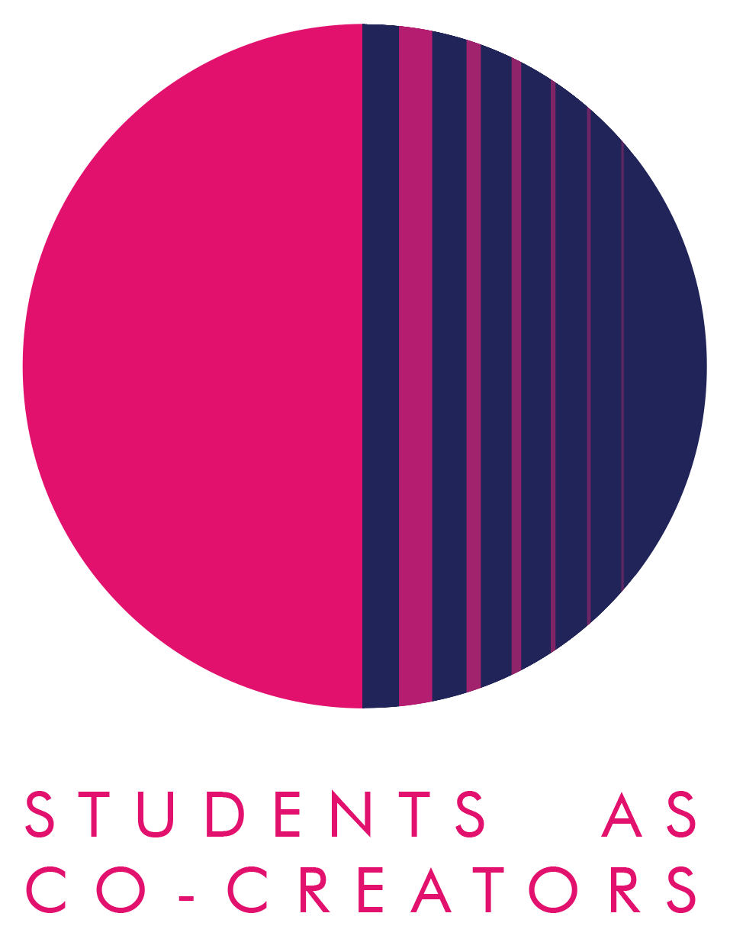

A Curriculum Design Collaboration

Decolonising the Psychology Curriculum

Student Partners:
Cheryl Alexander / Krystalle Anderson / Prerana Biyani
Sara Chaudhury / Eva Krivec / Irene Leonardelli Sicher

Academic Partners:
Haiko Ballieux / Jo Birkett / Bryan Bonaparte
Deborah Husbands / Catherine Loveday / Natasha Ramachandran

School of Social Sciences

Academic Year 2023-2024

Inspiration for the project
As a subject, psychology has developed in a milieu of racist and colonialist ideas with a history of racial discrimination (Augoustinos, 2009; Goodman, 2015). Being primarily formed and shaped by the perspectives of theorists who are White, non-disabled, economically advantaged and male (Reicher, 2001), psychology has subjugated the perspectives and knowledge of other groups, except when such perspectives have been used to convey groups as problematic (Pheonix, 1999). This has given rise to a curriculum that privileges Western ideas, serving to reinforce the dominance and legitimacy of this knowledge and power. Bhambra et al. (2018) argue that decolonising the curriculum is imperative to open up learning to neglected, alternative ways of thinking and to address historic colonialist oppression.
In a survey that the staff Psychology Diversifying and Decolonising Working Group carried out, we found that module leaders are keen to deliver a diverse and decolonised curriculum, however they were unclear about how and where to find it. The aim of developing a resource database was to enable lecturers and students to draw on and engage with diverse perspectives in different areas of psychology. Collecting data on the usefulness of this resource is imperative to its successful development and relevance to its intended audience.

What we set out to achieve
The main aims of this project were to develop and create a Global Psychology Resources Page on Blackboard for students and staff to engage with as well as collect Lived Experience stories from students to increase staff motivation to decolonise their modules and to raise awareness of the importance of decolonising and diversifying the curriculum amongst the students and staff in Psychology. We therefore divided the project into 2 parts:

Part I – Survey on the living document resource that the co-creation group developed:
- determine how useful Psychology students and staff find the resource.
- understand how psychology students and staff are engaging with the resource.
- understand Psychology students and staff perspectives on how the resource could be improved.

Part II – Collection of Lived Experience stories:
- understand what decolonisation means to students at the University of Westminster.
- empower students to represent their experiences of the impact of the curriculum in different mediums, as guided by the student co-creators.

Student-staff collaboration on the project
Students and staff attended several meetings in which the project was finalised. Students then created the Global Psychology Resources page on Blackboard and recruited students to participate in the Lived Experiences element of the project, which was held online and was student-led nd took the form of a ‘Silent Brainstorm’ and an ‘Artefact Exchange’. The latter involved participant students bringing along an object, song, poem, food, picture or anything else they could carry or a photo of something representing their cultural identity. They were asked to share the stories behind their cultural treasures so that all staff and students can discover the rich tapestry of identities within our community.The co-creator students came up with questions to ask the student participants to open up a conversation about what decolonisation means to them and to encourage them to share their lived experiences of the impact of the curriculum on their student life.
Further, staff members were asked to suggest 1 article or book, 1 website, 1 podcast or video and 1 question for the co-creator students to populate the respective sub-disciplinary discussion boards on the Global Psychology Resources page on Blackboard (e.g. Developmental Psychology, Social Psychology, Individual Differences, Biological Psychology, Cognitive Psychology, Counselling & Mental Health). Specifically, we asked staff members to think about resources that could inform about a non-Western perspective on their topic of expertise, or explicitly discuss decolonisation of their subject area.

Impact on learning & teaching
Some initial participant feedback from the events organised was that students thought the Lived Experience workshop mattered because it created a means to get to know fellow students and hear about their identities (especially appreciated in a large cohort such as psychology). Participants further commented on the safety of doing this in small groups in which they felt they could open up and share more personal stories and experiences. For example, one student commented that she got a better understanding of the difference between more individualistic versus collectivist societies/norms, which could impact on how students and staff relate to each other. Others commented on the importance of considering the time and context in which a particular (academic) topic/issue took place, including who developed it. Some students commented on the connection between artefacts and culture and how cultural background impacts our thoughts on the artefacts and what they symbolise. Finally, in the context of decolonizing the curriculum, the importance of option modules (and having a choice between wide-ranging modules) was highlighted.

We foresee that once the Global Psychology Resources page is more populated with relevant books, articles, podcasts, videos, and websites, this will form an invaluable resource for both staff and students, providing a common reference area that will allow for further conversation based on a mutual understanding of relevant stories. This is particularly valuable for those staff members that have indicated their interest in this important topic, but feel they are not necessarily equipped with the knowledge and/or language to feel comfortable contributing to what at times can be sensitive conversations.

Lessons for the future
One obstacle that we encountered was when to organise relevant events during the academic calendar in terms of both staff and student availability. We ended up organising the Lived Experience event quite late in Semester 2, which made it harder to recruit enough student participants as well as get more staff members to engage (especially during marking). It also proved difficult to get enough staff engaged with the Global Psychology Resources page.

However, we envision organising a psychology-wide staff-focused event based on the efforts and results of this project, to kickstart a decolonizing conversation based on developed tools and gained knowledge and insights.

References:
Augoustinos, M. (2009). Racism(s): One or many. International Journal of Psychology, 1, 43-45.
Bhambra, G. K., Gebrial, D., & Nişancıoğlu, K. (2018) ‘Decolonising the University?’, in G.K. Bhambra, D. Gebrial, & K. Nişancıoğlu (Eds.), Decolonising the university (pp. 1-16). Pluto Press.
Goodman, S. (2015). Qualitative psychology: A weapon in the battle against scientific
racism. Qualitative Methods in Psychology, 20, 24-27.

Krauss, J.E., Mani, S., Cromwell, J., San Roman Pineda, I. Cleaver, F. (2022). Bringing research alive through stories: reflecting on research storytelling as a public engagement method. Research for All, 6 (1). ISSN 2399-8121 https://doi.org/10.14324/rfa.06.1.20

Phoenix, A. (1999). Multiple racisms. The Psychologist, 12(3), 134-135.

Reicher, S. (2001). Studying psychology studying racism. In M. Augoustinos, K. Reynolds (Eds.), Understanding prejudice, racism and social conflict (pp. 273-298). Sage.

Trombeta, G., & Cox, S. M. (2022). The textual-visual thematic analysis: A framework to analyze the conjunction and interaction of visual and textual data. The Qualitative Report, 27(6), 1557-1574. https://doi.org/10.46743/2160-3715/2022.5456

