**The final report for CETI (July 2024)**

**Co-creator project: Promoting inclusive business-consumer relations through ethical consumer literacy**

**PIs: Koko Kondo & Nattida Srisaracam (WBS)**

**Introduction**

This project aims to respond to the UN SDG 2030 agenda, where we need to enhance ‘*equality and responsible production and consumption*’ (UN 2024). However, in our modern society, our everyday consumption patterns have become highly complex. It also needs to understand consumer’s literacy levels since consumers can be vulnerable when making decisions. This can also be pointed out in some studies, especially those that require education for young generations, such as Generation Z. Applying the stakeholder theory (Freeman, 1984, 1994) in this project also aims to narrow the gaps in consumer literacy. This is also seen as a gap in the literature suggesting business ethics and consumer literacy in the area of marketing. By having the opportunity to have co-creators in this project, we aim to explore and understand GenZ’s consumer literacy level and train the co-creators as co-researchers.

The research questions of this project are; (the third question will be achieved in the next phrase in Winter 2025).

1. What is the role of ethical consumer literacy in ethical decision-making through consumption?
2. What can affect consumers' ability and knowledge of ethical consumption behaviour?
3. To what extent can ethical consumer literacy facilitate business-consumer relationships?

**Background**

**Consumer literacy**

A study (Himmleweit 2014) has conducted research on consumer literacy in the UK with 250 respondents. Although age, education, and income are the strongest demographic correlations of consumer literacy, age is the strongest correlation. The study (Ibid) categorises into three processes ‘skills, knowledge, and engagement’. The study (Ibid) claims that age also relates to the pillar of ‘engagement’ which describes how people put literacy into practice.

On the other hand, how the business side emphasises on ethical aspects in packaging has been examined. For example, a study on eco-labels and consumer literacy in the U.S. and U.K (Gutierrez  and Thornton, 2014) focused on ‘sustainability’ products if consumers would purchase sustainable seafood with extra costs. More than 70-80percent of DC and London consumers have seen the eco labels. However, their knowledge of the issues in fishing and sustainable consumption acts can be questioned. They emphasis on educating the consumers.

In terms of ‘engagement, a study also has found the relationship between consumer literacy and brand value. Cui and Li (2024) examined CL through online brand communities and concluded that consumer literacy is important in the era of consumers are co-creator of brand value: ‘Consumers with low literacy tend to face more difficulties, more decision-making biases, and lower satisfaction in the interaction process’.

**Becoming an ethical consumer**

Furthermore, Fuentes and Sörum (2019, p. 131) argue that “being and becoming an ethical consumer remains a difficult endeavour.” Szmigin, Carrigan, and McEachern (2009), the ethical consumption context is a complex task environment. There are four dimensions related to ethical consumer literacy (Papaoikonomou et al., 2023):

* define ethical consumer behaviour,
* access and search for ethical information,
* understand and evaluate ethical information,
* engage in ethical consumer leadership

– for which two levels (basic and advanced) of literacy are suggested within each dimension. For example, a study (Alchemy, 2022) has found that 75 percent of Gen Z shoppers said they are influenced by whether products and brands align with their values when it comes to purchasing decisions (Ibid). Three in five Gen Z consumers were more likely to buy products that made sustainability claims than less than half of the general population (Ibid). However, the recent Mintel shows that Genz spends most on fashion (2023). Then, it can be argued that there might be a gap between consumer literacy (skills and knowledge) and engagement (practice). The myth of ethical consumers- do ethics matter in purchase behaviour (Carrigan & Attala, 2001)? They claimed this more than 20 years ago. However, we are still having similar behaviour amongst Genz and the study also emphasizes that the knowledge of consumers is the key element to making the decision of purchasing. The difference is that Genz has knowledge but may not show a strong engagement in actual consumption as ethical consumers. Consumers' nourishing good knowledge and practice through different channels and co-creating value for brands by engaging can make businesses act ethically.

**Methods (this part was funded by CETI’s co-creator call).**

**Mixed methods research design**:

Data collection: The study involves a mixed methods research design by adopting questionnaire surveys (n= 50) and two focus groups (4-6 participants per group)

- Data collection: The duration of your participation relates to the specific tasks involved in the study, altogether 1.5 to 2 hours.

- Students would be co-creators who will initiate and organise the workshop activities.

**Co-creators roles: designing a workshop**

We recruited five students. Except for one student from the Cavendish campus, all have taken the Business Ethics module (Level5).

One from level 6 had finished her small research on ethical consumer in fashion through a dissertation module and took a research initiative. The rest of level 5 students also actively participated. We had online and face to face meetings at campus to prepare for the workshop.

One of our student partners created the flyer above.

Another student who acted as a project manager had tried to invite ethical business leaders (i.e. a restaurant nearby claiming that they are ethical restaurants), but we found that they were not ‘ethical’ (greenwashing) since they tried to charge us.

In the end we decided to have the workshop as follows:

1. A guest speaker from Cavendish campus who was involved in a sustainability project. (knowledge)
2. Quiz (two groups) – testing the knowledge of sustainability using Jenga (Testing knowledge and skills)
3. Making a new product from rubbish (engagement)
4. Focus group (asking their engagement level)

Genz had good knowledge on sustainability. The participants did not know each other, so having Jenga was very good as an ice-breaking exercise. Co-creators also managed to ask good questions about sustainability. By doing so, they also learned them.

Jenga games with sustainable quiz

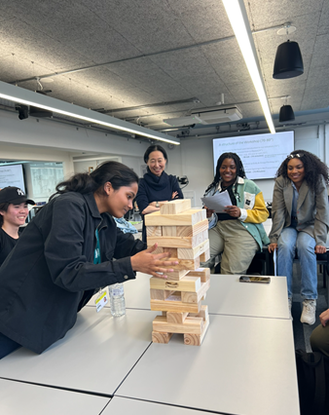

Creating a product by two groups was also fun to do and gave them new insights on how we can recycle the materials into new products. This exercise can give them some ideas about entrepreneurial opportunities.

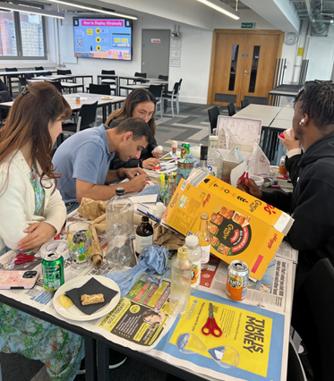

Results Group 1(Photo of the product)- Easter gifts

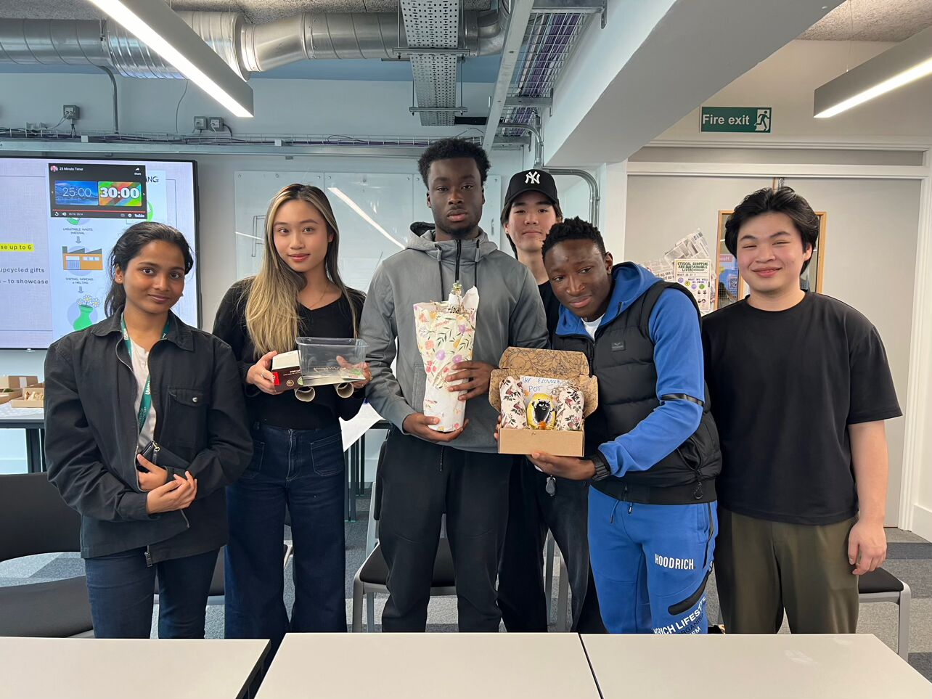

Group 2 (photo of the product)- imaginary box toy for kids

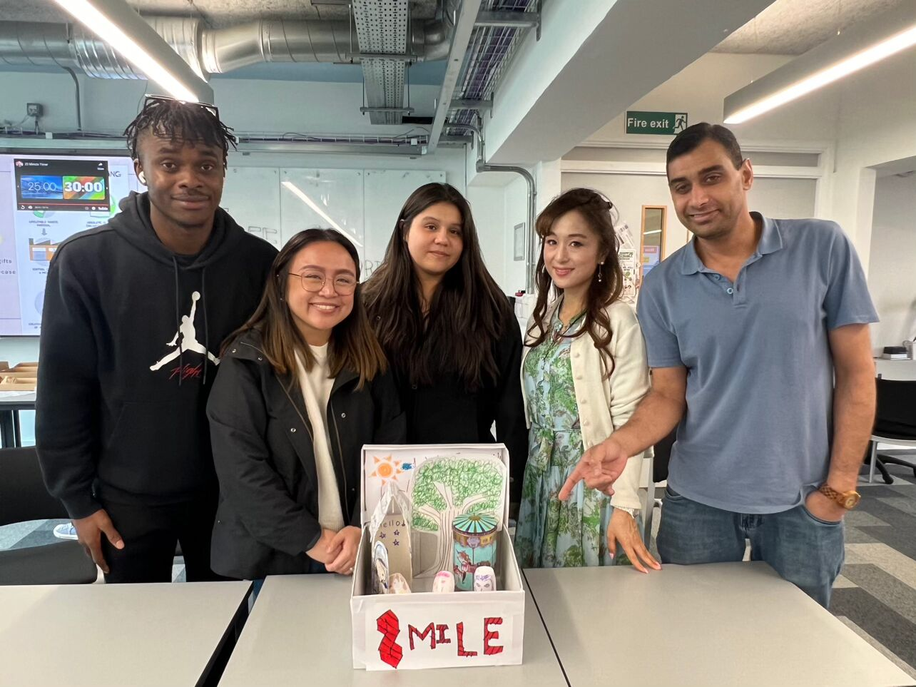

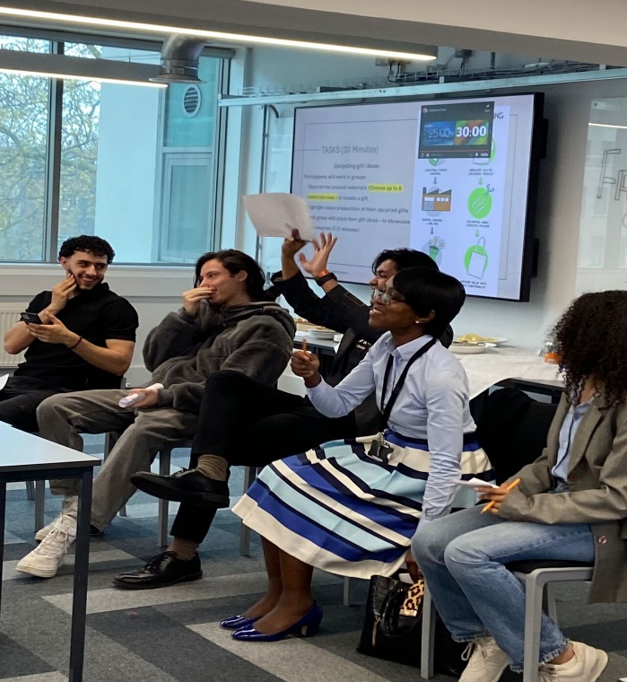

Focus group where they were asked further questions between knowledge and practices.

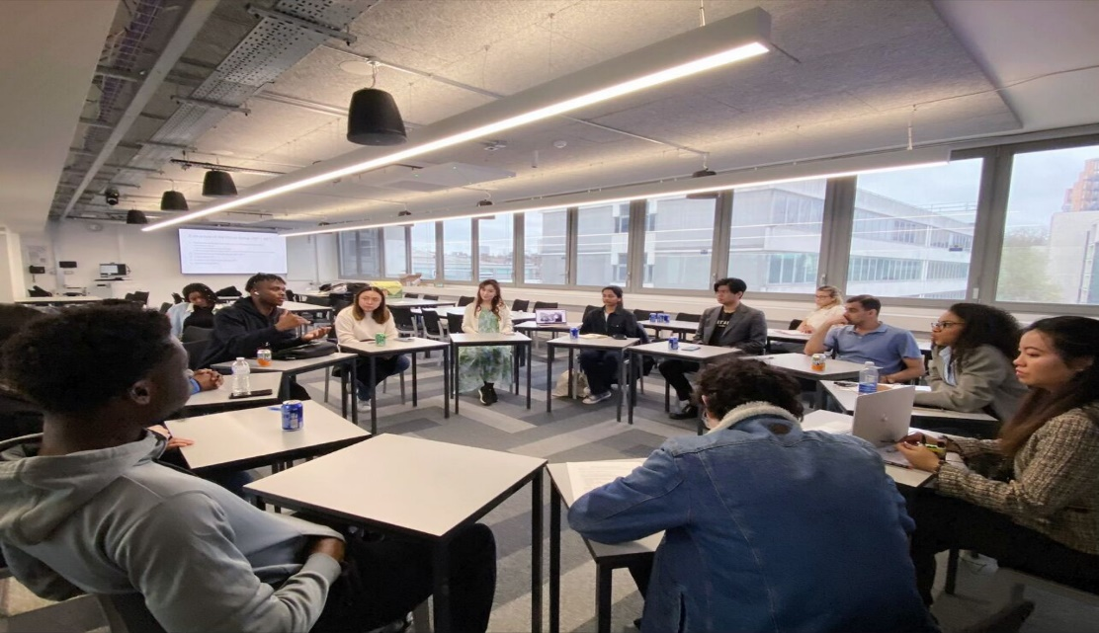

The results: many are aware of sustainable issues and try to be sustainable. But when it comes to practice, many agree that ethical products tend to be pricy, and price comes first. They were honest about their habits of spending and the final choice:

*‘Your main concern is, like I said, the expense and the quality because I feel like I just, I just feel like people once you installed going down the rabbit hole, it becomes a lot more complicated than it really needs to be for the individual. When you have your own priorities, not read, because if I'm being honest, you don't have thinking about like what the other person who made The thing is feeling or like the environment for being honest ourselves. You're thinking about your own pockets, your family, your primary issues, and I feel like, you know, we can all agree here.’*

Another point is that they don’t check labels for recycling.

*‘I well, I grew up doing it for cycling every single week for recycling 12 like it's just a daily thing that my family do. But We don't think Ohh is that recyclable.  
I think it's just after the purchase after consuming it.’*Phase 1 in this project shows interesting aspects, and Phase 2 should be more specific (particularly regarding consumer goods).

**Co-creator reflection**

Working with co-creators: From our point of view, they were actively working until the workshop. The preparation period was very short, and it became almost week 12 for the workshop. I worried about the participant's Creative thinking for making quizzes or coming up with some ideas on sustainable products was very interesting. After the workshop, they suddenly disengaged, but this could be the timing, too. Thus, we had only two co-creators who gave their views as follows

Cocreators- overall they learned the process of research, especially designing the methods and data collection. One also reflected that the workshop should have been done better by having more participants. But overall, it went well. One also felt that he put this experience in his CV, thinking that this opportunity enhanced his CV.

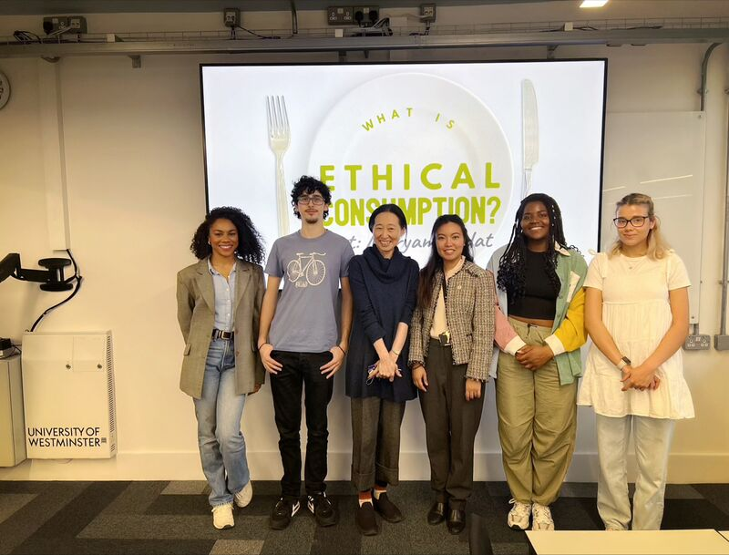

**Conclusions.**

There were some limits in this project. This time, we call it phase 1, and it explores the area, but in the next phase, we need to be more specific, such as fashion or food, etc., to gain more specific ideas for future business. At the same time, we need to educate young people because it is claimed that ethical consumption involves transformative processes to challenge those conventional consumption types (e.g. mass production, less conscious buying, and ethically questionable consumption (Fukukawa, 2002). Consumers at more advanced levels of ethical consumer literacy are likely to embrace this transformative potential – for which they should be supported by companies, policymakers, government, and other stakeholders (NGOs, consumer organisations). The role of consumer leadership is a call for change from businesses. Carfagna et al.’s (2014, p.171-72) study relating to food swap also highlighted that consumers would take further initiatives and described themselves as ‘entrepreneurs’ who are “trying to create a new culture of read food and empowering others.” Engaging in business-consumer relations is vital to accommodate this change from the business side. It demands structural and institutional change, consumer ethics education, and open discussion on ethical issues from businesses.

For this reason, further study should monitor if ethical consumer literacy has been developed by using action research methods. We need to understand their skills, knowledge and engagement more specifically by having particular cases (i.e. fashion) for this stage to have more concrete outcomes. In addition, we need to find better ecosystems where consumers can act as co-branders and stakeholders.

**References**

Alchemy (2022) ‘Three Quarters of Gen Z Shoppers Prioritise Ethics Over Price despite Cost of Living Challenges’ https://alchemmy.com/three-quarters-of-gen-z-shoppers-prioritise-ethics-over-price-despite-cost-of-living-challenges/

Carfagna Lindsey B., Dubois Emily A., Fitzmaurice Connor, Ouimette Monique Y., Schor Juliet B., Willis Margaret, Laidley Thomas (2014). “An Emerging Eco-Habitus: The Reconfiguration of High Cultural Capital Practices Among Ethical Consumers,” Journal of Consumer Culture, 14 (2), 158–78.

[Carrigan, M.](https://www.emerald.com/insight/search?q=Marylyn%20Carrigan) and [Attalla, A.](https://www.emerald.com/insight/search?q=Ahmad%20Attalla) (2001), "The myth of the ethical consumer – do ethics matter in purchase behaviour?", [*Journal of Consumer Marketing*](https://www.emerald.com/insight/publication/issn/0736-3761), Vol. 18 No. 7, pp. 560-578. <https://doi.org/10.1108/07363760110410263>

Cui, Zhongxin, and Guangming Li. (2024). "Consumer Literacy in Virtual Brand Communities: Dimension Exploration and Scale Development" Sustainability 16, no. 4: 1395. https://doi.org/10.3390/su16041395

Fuentes, C., & Sörum, N. (2018). Agencing ethical consumers: smartphone apps and the socio-material reconfiguration of everyday life. Consumption Markets & Culture, 22(2), 131–156. <https://doi.org/10.1080/10253866.2018.1456428>

Freeman, R.E. (1984). Strategic Management: A Stakeholder Approach, Pitman, Boston, MA.

Freeman, R.E. (1994) The politics of stakeholder theory: some future directions. Business Ethics Quarterly, 4(4), 409–421.

Fukukawa, K. Developing A Framework for Ethically Questionable Behavior in Consumption. *Journal of Business Ethics* 41, 99–119 (2002). https://doi.org/10.1023/A:1021354323586

Gutierrez, A.; Thornton, T.F. Can Consumers Understand Sustainability through Seafood Eco-Labels? A U.S. and UK Case Study. Sustainability **2014**, 6, 8195-8217. https://doi.org/10.3390/su6118195

Himmelweit, S. M. (2014). Consumer literacy. *International Journal of Market Research*, *56*(6), 709-716. <https://doi.org/10.2501/IJMR-2014-051>

Papaoikonomou, E., Ginieis, M., & Alarcón, A. A. (2024). The Problematics of Being an Ethical Consumer in the Marketplace: Unpacking the Concept of Ethical Consumer Literacy. *Journal of Public Policy & Marketing*, *43*(2), 133-150. <https://doi.org/10.1177/07439156231202746>

Szmigin, Isabelle; Carrigan, Marylyn and McEachern, Morven G. (2009). The conscious consumer: Taking a flexible approach to ethical behaviour. International Journal of Consumer Studies, 33(2) pp. 224–231.DOI: <https://doi.org/10.1111/j.1470-6431.2009.00750.x>

United Nations (2024) ‘Transforming our world: the 2030 Agenda for Sustainable Development’ <https://sdgs.un.org/2030agenda>