**A Curriculum Design Collaboration**

***Phryctoria Archmaester***

Students: Chaye Foster, Sabahodin Sharaf

Academics: Markos Mentzelopoulos, Stylianos Mystakidis, Kai Erenli, Jack Ingram, Hari Konda Ramamoorthy

**University of Westminster**

**Academic Year 2023-2024**

**Contents:**

Inspiration for the Project 3

Project Goals 4

Collaboration between Students and Staff 6

Lessons Learned from Working in Partnership 7

Conclusion 8

Figure 1: Collaboration with BFI students in Vienna (February 2024) 3

Figure 2: First prototype of the game created in Vienna 4

Figure 3: Octalysis framework with game mechanics 5

Figure 4: Updated version of the game presented at Glasgow 5

Figure 5: Presenting our research paper at the iLRN conference (June 2024) 6

Figure 6: Artwork for Polybius square 6

Figure 7: Game background artwork 6

Figure 8: Academic partner Markos achieving iLRNFuser Game Jam certificate in Glasgow 7

## 

## **Inspiration for the Project**

The inspiration for our project stemmed from a unique opportunity to participate in the iLRNFuser Game Jam 2024. This event, held from February 26th to March 2nd, 2024, provided a platform for students to explore immersive learning through game development. Our team, comprising students from the University of Westminster and Fachhochschule des BFI Wien, was motivated by the challenge of creating an educational game that would not only be engaging but also historically informative.

The inspiration for our project began with a compelling idea presented to us in a PowerPoint by our Course Leader, Markos Mentzelopoulos, and researcher, Stylianos Mystakidis. They introduced us to the concept of creating an educational escape room game focused on ancient Greek communication methods. Building on their foundation, we decided to add our own twist by opting for a 2D game design with intuitive drag-and-drop mechanics.

Our game, designed as a tablet-based experience for the University of Patras' Science and Technology Museum, aims to educate visitors - particularly children, young learners, and museum-goers—about the ancient Greek method of long-distance communication using fire signals, known as Phryctoriae. The game aligns with the United Nations' Sustainable Development Goal 4, which focuses on Quality Education, by enhancing players' problem-solving, memorization, and critical thinking skills.

The concept provides a rich visitor experience, allowing players to engage directly with ancient Greek telecommunications through an interactive tablet-based game. By understanding the historical significance of Phryctoriae, players not only learn about ancient fire signal communication but also gain insights into its impact on Greek history.

Technologically, the project leverages immersive and interactive gameplay elements, making it accessible and engaging using tablet devices. Inspired by popular 2D drag-and-drop games, our design focuses on combining fun with learning to ensure better retention and educational engagement.

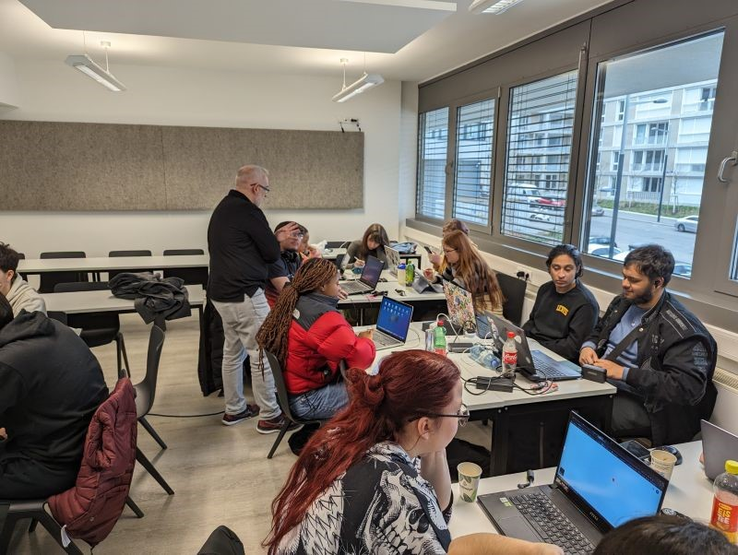

Figure 1: Collaboration with BFI students in Vienna (February 2024)

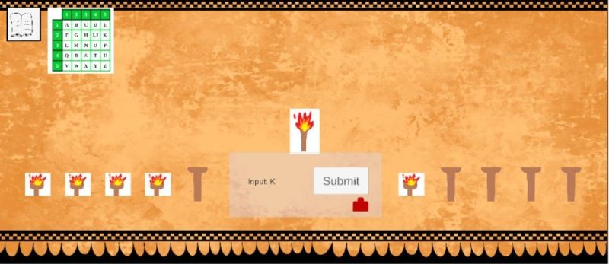

Figure 2: First prototype of the game created in Vienna

## **Project Goals**

Our primary objective was to develop an immersive educational game titled "Escape Room Puzzle Game: Become a Phryctoria Archmaester." The game is set in ancient Greece and focuses on teaching players about the Phryctoria communication system. We aimed to create a 2D puzzle game where players use the Polybius square to decode messages, with a limited number of lives adding a layer of challenge. To aid players, hints are available, and correctly submitting a decoded word allows them to progress to the next level.

The game features a scoring system to enhance player engagement and challenge, with elements designed using the Octalysis Framework to maximize user experience:

* **Dialogue System**: Explains the story, providing context and meaning to the gameplay.
* **Animated Fire on Torches**: Visual representation of accomplishment as players light torches.
* **Combinations of Lit Torches Form Letters**: Empowerment through problem-solving as players decode messages.
* **Scoring System**: Rewards player accomplishments, encouraging continued engagement.
* **Interactable UI**: Includes torches, buttons, and hints to empower players through control and interaction.
* **Health System**: A limited number of lives adds an element of avoidance, where failure leads to a game-over screen.
* **Audio**: Background music, sound effects, and game-over music contribute to unpredictability and immersion.
* **Timer**: Introduces scarcity by limiting the time available to solve puzzles.

Figure 3: Octalysis framework with game mechanics

Additionally, we set out to submit a research paper detailing our development process and educational goals, which we successfully presented at the Immersive Learning Research Network (iLRN) conference as a presentation with a live demonstration of the game.

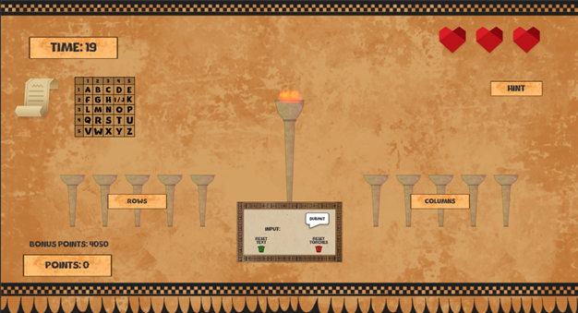

Figure 4: Updated version of the game presented at Glasgow

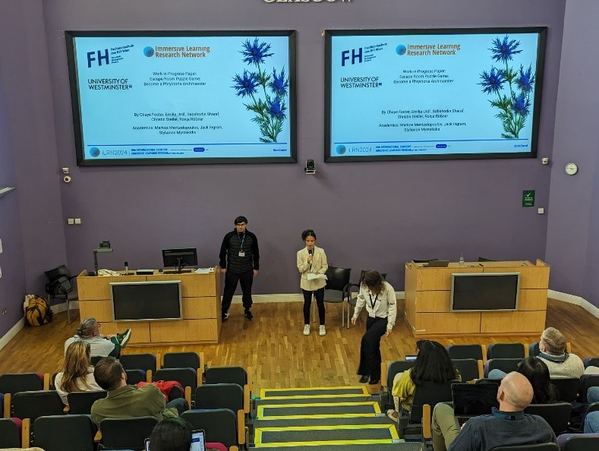

Figure 5: Presenting our research paper at the iLRN conference (June 2024)

## **Collaboration between Students and Staff**

The collaboration between students and staff was truly the cornerstone of this project, driving its success at every stage. As the team leader and programmer, I had the privilege of working alongside a diverse and talented group of individuals who brought their unique skills and perspectives to the table. One of my key collaborators was Sabahodin Sharaf, who not only contributed significantly to the development process but also joined me in co-presenting our work-in-progress paper at the iLRN conference. His insights and dedication were crucial to the refinement of our game's mechanics and the overall presentation.

Our collaboration extended beyond the technical aspects to the creative elements of the game. The art style and dialogue, essential components that brought our ancient Greek theme to life, were expertly crafted by BFI students Ronja Rößner, Emilia Urdl, and Christin Steller. Their work showcased a seamless integration of artistic and narrative elements, making the game both visually appealing and engaging for players. The collaboration with the BFI team was particularly enriching, as it allowed us to blend different cultural perspectives and artistic techniques, resulting in a more well-rounded and immersive experience.

Figure 6: Artwork for Polybius square

Figure 7: Game background artwork

Our project was further strengthened by the invaluable guidance we received from Stylianos Mystakidis. His expertise in immersive learning and educational technologies played a pivotal role in shaping the direction of our project. Stylianos provided us with critical feedback throughout the development process, helping us align our game’s educational objectives with the overarching goals of the iLRNFuser Game Jam and the conference.

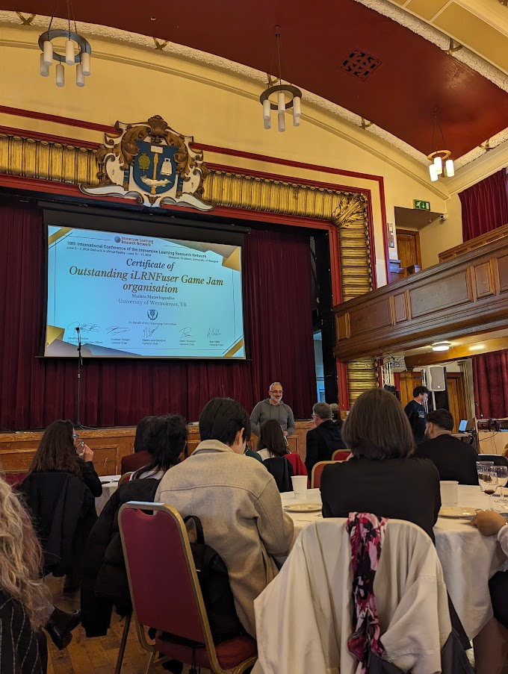The success of our project was also heavily dependent on the support and organisation provided by our academic mentors, Markos Mentzelopoulos and Kai Erenli. Markos, in his dual role as Course Leader for the Computer Games Development BSc course and Director of Student Engagement for iLRN, was instrumental in organising our participation in the iLRN conference and ensuring that we had the resources and support needed to develop our project. Kai, a key figure in the collaboration between the University of Westminster and Fachhochschule des BFI Wien, facilitated the cross-institutional partnership that was critical to the development of our game. Their encouragement and logistical support enabled us to focus on the creative and technical aspects of the project without being hindered by administrative challenges.

Figure 8: Academic partner Markos achieving iLRNFuser Game Jam certificate in Glasgow

In addition to these key contributors, the broader network of co-creators and academic staff provided a supportive environment that enabled collaboration and innovation. Whether through formal feedback sessions or informal brainstorming meetings, the partnership between students and staff was marked by a shared commitment to excellence and a mutual respect for each other's expertise. This collaborative spirit not only enriched the development process but also ensured that our final product was of the highest quality, ready to be showcased on an international stage.

## **Lessons Learned from Working in Partnership**

Working in partnership on this project provided us with numerous valuable lessons that will continue to inform our future work and collaborations. One of the most significant takeaways was the critical importance of clear communication and collaboration across different disciplines. As we integrated various elements such as programming, art, and educational theory, it became apparent that effective communication was key to ensuring that each component aligned with the overall vision of the project. Balancing the technical demands of programming with the creative requirements of art and the goals of educational theory required constant dialogue and mutual understanding among team members. This experience taught us how to articulate our ideas more clearly, listen actively to others, and find common ground when integrating diverse perspectives.

Another important lesson was the immense value of cross-institutional partnerships. Collaborating with students from different universities brought a wealth of diverse perspectives, skills, and expertise to the table. Each institution contributed its strengths - whether it was the technical expertise from the University of Westminster or the artistic talents from Fachhochschule des BFI Wien. This diversity not only enriched the project but also fostered a learning environment where we could exchange knowledge and approaches, broadening our own understanding and capabilities. The partnership also underscored the importance of flexibility and adaptability, as we navigated different academic cultures, communication styles, and working methodologies.

The project also highlighted the significance of iterative development, a process that became crucial as we moved from the initial concept to a functioning prototype. Our initial prototype served as a foundational platform, allowing us to test our ideas, gather feedback, and make informed decisions about further enhancements. This iterative approach taught us the importance of viewing a project as a living entity - one that evolves and improves over time through continuous refinement. It reinforced the idea that a project is rarely perfect from the outset and that embracing a cycle of development, testing, and revision leads to a more polished and effective final product.

Moreover, this iterative process developed a mindset of resilience and adaptability within our team. We learned to embrace feedback, whether positive or critical, as an opportunity for growth and improvement. By iterating on our design and functionality, we were able to address challenges, explore new ideas, and ultimately create a more engaging and educational game.

In summary, the partnership on this project was a rich learning experience that taught us not only about the technical and creative aspects of game development but also about the soft skills essential for successful collaboration. The lessons in communication, cross-institutional collaboration, and iterative development have equipped us with a stronger foundation for future projects, ensuring that we can work effectively in diverse, multidisciplinary teams and continue to produce innovative, high-quality work.

## **Conclusion**

The iLRNFuser Game Jam 2024 offered an extraordinary platform to delve into the intersection of education, history, and technology. This experience allowed us to transform a concept into a tangible, interactive learning tool that not only educates but also captivates players with its innovative design and engaging content. The success of our project is a testament to the power of collaboration, dedication, and a shared passion for learning.

Through the collective efforts of our team, we were able to blend historical education with modern game design, creating an experience that resonates with players and enhances their understanding of ancient Greek communication methods. Our journey from initial concept to prototype was marked by a commitment to excellence and a willingness to iterate and improve, ensuring that the game not only meets educational goals but also provides an enjoyable and immersive experience.

Looking ahead, we are excited to continue refining and expanding the game, further enhancing its educational impact. We see this project as just the beginning, with plans to introduce more features, levels, and content that will deepen players' engagement and broaden their learning experience.

None of this would have been possible without the unwavering support of our academic partners, whose guidance and resources were instrumental in every phase of development. Their involvement not only facilitated the creation of the game but also provided us with the incredible opportunity to present our work at the iLRN conference in Glasgow. Participating in the conference was a highlight of our journey, allowing us to showcase our project on an international stage, connect with experts in the field, and gain valuable feedback that will inform our future work.

In conclusion, the iLRNFuser Game Jam 2024 was more than just a competition - it was a collaborative learning experience that empowered us to push the boundaries of what educational games can achieve. We are grateful for the support we received and are eager to see how our work can continue to contribute to the field of immersive learning.