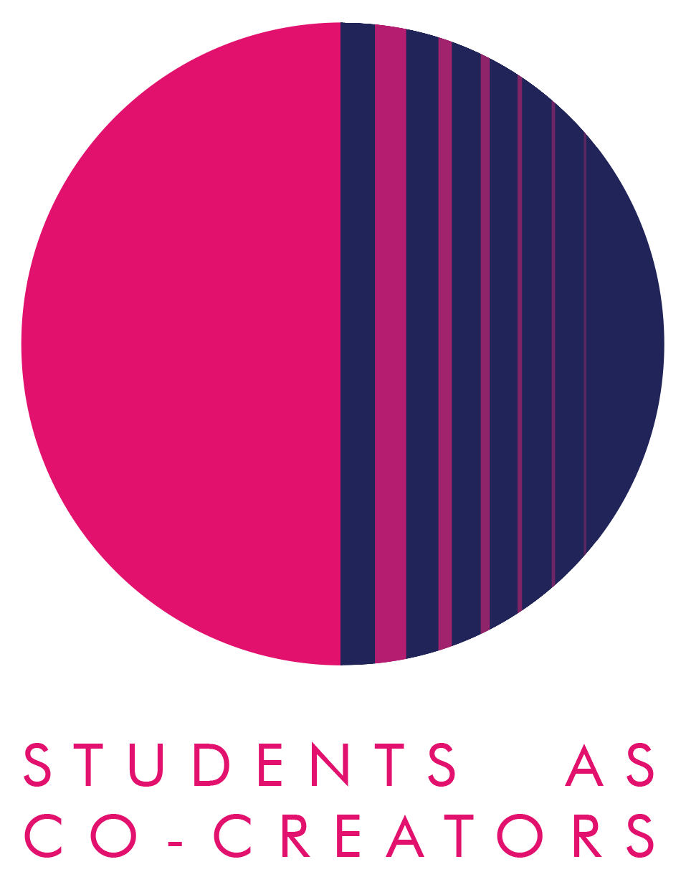

A Curriculum Design Collaboration

Decolonising Emerging Landscapes and Urban Ecologies

Clara Sachetti, Julaiha Sanofar Mohamed Abdullah, Mihika Mishra, Mona Shakeri, Neill Chauhan, Sara House, Shantanu Bhosle, Sruthy Menon, Vedant Kishore

Dr Krystallia Kamvasinou, Ripin Kalra, Ozge Suvari

School of Architecture and Cities

Academic Year 2023-2024

Inspiration:
The inspiration for this project came from discussions in the classroom during the first run of the module "Emerging Landscapes and Urban Ecologies" in Sem 2, 2024, recognising the need to respond to the diverse MA student cohort’s origins and employment destinations. The existing materials of the module curriculum predominantly focused on temperate regions and lacked diverse perspectives, particularly from the Global South. This imbalance prompted the desire to create a more inclusive and globally relevant curriculum, drawing upon students’ experiences and subject areas of interest.
Objectives:
1. Critically assess the module curriculum to identify problems and gaps in syllabus, learning materials and resources, teaching styles, and assessment content.
2. Co-create new materials, reading lists, and learning methods.
3. Generate recommendations and compile a report and poster for dissemination.
4. Formulate a monitoring exercise/survey for gathering future student opinions on curriculum diversity.
5. Update module materials for the 2024-25 module run.
Collaborative Students-Staff Approach:
Students and staff worked together through a three-phase process.
1. Initial briefing and brainstorming to identify areas needing decolonising (staff-led).
2. Background research and proposal formulation for updating syllabus content, assessments, and teaching approaches, with short PPT presentations (staff/student-led).
3. Final recommendations and implementation, including compiling a comprehensive report and summarising findings in poster form (student-led).
The collaboration involved students from three Masters courses (International Planning and Sustainable Development, Urban Design, and Urban and Regional Planning) with diverse international backgrounds (from Brazil and Honduras to Iran and India), bringing unique perspectives to enrich the curriculum. Staff members provided guidance and facilitated site visits (eg. to Kew Gardens) to enhance understanding of key concepts.
We conducted six 2-hour workshops in person and three online meetings between March-June 2024, to review existing content, conduct focused group work on geographical and climatic gaps in the module curriculum, and develop new case studies and reading list additions. Students also worked independently, doing research in the library and online. We set up a WhatsApp group for ease of instant communication, and a One Drive folder to deposit materials and work-in-progress, a project management Gantt chart, and drafts of the report.
Key Outcomes:
1. Updated reading list with 30% more Global South content
2. Introduced four new case studies from arid and tropical regions
3. Revised timetable to prioritise site visits
4. Monitoring survey for future students

The students' voices and feedback were captured as part of the report. For example, Julaiha Sanofar Mohamed Abdullah, MAIPSD, mentioned: "The co-creators project was particularly impactful, as it facilitated a collaborative learning environment where I could explore diverse practices from around the globe. This exposure broadened my perspective and provided valuable insight into innovative and effective solutions being implemented worldwide” (see attached project report for more).
Anticipated Impact:
- A more inclusive and diverse curriculum that better reflects global perspectives on emerging landscapes and urban ecologies.
- Enhanced student engagement by incorporating relatable case studies and literature from various geographical and climatic contexts.
- Improved learning outcomes as students gain a more comprehensive understanding of the subject matter.
- A model for decolonising curricula that can be applied to other modules in planning, urban design, and architecture.
- Long-term impact on students' professional development, equipping them with a global perspective for their future careers.
Lessons Learned:
1. The value of diverse student perspectives in identifying gaps in the curriculum.
2. The importance of balancing theoretical knowledge with practical experiences, such as site visits.
3. The need for ongoing monitoring and revision of the curriculum to maintain relevance and inclusivity.
4. The benefits of collaborative learning in broadening students’ understanding of global practices.
5. The significance of acknowledging and addressing colonial legacies in academic disciplines related to urban planning and design.

This project demonstrated the power of student-staff partnerships in creating more inclusive and globally relevant educational experiences. It highlights the importance of continual reflection and adaptation in higher education curricula to meet the evolving needs of a diverse student body and global society.

September 2024
Attached: Project report and Poster
2 Final Report Individual Sheet - CoCreator Program.pdf
3 Final Report Cropped Spreadsheet - CoCreator Program.pdf
final poster correction .pdf

