Student as Co-Creators Showcase and Celebration event 2023

UNIVERSITY OF WESTMINSTER



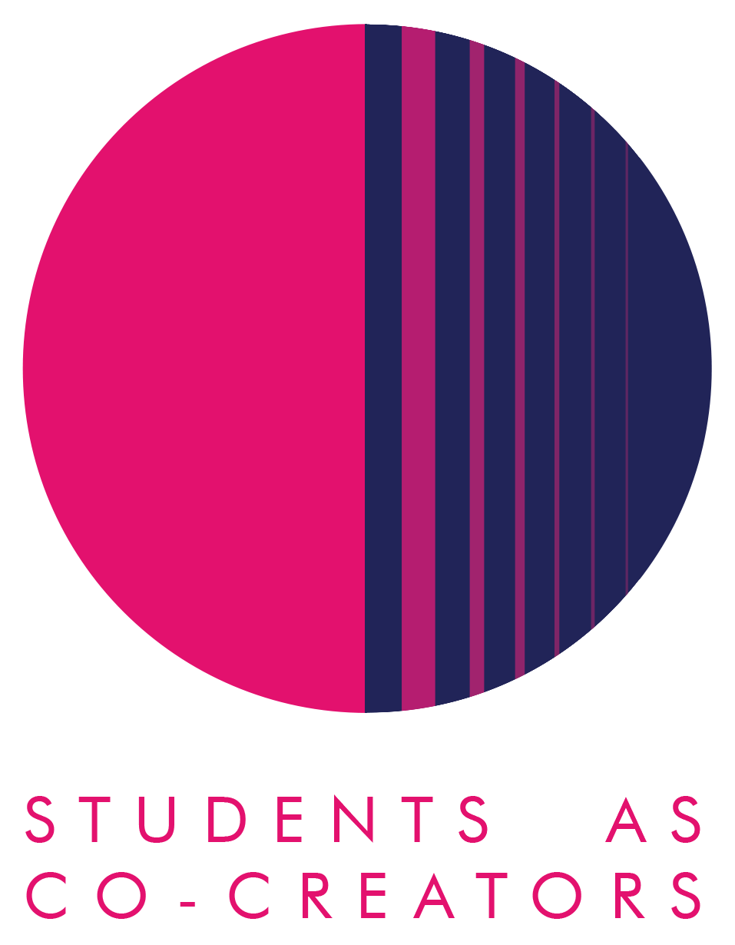**Introduction to Academic Practice: Sustainable Development in Partnership**

**Teodora Avram, Samiha Baksh, Morgan Lirette, Amy MacLatchy and Ayush Shah**

**Executive Summary**

Sustainable Development (SD) is defined as “an aspirational ongoing process of addressing social, environmental and economic concerns to create a better world” (QAA, 2021). At the University of Westminster (UoW), we have committed to attaining UN Sustainable Goal 4.7, 'Education for Sustainable Development.' (ESD) This involves addressing the three pillars of SD, which centre on social, environmental, and economic challenges.

Collaboration between students and staff offer a distinctive opportunity not only to dismantle traditional classroom hierarchies (Hall et al., 2022) but also to actively contribute to the curriculum, including assessments and content (Deeley and Brown, 2014; Chan and Chen, 2023), specifically when embedding and promoting ESD (Perello-Marín et al, 2018; Ho et al, 2023). Given that the content is intended for the students, it is crucial that it remains relevant, engaging, and innovative, providing opportunities for students to participate in ways that encourage meaningful interactions within ESD and beyond (Ho et al, 2023).

To actively embed SD in the core Foundation module Introduction to Academic Practice (IAP) we reflect on, evaluate and re-imagine, in partnership, the best practices to embed SD to supports the needs, recommendations and urgency of our students and the goals of the university.

**Aims**

In line with the University of Westminster’s (UoW) commitment to UN Sustainable Development Goal 4.7 ‘Education for Sustainable Development’, we aim to review and enhance the integration of sustainable development within the Life Sciences of IAP.

As this is intended for students this work was carried out in partnership with students to ensure the material is relevant, innovative and to include their voices and feedback.

**Methods**

The project had three phases. In the initial phase, student researchers from the team provided feedback on the module (IAP) through focus groups. The feedback was analysed and used to create a questionnaire. This questionnaire, developed in partnership and produced on Microsoft Forms, ensured data security with university email addresses. It aimed to evaluate practices that successfully embedded SD in the LS IAP module, covering various aspects like lectures, seminars, and assessments. The questionnaire featured 13 questions, including open-ended, ranking and scale questions. Students completed the questionnaire during lecture and seminar sessions, with participation incentivised by a draw for £20 vouchers. The data will inform future module iterations and support the revalidation process.

**Results**

Of the 200 LS Foundation students enrolled on the IAP module and asked to complete the survey, 30 students participated (14% of the total cohort). All respondents stated that they enjoyed the module. On asking the students of prior understanding of SD there were a mixture of responses, indicating that it supported their understanding: “I did have a little bit of prior knowledge about sustainable development as I had studied geography previously, but definitely after the IAP lectures and assignments my understanding of SD improved”. 57% of students surveyed felt that sustainable developed was very well incorporated in IAP, 27% felt that it was ‘excellently’ incorporated, with 13% felt neutrally, and 3% felt it was not well incorporated. 97% of students felt their understanding of SD was enhanced through the module. The survey indicated the students preference for quizzes, Ted Talks and Mentimeter for activities to embed SD. Suggestions from the students regarding what they would like to see more of in the future included: “I would like to explore the new innovative technologies and strategies being used to reduce environmental impacts, promote social equity, and ensure economic prosperity for present and future generations” and “I would love to learn more about how scientists like biomedical scientists or pharmacists incorporate sustainable practices into their work. I think that would align perfectly with my pathway for the future.”

**Recommendations**

The feedback from the survey and our focus group have informed how the next iteration of IAP will integrate SD. Quizzes will be included each week, as well as further Ted Talks. SD tours will be introduced to the Foundation students during student engagement week. These are designed to address the comments from students to see SD in practice. This may be further extended to include Walking the Walk, a sustainable development tour developed by Professor Andrew Smith in the Sustainable Cities and Urban Environment Research Community. Whilst the format of the assessments will remain, there is a concerted effort to ensure ESD and SDGs are incorporated, including the aspects that students enjoyed from this year. The presentation will focus on embedding SDGs, as well as the other assessment tackling aspects of ESD, such as the global food crisis, impact of pollution on health and the environmental impact of drug discovery. Together lecture content and seminar activities have been co-created to embed these themes. In the future, this project may lead to further co-creative processes in which students and staff contribute to curriculum design and content. It is important to involve students in this process as this material and delivery is intended for them. It has been challenging as embedding SD in a module that is focussed on delivering academic practice can feel disingenuous. Hence, the need to continually address feedback to ensure ESD is successfully and effectively integrated into the curriculum.

**References:**

Chan, C.K.Y. and Chen, S.W. (2023). Student partnership in assessment in higher education: a systematic review. Assessment & Evaluation in Higher Education, 1-13 Available at: <https://doi.org/10.1080/02602938.2023.2224948>

Deeley, S.J. and Brown, R.A. (2014). Learning through partnership in assessment. Teaching and learning together in higher education, 1(13), 3.

Hall, J., MacDonnell, J., McConnell, C., & Jones, J. (2022). Student–staff partnerships for diversifying and decolonising the higher education curriculum. Equity in Education & Society, 1(3), 327-341. Available at: <https://doi.org/10.1177/27526461221109870>

Ho, S.S., Bowser, G., Templer, P. and Green, S.A. (2023). Learning for sustainability: partnerships for the goals. Sustainable Earth Reviews, 6(1), 8. Available at: <https://doi.org/10.1186/s42055-023-00059-2>

Perello-Marín, M.R., Ribes-Giner, G. and Pantoja Díaz, O. (2018). Enhancing education for sustainable development in environmental university programmes: A co-creation approach. Sustainability, 10(1),158.

QAA. (2021). Education for Sustainable Development Guidance Executive Summary. Available at: https://www.qaa.ac.uk/docs/qaa/guidance/education-for-sustainable-development-guidance-executive-summary.pdf