**A Curriculum Design Collaboration**

***Student Digital Literacy Framework***

Student Partners: Teuta Asllanaj, Nicole Camilo Tayaca, Yasiru Doluwegedara and Amy Trautman

Academic Partner: Olga Nunez Pineiro

**School of Humanities**

**Academic Year 2023-2024**

**School of Humanities**

**Academic Year 2023-2024**

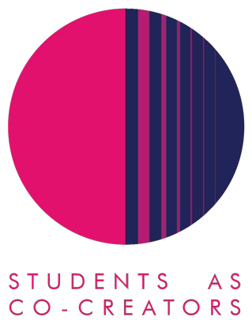

**Student Digital Literacy Framework Evaluation Report**

1. Where did the inspiration to do the project come from?

This Co-Creators project came about as a result of a realization that increasingly students are required to have an understanding of certain digital skills that are not necessarily covered in their degree modules, yet these are often skills that students are assumed to possess in order to progress within their degree and subsequently use in the wider world of work. As we know, being able to use technology is now considered a vital 21st century skill, yet we need to look beyond merely how to use the technology at our disposal and instead consider how we think, how we access information, the different ways we can communicate and work with others and the essential life skills that are needed in our current personal, social and professional environments.

1. What did you set out to achieve?

The objective of the project was to develop a digital learning framework appropriate for use across the School of Humanities and beyond. The idea was to work on the creation of the framework making use of the valuable work already carried out in this area by JISC as a starting point and generating something more customized towards our own specific circumstances.

1. How did students and staff work together on this project?

Our default tool for both collaboration and communication was Microsoft Teams which we used for regular team follow-up meetings to discuss the developments and to present and share the content that was being produced and updated. As per previous Students as Co-Creators projects, not all of the student partners were familiar or used to interacting via Teams and this proved a little tricky at the outset however all participants soon became accustomed to this communication channel. The advantage of Teams was that it allowed us to hold regular meetings online from our different locations and it proved very helpful for quick interactions, queries and feedback between team members. The meetings were convened by the academic partner.

Participants were split into sub-groups to fulfil a number of tasks that involved producing the digital framework based on the following 3 categories namely, Information literacy, Media literacy and

ICT literacy. We had a great mix of student participants with several of the team from the Computer Science school and the remainder from Humanities. The students from Computer Science were able to bring a different perspective to the table and this greatly benefited the project overall. The academic staff partner provided regular feedback and guidance to the group.

1. What kind of impact do you anticipate that your work may have on learning and teaching going forward (specific to your course/module or in a broader context)?

As detailed previously, the intention here was for the project team to create a Digital Literacy Framework and whilst this was initially focused on the School of Humanities it became apparent that this has the potential to be useful to the wider community. In this particular area, it seems that there may be initiatives that are university-wide that are not necessarily common knowledge (for instance the possibility for students to take certain Microsoft or Adobe courses free of charge) and there may be particular school, courses or module teams that have developed digital skills programmes that perhaps could be offered to a wider audience. Communication is key to improvements in this regard as there is a tendency for different groups to sometimes work in silos.

1. Any lessons learned from working in partnership?

This Students as Co-Creators partnership project was very rewarding. The student participants were very enthusiastic and made valuable contributions to the project throughout. Not all students are necessarily au-fait with MS Teams and some basic training in this area may be useful. This could be probably covered by viewing some of the video tutorials that are available on the internet.

One aspect that worked particularly well was the combination of students from Computer Science and Humanities. Given their specialism, the former were well versed in the technological tools available whilst the Humanities students were able to offer valuable insight on how technology and digital skills are seen from their perspective. This is certainly something to be considered for future projects - the recruitment of participants from other Schools although this may only work for certain projects.