**A Learning & Teaching Research Collaboration**

***Placing Wellbeing at the Heart of Legal Education: A partnership with students to enhance support and wellbeing within the Westminster Law School***

Student Partners: Dilmin Arslan, Anmar Balluz, Olivia Donda-Akatshi, Lyraib Khan, Nevena Martinovic, Ilda Murrani, Ioanna Nakos

Academic Partners: Dr Sylvie Bacquet & Eshan Dauhoo

**Westminster Law School**

**Academic Year 2022-2023**

**1. Executive Summary**

**2. Background and Aims**

**3. Methods**

**4. Results**

**5. Discussion**

**6. Conclusion and Recommendations**

**7. Dissemination**

**8. Research Team Reflection**

**Section 1. Executive Summary (300-400 words)**

As the Law Society calls for a mental health culture change in the profession (The Law Society: 2023), it is vital to rethink legal education and raise mental health and wellbeing literacy amongst future lawyers. This project sought to challenge traditional hierarchies and power dynamics by collaborating with Law Students on the LLB programme at the Westminster Law School (WLS) in order to gain a better understanding of how we can engage their peers with the mental health and wellbeing discourse. The team conducted a qualitative analysis using in-depth conversations with student partners as well as focus groups in order to assess existing provisions for student support and wellbeing with the school as well as identify gaps and brainstorm ideas for future developments. In the spirit of co-creation, the researchers allowed student partners to choose how they wished to contribute to the study.

Data gathering focused on four areas which the researchers identified as tightly linked to student wellbeing namely the physical environment, the virtual environment, wellbeing related events and activities and communication with students. The study revealed that both academics and students shared a common understanding of the concept of wellbeing; this shared understanding provided a solid foundation on which to explore our four lines of enquiry.

The data confirmed that the physical environment plays a very important role in students wellbeing and engagement, highlighted the limitations of the Virtual Learning Environment (VLE) for promoting wellbeing related content, gave us an insight into how students prefer to communicate and provided some valuable information for the design and planning of future events and activities. Our findings will be used to inform future delivery of personal tutoring programmes in the Law School, embed wellbeing education into the curriculum and form the basis for further collaborations.

**Section 2. Background and Aims (200-300 words)**

The legal profession is currently facing a mental health and wellbeing crisis (Chilvers: 2021) with high levels of burnout and mental ill health (Law Care: 2021). There is evidence in the literature to indicate that lawyers are more prone to suffer from work related stress, anxiety and/or burnout due to the nature of the profession as well as their personality type. Lawyers are generally high achievers, competitive, perfectionists and overthinkers. In addition, they operate in a highly regulated environment, where working long hours is seen as a sign of professionalism and resilience. This can create psychological unsafety, a fear and blame culture as well as negativity bias (Rimmer: 2022). Some of those traits can also be observed within law students and there is evidence to show that law students are amongst the most stressed cohorts (Jenkin: 2019). It is more important than ever therefore that that law students are provided with the knowledge and tools to face the challenges of their studies and adequately prepare for the profession. It is also the case that most law students tend to focus purely on the academic side of their studies, ignoring the importance and impact of developing a positive relationship with their studies and peers. By promoting wellbeing literacy within our student population, we aim to foster a sense of community in the Law School. Having students as co-creators enhanced the sense of community, participation and engagement in the project (Lubicz-Nawrocka & Bovill: 2021)

The project aims emerged from the work that our team has previously carried out in this field. Sylvie Bacquet has been the Senior School Tutor in the Law School for a number of years while Eshan Dauhoo joined the Law School in September 2022 as Lecturer in Wellbeing and Legal Education. We wanted to develop and improve the current Student Support and Wellbeing provisions in the Law School by listening to students’ voices and learning from their shared experience in order to further strengthen the sense of community within the Law School. Ultimately, we wanted to elucidate whether students are more likely to engage with material when they have a sense of ownership which derives from being involved in the design and delivery of such material. Our findings will feed in the implementation of the University Policy in 2023/24 and provide the basis for further discussions with the Head of School, and course leaders.

**Section 3. Methods (150-300 words)**

The project which was mainly qualitative sought to carry out 3 tasks:

1. Review the existing provisions in relation to student support and wellbeing,
2. Identify themes for a series of workshops related to wellbeing while studying law,
3. Review and expand the student support and wellbeing platform on the VLE.

The first task necessitated a small-scale empirical survey (described below), while the second and third tasks were carried out by working in direct collaboration with the student partners. As we had 7 partners, we asked them to select an area that they would like to work and focus upon.

In relation to the first task, we carried out 3 focus groups, totalling 11 students from the LLB which is the largest undergraduate course in WLS totalling around 1, 200 students. There were 6 first year students (L4), 3 second year students (L5) and 2 third year students (L6). Students self-selected in response to a call via Blackboard. All the participants were female[1] and the sample was fairly robust in terms of ethnicity. In addition to our focus groups, we held various meetings with our student partners to brainstorm some of the topics discussed in the focus groups. Those findings were then compared against the finding of the empirical study and helped shape the focus and direction of the other two tasks.

Most of the meetings were held online as it is what our partners and participants found most convenient. The focus groups were recorded and transcribed. They were then analysed using a thematic analysis. The themes were derived from the focus groups guides (see appendix 1) which were developed by the academic partners and reviewed and piloted by our student partners. Participants were provided with an information sheet about the project (see appendix 2).

For the second task, we held online meetings with two of the student partners who chose to focus on designing themes for the well-being workshops. From our discussions, we produced a list of potential themes and decided, as a team, that our first (pilot) well-being workshop would focus on ‘balancing work/study and life as a law student’. Students were invited to sign up for the workshop via Eventbrite and one of the student partners also assisted in the delivery of the workshop.

For the third task, two meetings were held (online and in person). Our in-depth brainstorming sessions led to a number of action points to be carried out for 2023/24.

**Section 4. Results**

The focus groups were organised around four themes which the researchers identified as key to support and wellbeing with the Westminster Law School namely the physical environment (space including classrooms, study space and social spaces); the virtual environment (the VLE (Virtual Learning Environment) (Blackboard), the Student Hub); events and activities at University, College and School levels and communication in relation to student support and wellbeing.

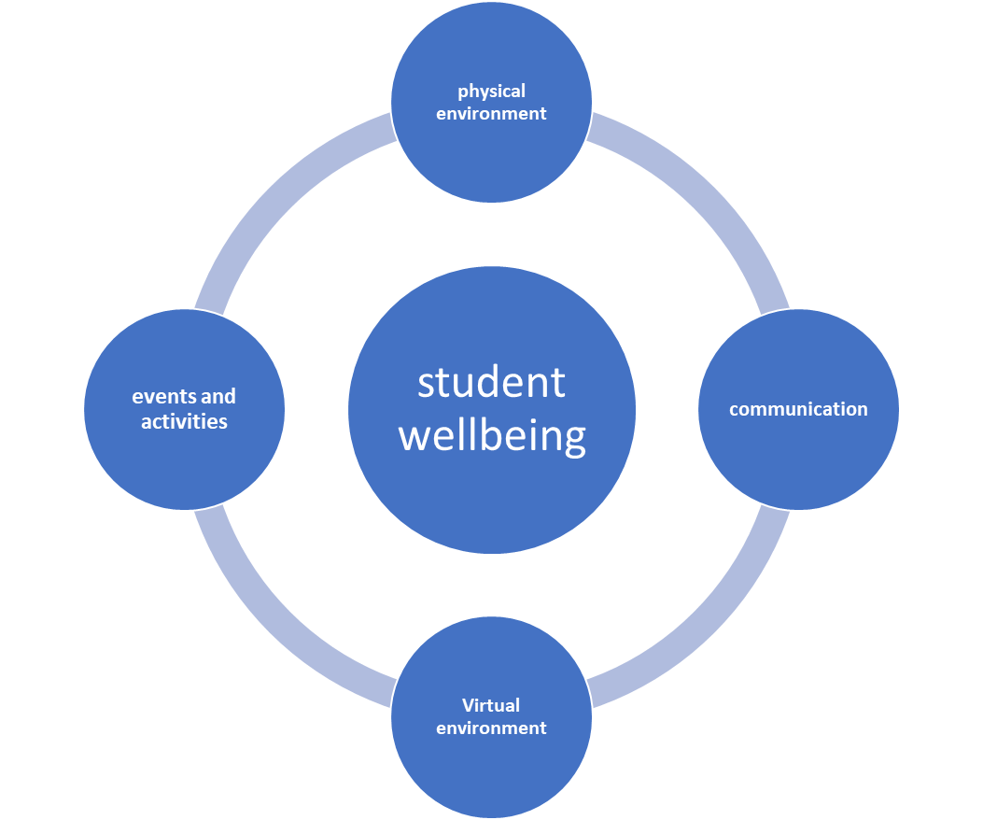

Before beginning a discussion on wellbeing, we felt that it was important to ensure a mutual understanding of the concept and we therefore asked the participants to tell us their definition. In general, our definition of wellbeing aligned with the students’ one which was pleasing. One participant described wellbeing in those term: ‘*I feel like well-being would relate to both your physical state and mental state like, especially because of law like it is very it is quite a challenging subject. So, I assume that in terms of like support and wellbeing would be like just I mean means of making sure that your internal environment and both are external environment are good or even care like* *it's not too overwhelming like we're not in deficit or excess sort of anything that we need.’* MJFG1 Another as ‘*being comfortable being happy in your environment*.’ MAFG3

**Role of the physical environment in contributing to students’ wellbeing: Space matters**

The Westminster Law School has its own building on Little Titchfield Street. It is significantly smaller than the other University campuses e.g., Marylebone and Cavendish and has a vertical structure based on 6floors with a relatively narrow staircase and narrow corridors. There is one large lecture theatre which was built more recently and some small classrooms. There is one social space on the ground floor of LTS and the Library was moved to the Cavendish campus during the summer of 2022. The old library space has been transformed into a silent study area with individual cubicles.

It was clear that there is a direct correlation between students’ wellbeing and the physical environment. Difficulties with classrooms technology, layout and inadequate room temperature can all hinder students’ experience and impact their wellbeing. Problems with IT, room temperatures can have a significant impact on students learning experiences. One participant commented: *‘Some of my friends say they don't even want to come to lectures cause it's too cold in there’* CNFG1 and another ‘*when it's like wintertime, it's really cold in our building, especially the lecture hall*.’ KKFG3

Opinions on the facilities at LTS were varied but participants pointed to the lack of atmosphere within the Law School in comparison to other buildings such as Cavendish for instance ‘*in our building, it's kind of quiet and I think people just go to lessons and come straight out*’ KKFG3. This is indicative of our ongoing difficulties in the Law School of creating a sense of community amongst students.

Social spaces are at the centre of the student experience and opinions were mixed on the transformation of the First-Floor library in LTS. While some students missed the vibrant library space with bookable glass pods, other were appreciative of the individual quiet study space. One student commented: ‘*Now we can actually get on with our work, not be distracted, not have loud people in there*’ THFG2 but another spoke nostalgically of the glass pods rooms ‘*we were able to book it. I found that* *very like I preferred that knowing* *there's my space and I can study there with my friends. Obviously, some people took advantage of that, but I was able to book the room. The rooms like probably a day or two days before knowing I can go into university have that space. But now that's gone. So obviously now I* *don't like actually sitting in the library. I don't know. I just feel very overwhelmed as myself in a library study*.’ YRFG2

In light of the above, some our students are encouraged to make use of other campuses. Some of our participants made use of those facilities especially the Cavendish campus which is a short walk from the Law School. They found it more spacious and vibrant. ‘*I do have to always like go to a different campus when I want to, like, do independent studying*.’ MAFG3

In addition to suitable study spaces, students need a cafeteria, social space but also ‘*somewhere to chill’*. One student suggested ‘*a place where you can just like if you're feeling a bit overwhelmed or stressed about whatever you're doing your exams, coursework, they can just go and chill, not necessarily library, maybe just somewhere where you can talk to your friends a little bit, maybe not the cafeteria because everyone's eating there just somewhere where you can go talk to other people, maybe just chill for a little bit*.’ THFG2 Views on the Law School cafeteria are generally positive although some of our participants commented on the relatively small size and the overcrowding.

Students also suggested that it would be nice to have more signposting on the walls: ‘*when I first came to the university, I didn't know we had like a library in the basement. It wasn't until it was gone. I found out.*’ KKFG3

Some students also felt that they would benefit from a human presence in the Law School where they could go for academic queries but also for a general chat about their studies. ‘*We just need people that are always on standby that we can always go to the coming overwhelmed with the course for life itself generally and it's like affecting our studies*’ MJFG1. Pre-covid, the Law School had a ‘Help Desk’ in the area adjacent to the cafeteria and the intention was to re-launch, in a similar format, the Help Desk this academic year. Students were recruited as Law Peer Mentors (LPMs) and part of their role was to provide support via the Help Desk. Unfortunately, unforeseen circumstances resulted in the need to postpone the re-launch until the next academic year. The LPMs, however, were able to provide exceptional support during a two-day Legal Education Conference that was hosted at Westminster Law School.

**Promoting wellbeing through the Virtual Learning Environment: Beyond Blackboard**

Blackboard has been the main vehicle for promoting wellbeing initiatives in the Law School while the Student Hub is used for university-wide events. The Personal Tutoring Team has launched a Blackboard site called Student Support and Wellbeing which provides self-learning resources for our LLB students (those make up the largest cohort with circa 1,200 students), it is used for cascading relevant University events and workshops as well as wellbeing related communication with our students. Quantitative data obtained from the Blackboard site shows that out of 768[2] students registered on the site, 512 had accessed the site at least once. 269 students spent some time on the site. Time spent varied between a few minutes to 20 hours with 160 students spending more than 10 minutes on the site. The in-depth discussion carried out with our student partners on the Student Support and Wellbeing Blackboard site revealed that the content was good, pitched at the right level but that the site needed more visibility and ease of access: ‘…*for me I'm with the well-being platform on Blackboard I didn't know about it at first because it never came up on my Blackboard page. I only found out about it through e-mail because I kept on seeing like something has been added on well-being*.’ KKFG3

It was suggested that it would be a good idea to transfer the content onto an App or a social media site. We discussed the possibility of setting up an Instagram account associated to the platform and this idea was welcome by students: ‘*I feel like to make it more engaging. I think it would be nicer if it had like its own app. Like, you know when you have like the calm meditation app headspace, I feel like that's what we kind of need because they'll be different from your education platform*.’ KKFG3 Students were adamant that any such provisions should be clearly separate from Blackboard which is very much associated to strictly academic content: ‘*Blackboard if you if you're a new student, especially if you're going into it, you don't know which section to go to. Know what you'll find. If there's about a million* *notifications you don't wanna read through all of it. You want something* *quick, you can look at maybe see a picture and access.’* YRFG2 Speaking of Blackboard one student said: ‘*But if it feels like there's something that you have to do instead of a place to get support*.’ KKFG3 All of our participants therefore agreed that they would be more likely to engage with such a platform if it was outside of Blackboard. This finding was supported by our student partners.

**Communication with students: A matter of personal preference**

It was clear that there is room for improvement in how we communicate with our study body. It was interesting that quite a few participants requested activities or events that we already provide. This clearly suggests a break in the lines of communication or at least a disjoint in how we communicate with our students and the mode of communication that they might expect.

In the focus groups, we explored different modes of communication such as Blackboard announcements, emails and social media. It became clear that methods of communication are very much subject to students’ preferences. While some liked emails: ‘*I definitely think like emails is like the way forward because I I'm always checking my e-mail*’ (MAFG3) others found the volume of emails overwhelming: ‘I feel like it gets overwhelming’ KKFG3 especially when they are not directly relevant to the recipient: ‘*I prefer to have emails that's gonna benefit me or like if someone's not coming to a class that I'm not even attending or go to. I don't really need to hear it* *cause it's just builds up my e-mail and I won't see emails that I do need to see*.’ YRFG2 There was a sense that the volume of emails needs to be controlled.

When it comes to communication students wanted: ‘*…. something that's kind of like in your face’* (MJFG1) and suggested strategic advertising on site for instance near lifts and entrances. A number of our participants and student partners also suggested that lecture shout outs would be helpful, or adverts displayed on the board while students settle into class. Students agreed that large TV screens onsite are an effective way to advertise events rather than email communication however it presupposes that students spend time onsite.

One student commented that they would like it if ‘*the university offered like support or like little groups that we can like meet up and then we can learn about CBT like mindfulness and like, … things that can make us feel* *more calm and meditated.*’ KKFG3 We pointed out that those things exist, but the student did not know about them which as discussed above confirms that there is an anomaly in how we communicate with students.

In addition, participants explained that they sometimes struggle to get it touch with their personal tutor. This is well known to us and is not a specific issue to the Law School, but we are constantly exploring ways of resolving this issue.

**Wellbeing Events and Activities: How can we engage students?**

As per our hypothesis, Law students are unlikely to take advantage of university wide opportunities when it comes to support and wellbeing. There seems to be an expectation that help should be provided in house in order to be tailored and targeted ‘*Preferably the law school one, because I guess there’s more people from the same kind of background like because you’re going to the same campus and everything and even preferably like studying the same topic. So, you’d have more that you can kind of relate to.*’ LKFG1 This could be linked to geographical issues – students are unlikely to want to travel to another campus for a workshop. A few students however reported having used the counselling services and other 1:1 provisions.

We used this section to explore ideas that were developed with our student partners. In particular, we tested out a plan to develop a series of wellbeing workshops in the Law School. Most of the participants favoured the idea and recommended that we focus on themes such as: managing their workload, procrastination, dealing with stress or finding motivation. ‘*I think a lot of law students are quite stressed out, so it would be really nice if we were able to get like a workshop on how we manage our stress* ‘ (MAFG3) One student however would not be interested in attending group events due to feeling self-conscious ‘*that would be the last thing I would want to be in a room with other people feeling the same as me.*’ YRFG1

We teased out whether students would prefer face to face, or online events and the response was mixed with perhaps a slight preference for face-to-face events. It was clear that students would prefer the workshops to take place on days they are already on campus due to factors such as travel costs, distance travel, other commitments but we were unable to get a conclusive reply on the best timing as the responses varied although some participants pointed out that they are quite tired immediately after a lecture.

There was a consensus that events need to be promoted more and well in advance. ‘*I think first of all, it would just be like making more students actually aware of it, because there is a lot of support that is actually available. It’s just not actually knowing until you actually search for it yourself or not knowing where to search for it in a proper way. I guess obviously the new Blackboard site is actually something that is welcomed because it does give you that platform to a certain degree*.’ LKFG1

We also tried to understand how we can ensure that the events we plan are well attended as this has been one of our main challenges over the years. One student suggested framing wellbeing events in terms of academic achievement. ‘*And if you’re, like, struggling with that, you might be wondering, like, how you can fix your grades because obviously, like mental health is an important, but also like people, I mean, especially in the law profession, I feel like a lot of the time don’t necessarily see that as a first priority*.’ NMFG2

**Section 5. Discussion (300-600 words)**

One of the incentives for this research was to gain a deeper understanding of the needs of our students in terms of support and wellbeing. In particular, one of our main challenges has been to engage students with events and activities and to create a sense of community in the Law School. The findings in relation to the physical environment have confirmed previous data which the WLS has obtained through student module evaluations and course committees as well as feedback from teaching staff. Ultimately, we are limited by the design, age and size of the building but in the future, it would be worth seeking feedback from the Law School student body before any major changes such as the first- floor study space transformation take place. This will be fed back to our Head of School.

Some of the findings in relation to communication confirmed our predictions and correlate with previous feedback from students. While the University has a lot to offer, there is a lack of visibility, and the volume of communication can be overwhelming especially if it is not targeted to specific groups of students. As this project has demonstrated, there is not a one size fits all when it comes to communicating with our students. However social media increasingly seems to be the platform of choice for non-academic matters. We were able to collect ideas for a series of workshops as well as design and deliver a pilot workshop on balancing life and studies and we hope to start running those workshops in the 2023/24. The outcome of the qualitative survey will shape the implementation of the tutoring policy for 2023/24 and the project has given us ideas for future projects.

The ideas and concepts we have explored in this report are not without challenges. The enthusiasm and passion of our co-creators and partners may not reflect the whole cohort and ultimately those students who are most vulnerable will often not engage with the wellbeing discourse. There are inevitable gaps between demand and engagement even from the most enthusiastic students as they get caught up in the day to day demands of being a law student in London. Convincing colleagues that wellbeing education is as important if not more than subject specific content is also a challenge we still have to overcome. This is discussed in further details in the reflection section below.

**Section 6. Conclusions and Recommendations** (200-300 words)

The project sought to enter in a dialogue with our student community in order to shape the future of how we provide a well being education that best meets the needs of WLS students. It was refreshing to see that our project was met with so much enthusiasm from like-minded students. This resulted in a larger and richer partnership than we initially planned for. When it comes to wellbeing, student and staff understandings both align and ultimately, we share the same goals. During the project we were able to identify gaps in our current provisions especially in relation to the physical space and communication with students. While we do not have control over every issue that was raised, having the evidence from the student voice will give us an impetus to initiate change where it is possible.

The findings from this project will inform the implementation of the University Personal Tutoring in 2023/24 which will focus on 4 areas:

* **WLS Space Matters** – the physical environment remains a concern in WLS – we will seek to engage students in the recently formed IT and Estate working group. Our findings will be shared with the working group.
* **Beyond Blackboard** – we are currently in discussions with our Head of Department (HoD) and the Student Law Society about developing a social media account (Instagram) to host some of the wellbeing content that is currently on Blackboard. In the longer term we are planning to apply for QHT funding in order to develop an app to host that content. We are in discussions with the LLB Course Leader to get input from our newly recruited Student Peer Mentors.
* **The Communication Conundrum** – it is hoped that working on the first two areas will have a direct impact on communication. A request has been put via the HoD to obtain a large TV screen to display information in the LTS building – we understand that this is not an easy process and will therefore continue our ‘We are Here to Help’ campaign throughout the building. Unfortunately, our recently purchased signs have been removed again so this will need investigating with Estate.
* **Successful Events & Activities** – a successful event is one which is well attended and where students engage. We will pilot the rest of our workshop series.

**Section 7. Dissemination (200-300 words)**

This report will be disseminated to colleagues who have responsibility for student experience and personal tutoring including the Head of Department, Assistant Heads and Course Leaders. The findings will be incorporated in training material for personal tutors and some of them presented at the next WLS away day. This will also form the basis for future projects as described above.

The findings will form the basis for further research on wellbeing within legal education and we hope to be able to publish an article.

**Section 8. Reflection (200-300 words)**

It was interesting that during the project, the academic partners at times found it difficult to communicate with and get hold of the student partners. We set up a Teams chat group, but it was clear that it was not being read by most students and we often resorted to group emails which worked a little better. Generally, as academic partners we needed to manage our own expectations of what working with students entails. It was also difficult to manage such a large group of partners (7) and in hindsight it would have been easier to have a smaller team. While working in partnership with students has many benefits, it can also present challenges in terms of being able to come together due to various constraints on both sides such as timetable, professional and personal commitments. Most of our students have a part-time job and/or family commitments such as caring responsibilities and therefore tend to be time poor.

Overall, it was very encouraging to see that there was a strong interest in well-being amongst our law students. We had an amazing response from students wanting to get involved, in some form or other, in the project. The high response rate was also one of the reasons why we finally recruited 7 student partners, but it was clear that there was a gap between the interest in the project and being able to fully commit to it. This also required managing expectations on both sides.

It was very positive and encouraging that the project revealed a shared understanding of wellbeing between academics and students. It is also promising to know that with the right mindset and space, we have an opportunity to build a meaningful relationship with students that can promote a greater sense of community.

**Sources:**

Chilvers E, ‘The Legal Profession has a major mental health crisis with wellbeing a low priority’, <https://www.engagehealthgroup.co.uk/the-legal-profession-has-a-major-mental-health-crisis-with-wellbeing-a-low-priority/> 6 August 2021

Jenkin M., ‘Legally drained: why are stress levels rising among law students?’, 19 November 2019, <https://www.theguardian.com/law/2019/nov/19/legally-drained-why-are-stress-levels-rising-among-law-students>

Law Care, *Life in the Law*, 2020/21, <https://www.lawcare.org.uk/media/14vhquzz/lawcare-lifeinthelaw-v6-final.pdf>

Lubicz-Nawrocka T. & Bovill C. ‘Do students experience transformation through co-creating curriculum in higher education?’ *Teaching in Higher Education*, 2021.

Rimmer, E., ‘How thinking like a lawyer can affect your mental health’ *The Lawyer*, 10 October 2022, <https://www.thelawyer.com/how-thinking-like-a-lawyer-can-affect-your-mental-health/>

The Law Society, ‘Time for a mental health culture change in the legal profession’, <https://www.lawsociety.org.uk/contact-or-visit-us/press-office/press-releases/time-for-a-mental-health-culture-change-in-the-legal-profession>, 27 June 2023

**Appendices:**

*Appendix 1 Focus group guide*

**Law School Physical Environment:**

* What do you think could help to create a more welcoming atmosphere in the school?
* What would encourage students to spend more time in the law school campus?
* How could we make your experience of the Law School more accessible/student-friendly, particularly for new students?

**Law School Virtual Environment:**

* What could help you engage more with the student support and well-being platform?
* What would you suggest to make the well-being platform more appealing to law students?

**Law School Events and Activities (Well-Being and Support)**

• What are the main areas of well-being that you think are most relevant to law students?

• Do you attend University workshops? If so which ones?

• If you do not attend any University workshops related to wellbeing why? Are you more likely to attend Law School workshops?

• What type of well-being workshops do you think law students are most likely to attend?

• What would you like to see more of in the law school to promote the student experience?

• What could help build a stronger community experience in the law school

**Law School Approach to 'communicating' (Well-Being and Support)**

* How could we help to make accessing well-being resources more effective?
* What means of communication do you prefer when it comes to receiving updates about well-being and support?
* How often would you like to receive communication from the Law School Student Support and Wellbeing team?

*Appendix 2 Participant Information Sheet*



1. Over 70% of our law students are female.
2. The discrepancy in numbers is most likely due to students having graduated on 23rd June 2023