**Learning and Teaching Research Collaborations**

***Developing science education via art-based activities.***

**Students co-creators:**

**Manel Madani**

**Manoucheher Karimir**

**Megan Hogben**

**Academic Partner:**

**Dr Manal Mohammed**

**School of Life Sciences**

**Academic Year 2023-2024**

**1) Research topic and question:**

Can we develop science education through art-based activities?

**2) Aims:**

The team aimed to discover the effect of art in facilitating science learning and education. Although students are studying biomedical science, they have some good artistic skills and are keen to combine their artistic skills with their scientific knowledge to develop science learning and education. Students used agar media for drawing instead of papers (agar media which are used for bacterial growth). The drawing topic was related to science. They drew about multi-drug-resistant bacteria to alarm people about antimicrobial resistance.

**3) Methodology:**

Students used their skills in art to draw on agar about multi-drug-resistant bacteria to alarm people about antimicrobial resistance.

**4) Results:**

Drug resistance or antimicrobial resistance (AMR) happens when germs develop the ability to resist and defeat the drugs designed to kill them. That means the germs are not killed and continue to grow. It is estimated that bacterial AMR was directly responsible for 1.27 million global deaths in 2019 and contributed to 4.95 million deaths. This drug resistance is caused by several factors, including unrestricted access to antimicrobials, inappropriate selection and overuse of antibiotics, poor-quality antibiotics, as well as genetic mutations within the microorganism. AMR is a problem for all countries at all income levels. Its spread does not recognize country borders.

Students did the following figures:

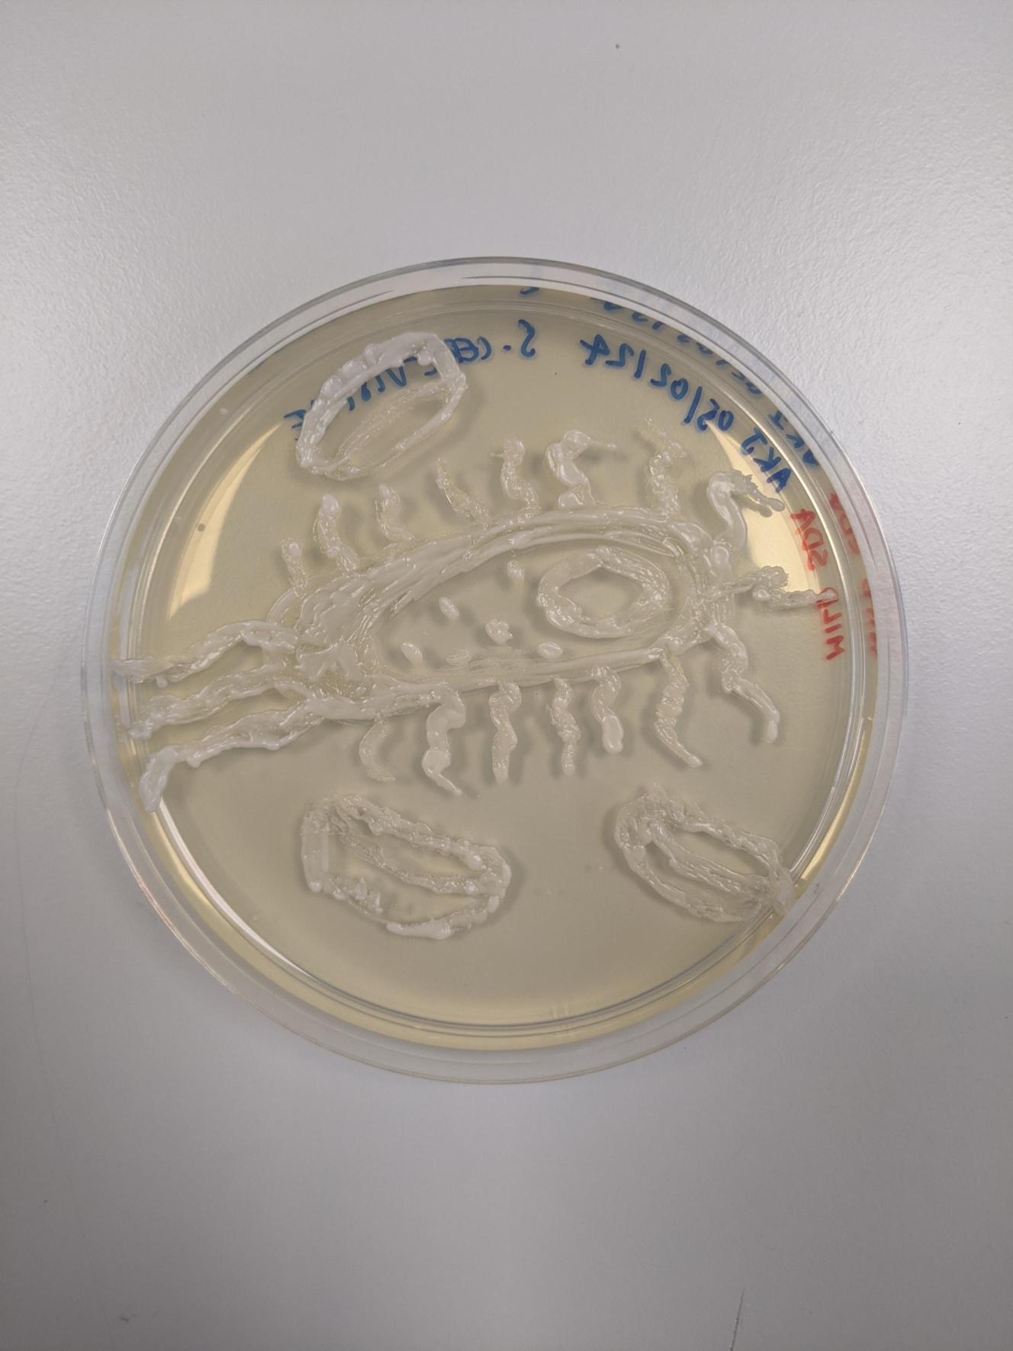

**Fig 1. Drawing of *E. coli* on Agar.**

**Fig 2. A mechanism of antimicrobial resistance.**

**Fig 3. Information collected about MRSA.**

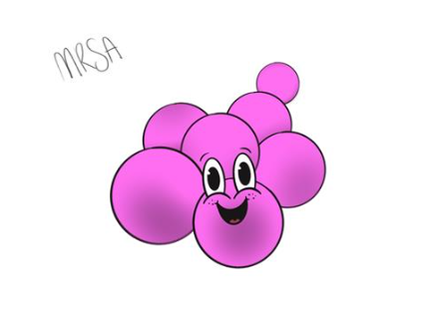

**Fig 4. Drawing of MRSA (Methicillin Resistant *Staphylococcus aureus*) and *E. coli*.**

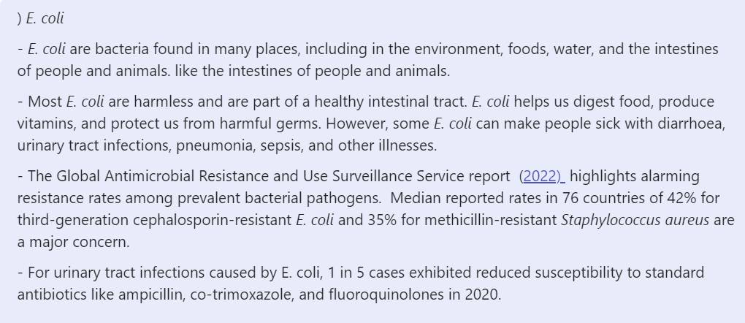

**Fig 5. Information collected about *E. coli* and *M. tuberculosis*.**

**5) Conclusion:**

The team members got the opportunity to develop their laboratory and research skills on this collaborative project as they worked in the laboratory under the supervision of the academic staff member. Also, they got the opportunity to work together to develop their teamwork skills and time management skills. Students developed their artistic skills as they were interested in carrying out their postgraduate studies in Medical Art. The art activities will be presented on posters within the School of Life Sciences with interesting information and questions to facilitate students’ learning. Also, posters will be attractive to our visitors during open days and applicant days.