**A Learning & Teaching Research Collaboration**

***Groupwork: Advantages & Disadvantages***

**Student Partners:**

**Ishwari Agarkar**

**Kamnoor Begum**

**Academic Partner:**

**Dr Manal Mohammed**

**School of Life Sciences**

**Academic Year 2020-2021**

**1.EXCUTIVE SUMMARY**

Group work is the stepping stone to a successful career in all sectors. Through it is implemented early on in a student’s education, this skill can be built upon and used at work or in a professional environment.

**2. BACKGROUND & AIMS**

***2.1 Background***

In the academic year 2021/2023 BSc (Hons) Biomedical Sciences students at the University of Westminster were made to participate in group tasks more than in previous years to attempt to subside from the missed examinations during the pandemic as it can be just as beneficial due to the fact that it helps students develop a crucial skill.

Group work is used to combine the mind of intellectual individuals. It’s a huge aspect of improving students’ professional and personal skills. Group work is highly desired in the work environment as it allows employees to work more efficiently and increases team productivity with the addition of creating more innovative ideas to reach a combined target. A study conducted on a group studying higher mathematics showed that group work has 3 main benefits, the first one is that it leads to better mastery of topics. The second is, that it improves communication between the students. And lastly, it allows for self-assessment thus causing the student to self-evaluate decisions and this has a better judgement towards certain situations or tasks (Yadgarovna and Husenovich, 2020). Furthermore, teamwork creates task-related conflict which has a positive correlation with the progression of the group as the work is critically analysed by the team members (Jehn,1994). In addition to this, group work reduces the chances of failure due to a lack of knowledge.

***2.2 Aims***

The project aimed to get students’ feedback on groupwork.

***2.3 Objectives***

The aims were achieved by conducting a survey to gather feedback from level 5 Biomedical Science students. Obtained data was then analysed and discussed by the research team.

***2.4 Stakeholders***

Conducted research will have an impact on current and future undergraduate Biomedical Science students’ study and experience at the University of Westminster. Although participants included level 5 biomedical students only, the intended beneficiaries are biomedical science students across all undergraduate levels including distance learners and postgraduate MSc students. The findings of our evaluation will be used by the module and course leaders as well as other disciplines throughout the university.

**3. METHODS**

A questionnaire was designed in order to gather feedback on groupwork. Both closed ended and long ended questions were included on Google Forms, was used to create the questionnaire this ensured that the questionnaire was easily accessed by students and staff. The final version was shared via email and blackboard announcement with all levels 5 Biomedical Science students. Twenty-four students responded to the email and participated in the research by completing the survey, although the number of students that responded was small, these questions were also discussed in person with students during a tutorial. Prizes in the form of 6 amazon vouchers (£20 each) were available for the participants. The prizes were selected via entering participants into a draw post completion of the questionnaire. Students who wished to enter the draw were asked to provide the University email address. Data collected from the questionnaire was then analysed using the responses section on google questionnaire. Closed questions responses were tallied and reported in terms of frequencies and percentages. Similarly, common trends were analysed in the Open-ended questions. As a result, gathered data was used to write up a project report.

**4. RESULTS**

Summary

Alongside a group work questionnaire, which has 24 student responses, student co-creators spoke to fellow students during their group work tutorial session to discuss thoughts on group work.

Student Perspectives on group work

The group work questionnaire received a total of 24 responses. Of those, 7 students enjoyed group work and most of the students answered that they liked group work for the following principal reasons; being able to develop team working skills (9 students), greater result satisfaction and efficiency (4 students) as well as granting an opportunity to get to know fellow classmates (2 students) (Figure 1A). Nonetheless, 15 students did not enjoy group work as shown in Figure 1A where 12 students answered how ensuring all group members' participation and fair contribution have been difficult whilst working in their respective groups. The remaining majority commented that meeting up due to different time schedules was challenging amidst the group work. Students also commented that apprenticeship students do not have similar schedules to the rest of the class, or some students live a long distance away from the university. There were also mentions of personality clashes which made it difficult for students to work effectively in a group. Similarly, 14 students preferred working with their friends which was suggested in the tutorial session to be due to easier and more effective communication during group work (Figure 1B). Despite this, 19 students responded that they felt there was adequate time to get to know one another and come together as a team as shown in Figure 2. Additionally, Figure 3 indicates that most students found their assigned roles to fit their strengths.

14 students responded to being happy with the marking rubric having some marks assigned to group work and some marks assigned to individual work, with 7 students not being happy with the mark distribution and the remainder being unsure (Figure 1C).

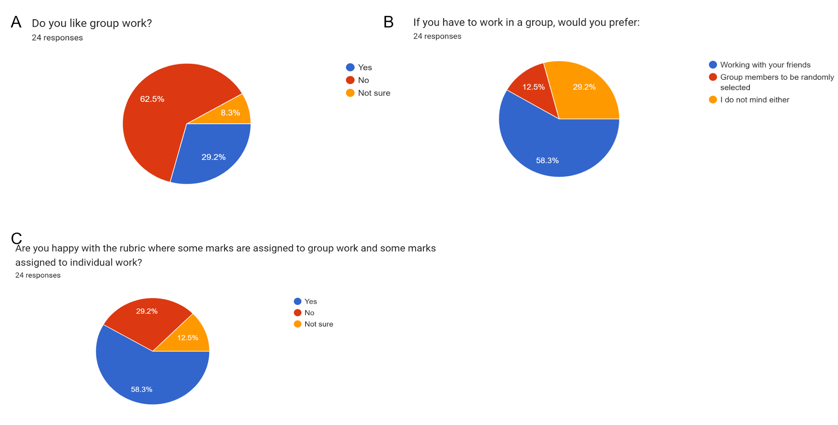

**Figure 1: Result summary of students' responses regarding group work (1A and 1B) and mark distribution (1C).**

Forms response chart. Question title: Did you get adequate time to get to know each other and come together as a team?
. Number of responses: 24 responses.

**Figure 2: Student responses on whether there was enough time to come together as a team.**

**Forms response chart. Question title: Did the role you were assigned fit your strengths?
. Number of responses: 24 responses.**

**Figure 3: Student responses on whether the roles that were assigned were reflective of their strengths or not.**

Challenges with group work

A total of 17 students highlighted various challenges while working in groups which primarily related to communication, varying work paces among group members, and differing work ethics, resulting in certain members contributing less effort than others.

For example, one student commented “*fear of letting them [their group] down*” whilst another commented “*making sure everyone was on the same page and had a good understanding of everything*”.

Figure 4A illustrates an even distribution of agreement ranges in response to the question “*Were the responsibilities divided within the group fairly?*”. Additionally, the majority of the students gave a rating greater than 5 regarding the question on the group members' effort, with 10 students giving a rating less than 5 (Figure 4B).

Moreover, Figure 5 demonstrates that 50% of the students found arranging meetings for the group project as the most time-consuming aspect. Additionally, 37.5% commented on communication and decision-making issues as well as 12.5% mentioned task distribution being the most time-consuming detail to decide on as a group. Students suggested both in the questionnaire and tutorial session that attendance for tutorial sessions should be marked to enforce student attendance and an option to meet online should be offered to students once groups are formed.

**Figure 4: Student summary on fair distribution of group tasks (4A) and efforts (4B)**

**Forms response chart. Question title: What took the most time deciding as a group? 
. Number of responses: 24 responses.**

**Figure 5: Student main comments on time-consuming decisions made as a group.**

Recommendations for effective group work

In response to the question “*What should tutors know about you to make it easier for you to work in groups?*”, 17 students also responded with key points revolving around four main points; health and mental health including anxiety and hidden disabilities, work ethics and different schedules and ensuring a better form of communication for all groups.

Student feedback

Student feedback from 18 students was collected which elucidated the importance of group work. For instance, several students emphasised how they became more aware of the relevance of having time management and organisational skills as well as helped build their social confidence and communication skills. One student highlighted how the skills learnt during the group task are important for working in a professional scientific environment. Another student mentioned that working as a group enabled them to work to the best of their abilities as they were partly responsible for their grade on this task. Many students wrote how they were sceptical about the group task and initially found it difficult due to not knowing all the group members or having unresponsive members. However, those students also mentioned how working as a team allowed for acknowledgement of their strengths and weaknesses as well as enabled growth in knowledge due to sharing ideas with one another.

**Discussion**

Our aim was to explore Level 5 Biomedical Science student’s thoughts on group work and as depicted in Figures 1 to 5 as well as the students’ reflective feedback, this has been successfully accomplished.

Figure 1A indicated that most of the university students held a negative perception of group work. The primary concerns mentioned by the student’s included difficulty in ensuring fair participation from all members and coordinating group meetings. Nonetheless, as mentioned in Figure 1A, 7 students enjoyed group work. Additionally, the positive perceptions of group work from the student feedback were indicative of being associated with increased engagement and strong work ethics. Understanding students’ thoughts on group work is pivotal for educators as it enables them to implement effective strategies to address these challenges and ensuring student engagement. For instance, a study by Melguizo-Garín et al. (2022) demonstrated that group work incompetency negatively affects student satisfaction and may negatively affect the work outcome due to decreased motivation and less willingness to complete tasks to a high standard. However, it is worth highlighting that 14 students preferred working with their friends which could indicate students’ disinclination in socialising and forming new friendships due to wanting to stay within their comfort zone for the sake of easier communication.

Many students from the student feedback demonstrated a good understanding of the importance of group work and identified the potential application into their future endeavours. Enabling active student engagement in group work and group cohesion can help build transferable teamwork skills such as communication and promote critical thinking which is especially important for potential biomedical science endeavours such as scientific research (Jones, Pino-Pasternak and Volet, 2022).

**6. CONCLUSION & RECOMMENDATIONS**

In conclusion, this study reveals diverse perceptions of level 5 biomedical science students towards group work, reflecting both positive and negative sentiments. While some students expressed positive thoughts about group work and the willingness to understand its importance in developing social confidence and transferable skills, other students held more negative perceptions regarding fair participation and difficulties in meeting up and lack of effective communication.

As such, it is important for educators to acknowledge and address the positive and negative aspects of group work. To achieve this, educators should emphasise the significance of social skills for future careers and everyday life while implementing effective group work practices to create a more amicable and comfortable group environment prior to groups starting work. One way of creating a positive group atmosphere is incorporating icebreakers or team-building activities at the beginning of group work. These activities will not only establish a rapport among members but also encourage communication and smoother collaboration.

In addressing students’ concerns about group work, educators can consider enforcing student attendance to ensure all members are actively engaged. Another strategy could be to encourage online team meetings to accommodate different schedules and thus promote equal participation. Moreover, gaining a rough understanding of students’ personality types or becoming aware of student’s willingness to take on leadership roles or be team members may contribute in the creation of a cohesive group environment.

**7. DISSEMINATION**

The report will be shared with the head and assistant heads of school and course leaders, so they can read our findings to implement in the upcoming school year.

**8. RESEARCH TEAM REFLECTION**

The overall experience of understanding the level 5 cohort’s opinion was an eye-opener on the improvements that could be possibly made by the teaching team at the University of Westminster. Many students stated that they had anxiety while working with new students which could be taken into consideration during lesson planning. Furthermore, in terms of the actual project, since it was done at the end of the term, time management was quite difficult as many final assignments were coming to the deadline. Nevertheless, the team and supervisor were extremely understanding, and the work was split up efficiently.

**8. ACKNOWLEDGEMENT**

Many thanks to Dr Caroline Smith (Assistant Head of School of Life Sciences - Curriculum Design and Student Experience) and blackboard support for their support.

**REFERENCES:**

1. Jones, C., Pino-Pasternak, D. and Volet, S. (2022). Embodied Interaffectivity in the Emergence and Maintenance of Group Cohesion. *Frontiers in Psychology*, 13. Available from https://doi.org/10.3389/fpsyg.2022.822072 [Accessed 28 November 2022].
2. Melguizo-Garín, A. et al. (2022). Relationship Between Group Work Competencies and Satisfaction With Project-Based Learning Among University Students. *Frontiers in Psychology*, 13. Available from https://doi.org/10.3389/fpsyg.2022.811864 [Accessed 25 March 2022].
3. Yadgarovna, M.F. and Husenovich, R.T., 2020. Advantages and disadvantages of the method of working in small groups in teaching higher mathematics. Academy, (4 (55)), pp.65-68.
4. Jehn, K.A., 1994. Enhancing effectiveness: An investigation of advantages and disadvantages of value‐based intragroup conflict. International journal of conflict management.
5. Brahm, C. and Kleiner, B.H., 1996. Advantages and disadvantages of group decision‐making approaches. Team Performance Management: An International Journal.