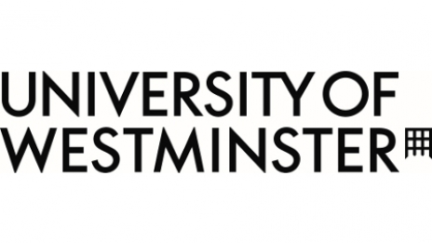

Students as Co-Creators programme

**From Campus to Corporation: Employment Outcomes for Westminster's International Marketing Alumni**

Supervisor: Wendy Histon

w.histon@westminster.ac.uk

Team: Isabella Capra & Elahe Jamshidi

Contact: [2019829@westminster.ac.uk](mailto:2019829@westminster.ac.uk)

### Table of Contents

### executive summary

### background and aims

### methods

### results

### discussion

### conclusion

### lessons learned

### research group reflection

# executive summary

Navigating the transition from university to the workforce is a multifaceted process influenced by individual qualifications, economic trends, and institutional support. In a rapidly evolving job market, the correlation between academic pursuits and professional success is not always straightforward, particularly for international students. Graduates often encounter a reality where the skills acquired during their education must be supplemented by practical experience, adaptability to meet the shifting demands of employers, and a robust network of industry connections.

Higher education institutions play a crucial role in this context, not only in providing academic knowledge but also in facilitating career readiness through various programs, services, and connections. The efficacy of such support is a subject of ongoing discussion, particularly considering the unique challenges faced by recent graduates, such as increased competition and technological disruption.

This study aims to explore the employment trajectories of Westminster University international marketing alumni, seeking to understand how their university experience has impacted their career paths, what practices led them to their current positions, and how they are planning for future professional development. By examining the interplay between educational background and employment outcomes, the research intends to identify key factors that contribute to or hinder professional integration and success. The findings are expected to offer valuable insights for enhancing educational practices and career services, ultimately aiding current and future students in their professional pursuits.

Although the study specifically focuses on Westminster University international alumni, we have also decided to branch out to international alumni from other universities, current international students either searching for a placement/internship/graduate scheme or currently in one, and other alumni/students with valuable industry knowledge. This broader approach aims to gather diverse perspectives and enrich the overall analysis.

# background and aims

This study was inspired by firsthand observations and experiences of the challenges international students face in securing employment in the UK in their field of study during and after their academic pursuits. As a team comprised of two international students, we were particularly motivated to delve deeper into understanding the underlying reasons for these difficulties and, more importantly, to identify the strategies that have enabled other international students to successfully obtain employment in the UK. Prior to embarking on this research, it was evident that international students encounter numerous additional obstacles in securing employment relevant to their studies. However, the specific nature of these challenges and the preparation required to navigate them remain insufficiently documented.

The initial impetus for this research project stemmed from the limited information our team could gather through personal inquiries and consultations with university staff regarding effective job-seeking strategies for international students. This lack of comprehensive guidance highlighted the need for a formal investigation. The primary aim was to develop a concrete set of steps to assist international students aspiring to live and work in the UK after their studies. Additionally, this project sought to bridge the knowledge gap between academic preparation and industry demands by providing practical advice and marketable job-navigation techniques.

It is also important to note that this study only involved international professional who were former students that focused on the field of marketing or communications.

# methods

This study employed a multifaceted research approach, incorporating interviews, surveys, live presentations, conferences, and secondary resources. We leveraged the university's network to connect with alumni working in marketing and conducted interviews with a total of 14 individuals. These interviews provided valuable insights into the challenges and successes experienced by international students in securing employment.

To reach a broader audience, we attended both university and external events related to planning for the Graduate Visa path and the Skilled Worker Visa path. These events offered additional perspectives and information relevant to our study.

Surveys were distributed to all interview respondents and extended to other potential participants who were unable to attend face-to-face interviews. This allowed us to gather a wider range of data and experiences.

Furthermore, we conducted an in-depth analysis of the recently updated requirements that international students must meet to be eligible for a Skilled Worker Visa. This secondary research helped contextualize our findings and provided a comprehensive overview of the current employment landscape for international graduates.

## interview process

Our interview process was designed to be thorough and professional. We developed a structured interview guide to ensure consistency across all interviews. Each interview was conducted in a confidential and respectful manner, either in person or via video conferencing, depending on the participant's availability and preference. We aimed to create a comfortable environment for participants to share their experiences openly and honestly.

All interviews were recorded with the participant's consent and subsequently transcribed for analysis. This allowed us to systematically review the data and identify common themes and insights. The information gathered from these interviews was crucial in shaping our understanding of the specific challenges faced by international students and informing the recommendations provided in this study.

# results

## survey findings – charts & graphs

**Respondents Demographic Background**

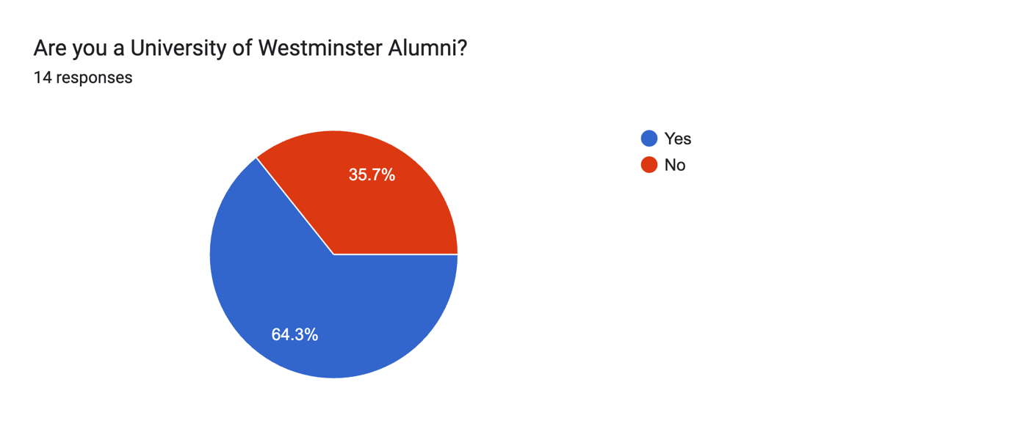

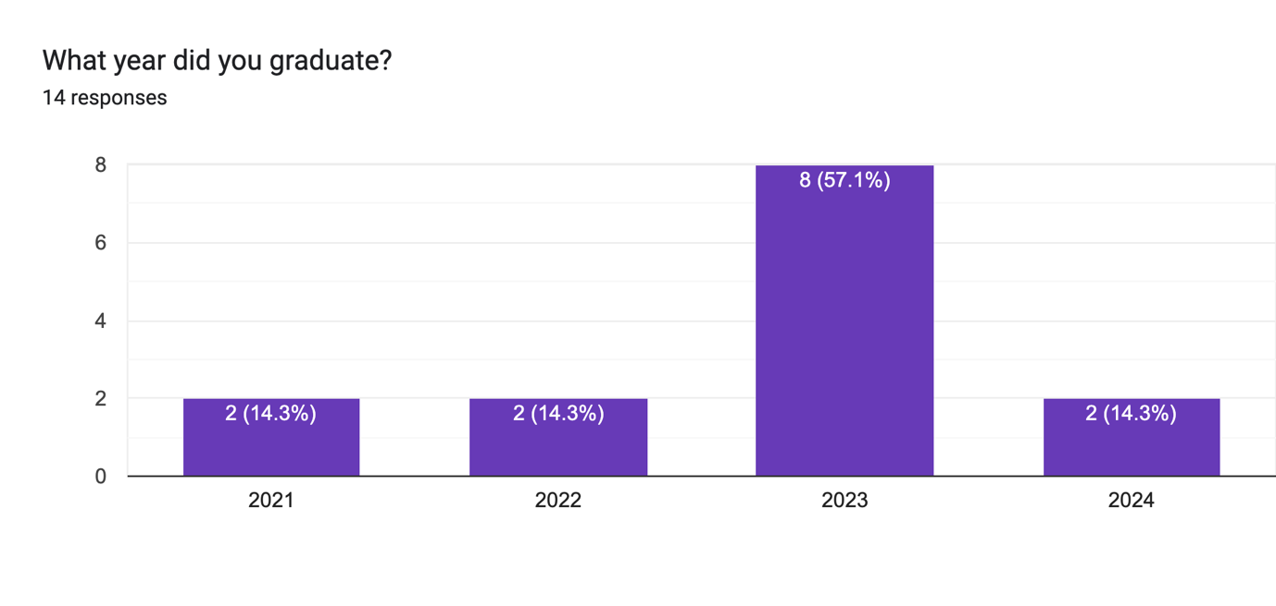

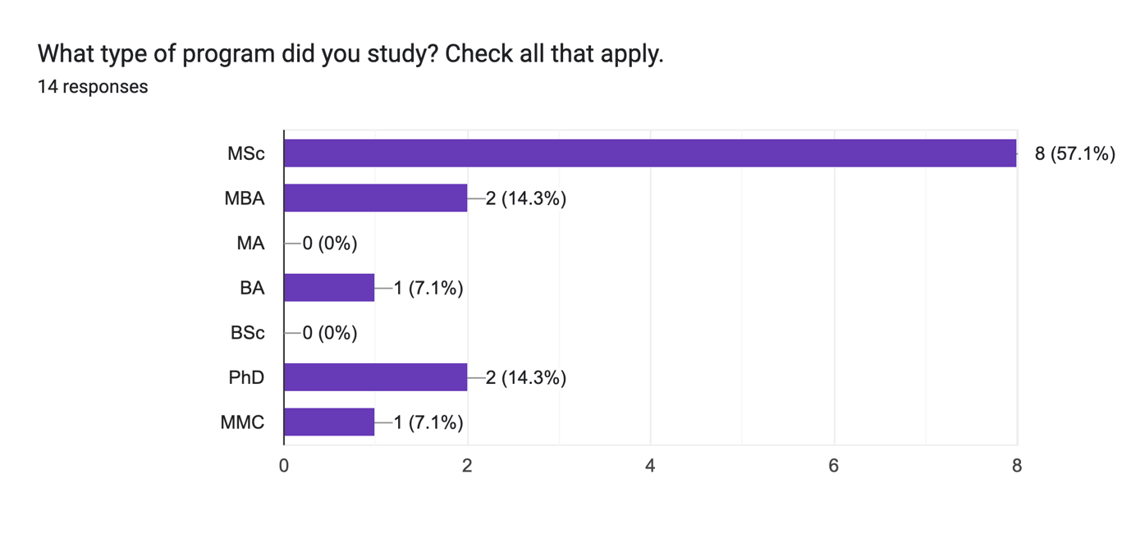

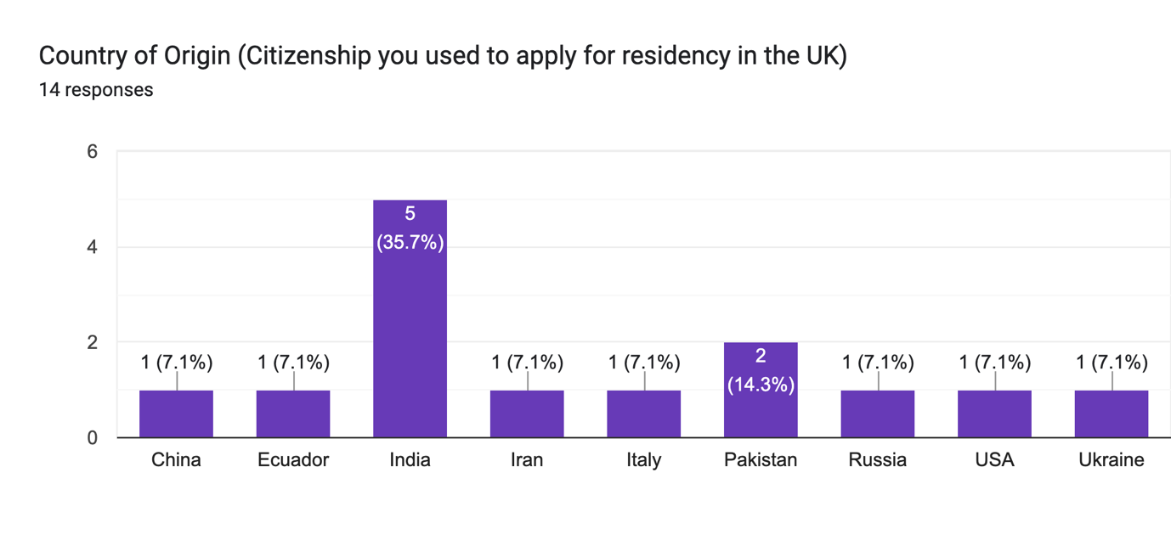

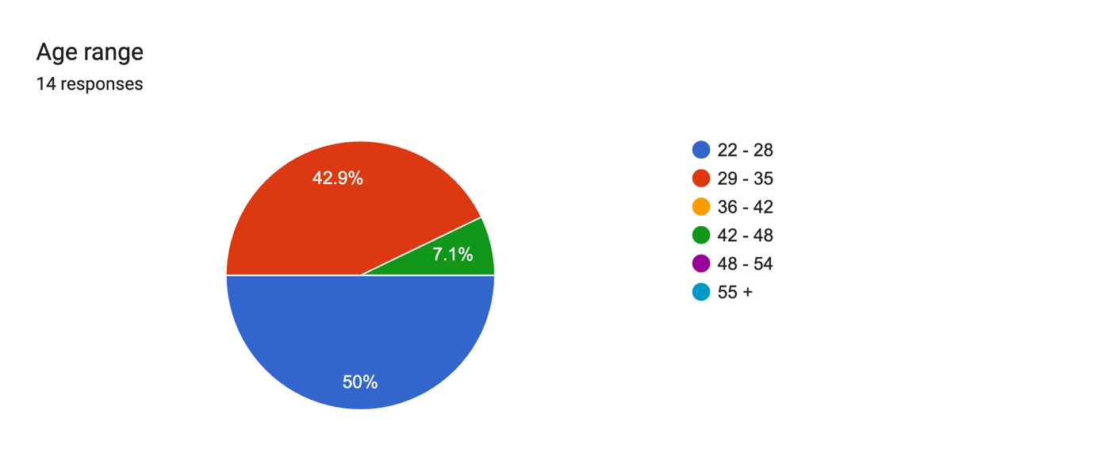

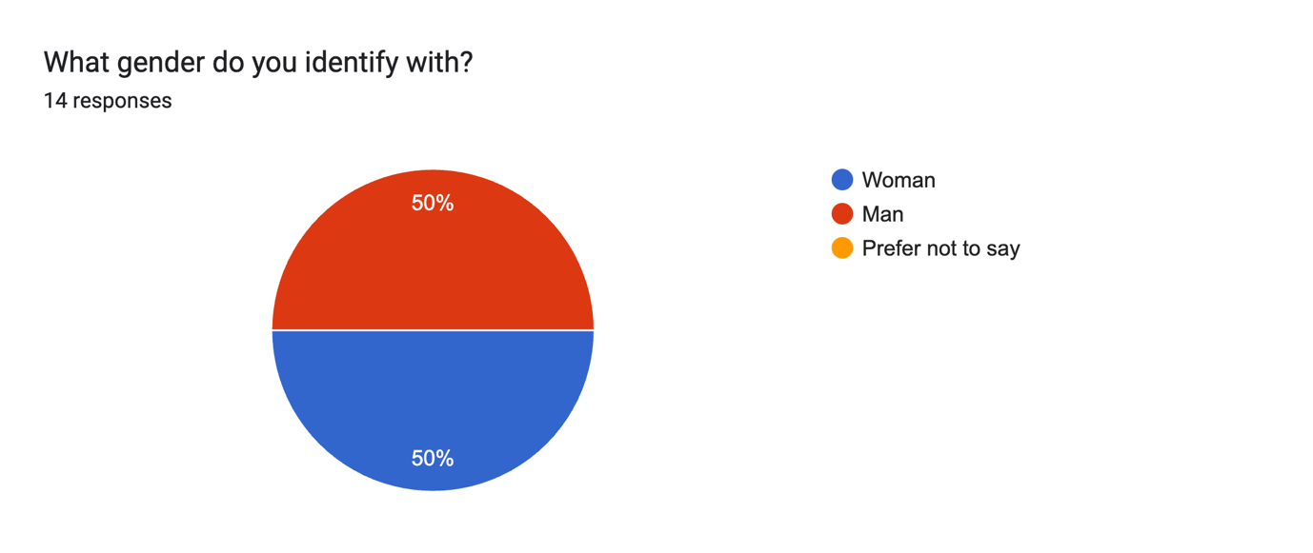

**Respondents Visa Path**

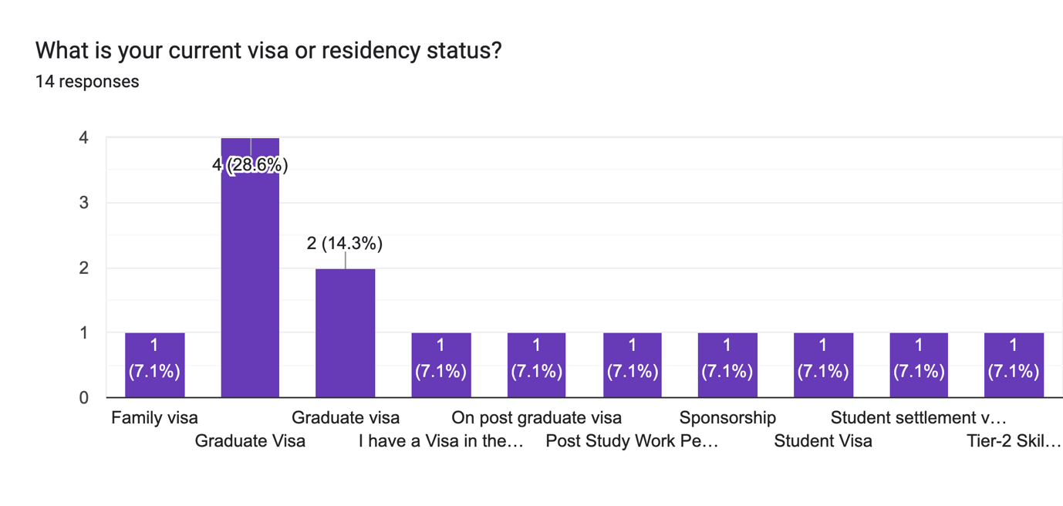

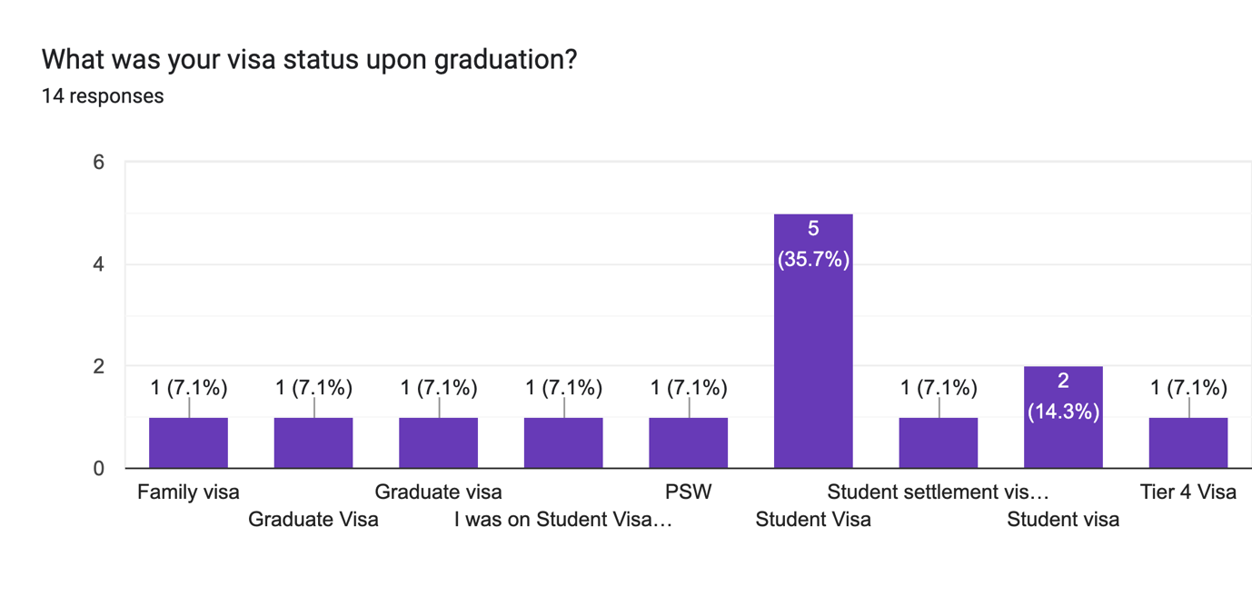

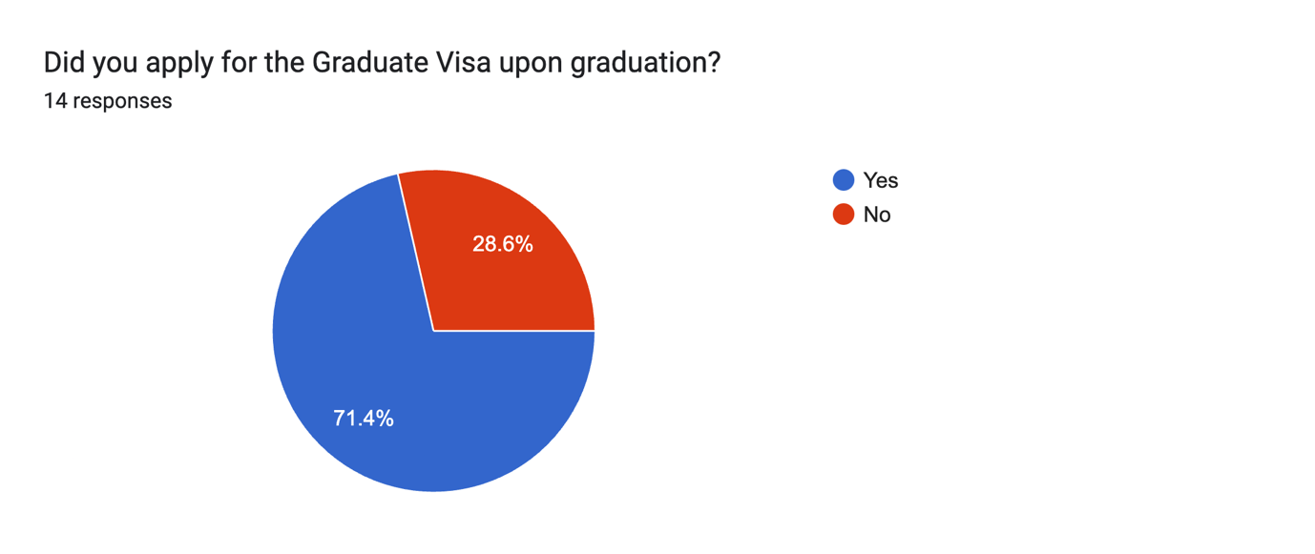

**Respondents Past and Current Employment**

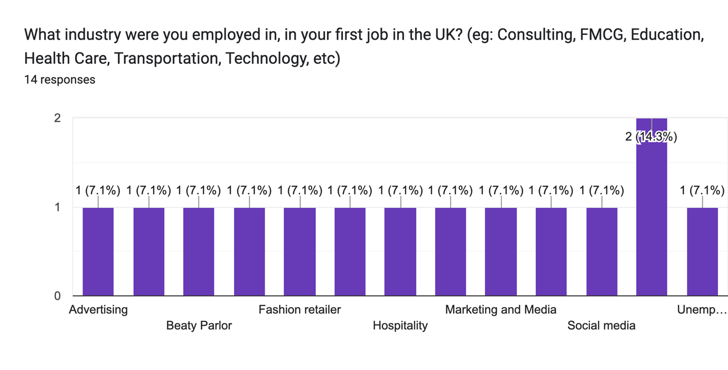

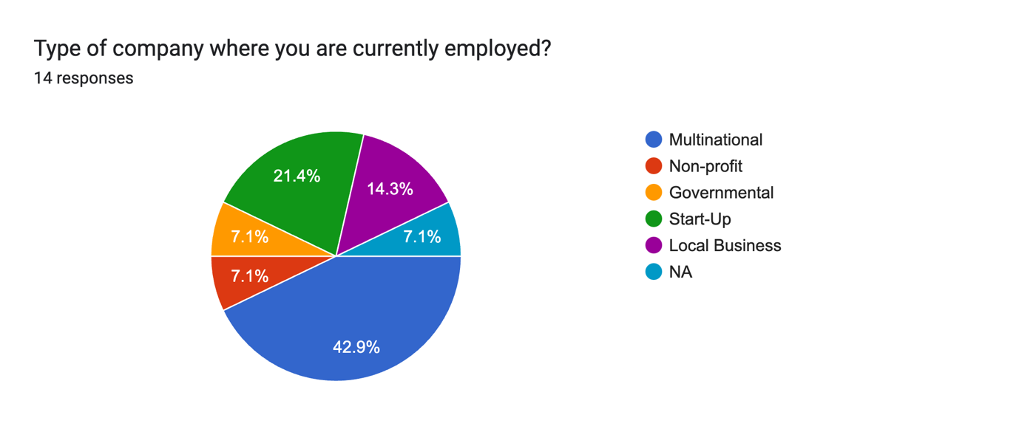

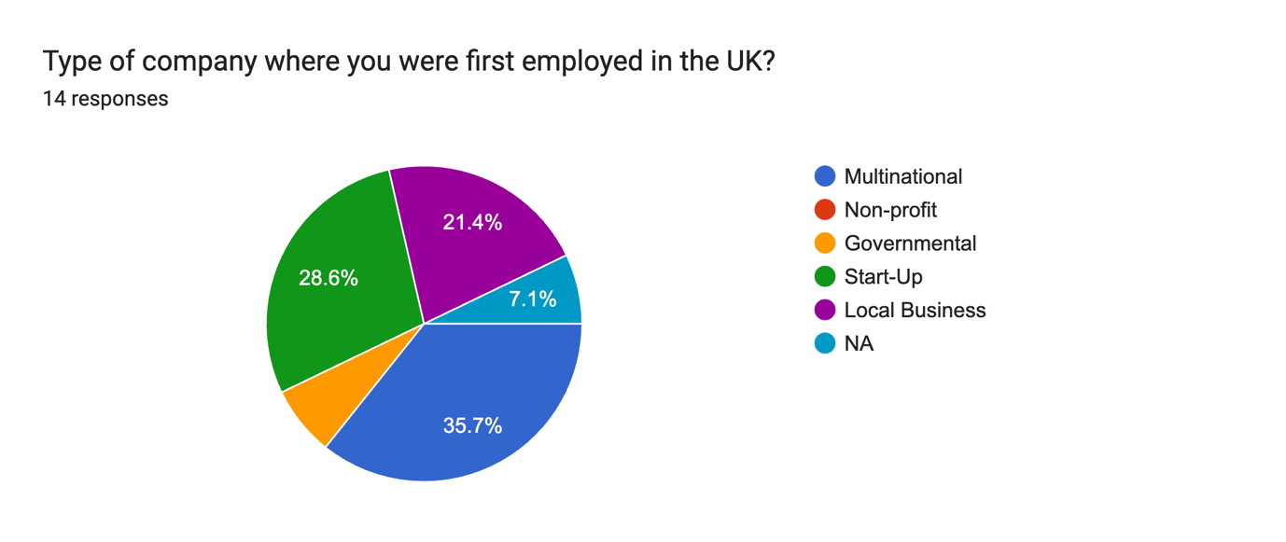

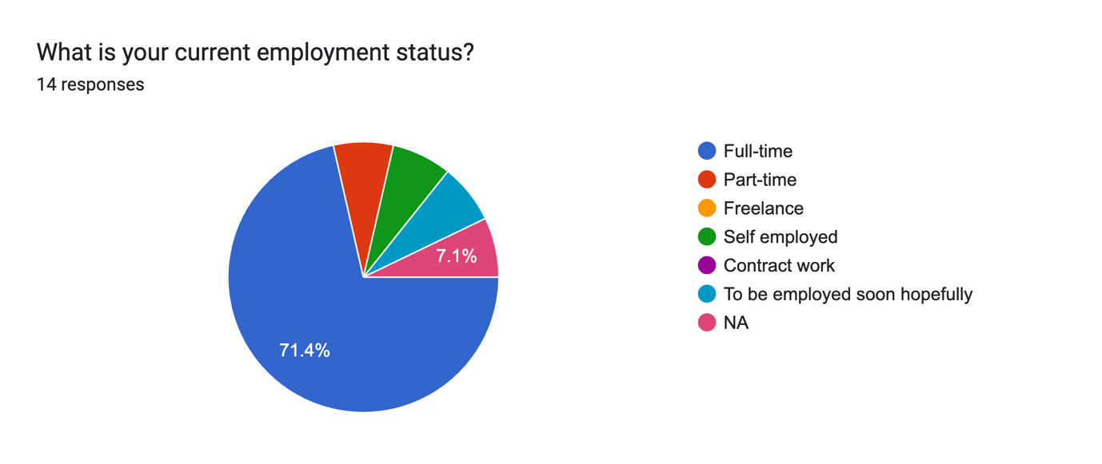

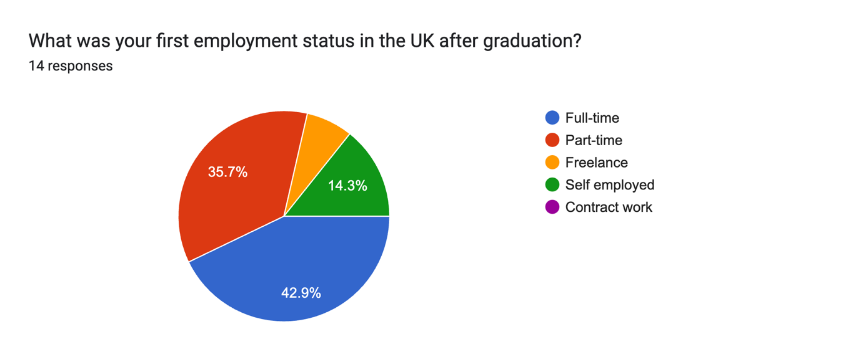

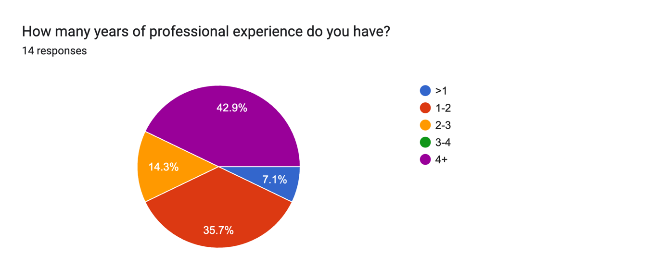

**Respondents Job Search Strategies**

Forms response chart. Question title: How did you go about searching for your first job? Check all that apply.
. Number of responses: 14 responses.

Forms response chart. Question title: How long did it take you to find your first job in the UK after completing your studies?
. Number of responses: 14 responses.

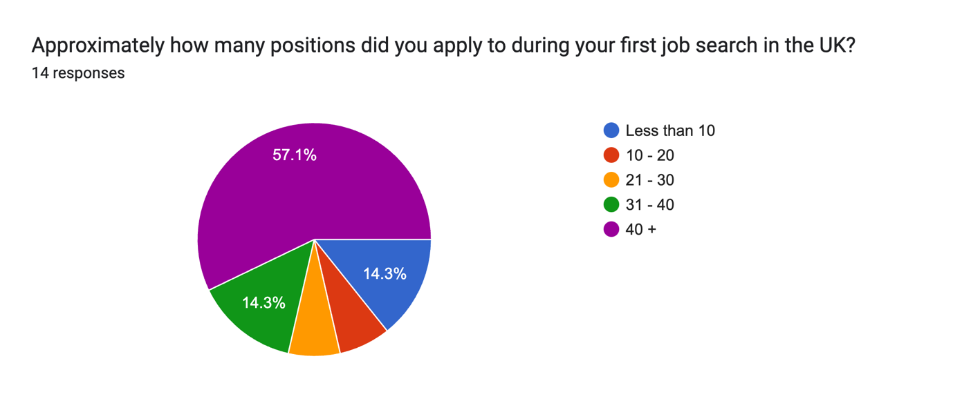

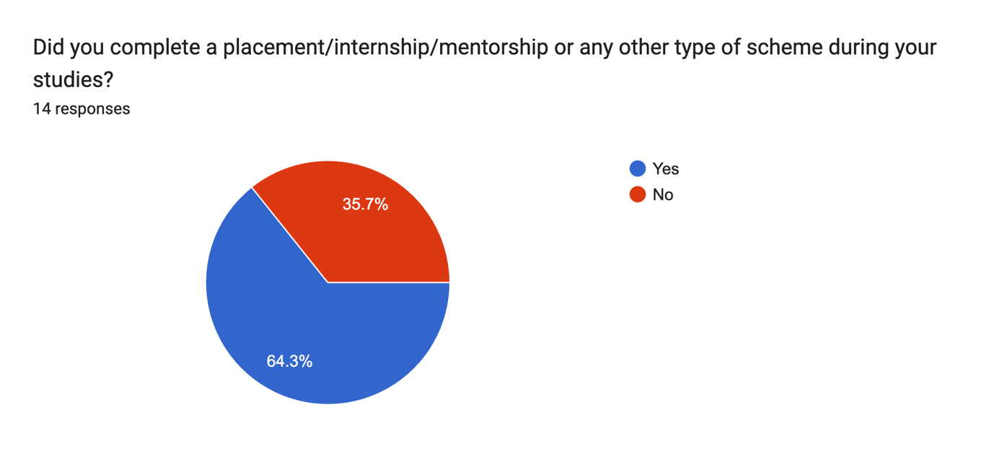

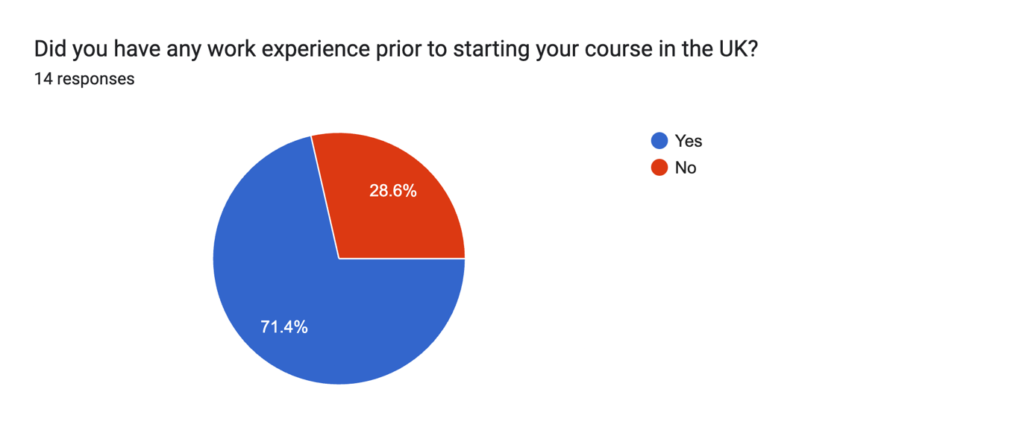

Forms response chart. Question title: What were the key factors that you feel contributed to securing your first job? Check all that apply.
. Number of responses: 14 responses.

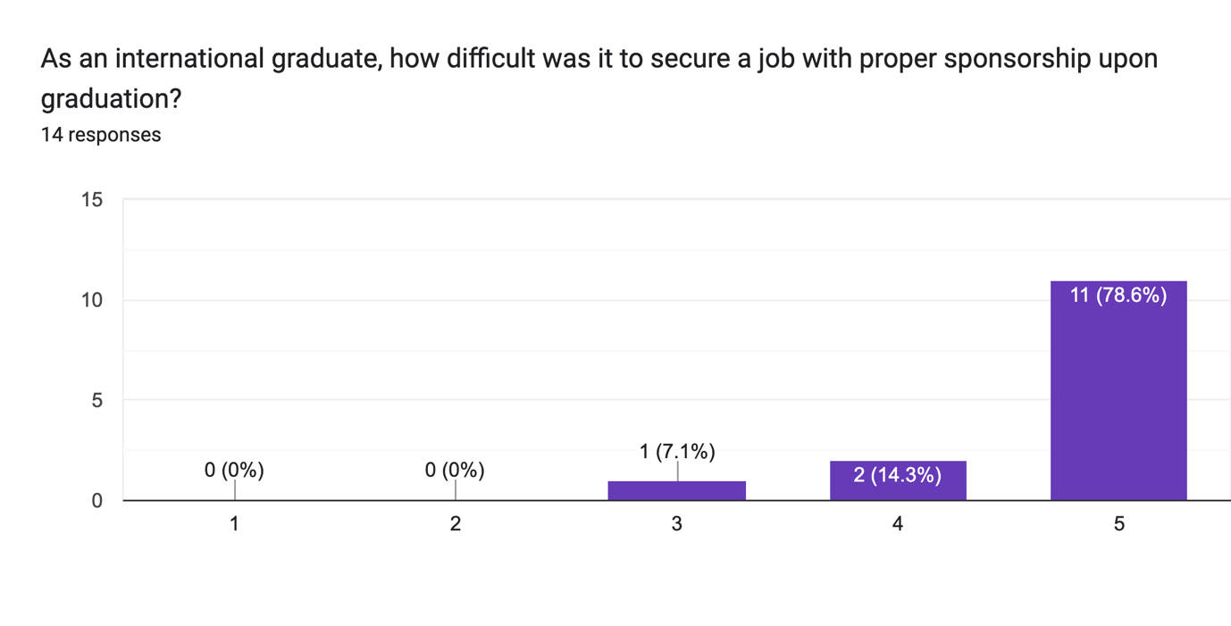

# Forms response chart. Question title: Compared to UK nationals, how much more competitive do international applicants have to be in the job market?. Number of responses: 14 responses.

## interview findings

## Visa and Residency Challenges

Many alumni highlighted visa and residency issues as significant hurdles in their job search. For instance, Dr. Daryna Lysenko from Ukraine emphasized the importance of employer support in securing a student settlement visa. Similarly, other alumni faced ongoing challenges in finding skilled worker visa sponsorship despite having relevant experience.

## Job Search Strategies

The data revealed that successful job search strategies varied widely among alumni. Common methods included:

**Online Job Portals**: Platforms like LinkedIn, Target Jobs, and Indeed were frequently used.

**University Career Services**: Many alumni benefited from the resources and guidance provided by their university’s career services.

**Networking**: Personal connections and networking events played a crucial role in securing employment for many respondents.

## Time to Secure Employment

The time taken to secure the first job varied, with some alumni finding employment within 1-3 months, while others took over nine months. For example, Riccardo Carra found that obtaining a graduate visa was a worthwhile investment, even though it took him 3-5 months to secure a job.

## Key Factors in Securing Employment

Alumni identified several key factors that contributed to their success in securing employment:

**Past Work Experience**: Prior experience in the field was a significant advantage.

**In-demand Skillset**: Having skills that are highly sought after in the market, such as data analytics and digital marketing, was crucial.

**Flawless Interview Skills**: The ability to perform well in interviews was repeatedly highlighted as essential.

**Personal Connections**: Networking and personal referrals often opened doors to job opportunities.

## Skills in Demand

The top skills identified as in demand for marketing graduates included:

**Technical Skills**: Data analytics, Google Ads, and AI in marketing.

**Soft Skills**: Communication, teamwork, adaptability, and networking.

**Creativity**: Ability to think creatively and present ideas effectively.

# discussion

## Possible Limitations and Issues

One limitation is the small sample size of 14 individuals, which may not fully represent the broader population of international students in the UK. The study's focus on marketing and communications alumni limits the generalizability to other fields. Additionally, subjective interviews and self-reported surveys can introduce biases.

## Analysis

Despite these limitations, the research provides valuable insights into the employment challenges and strategies of international students. It highlights the critical role of visa and residency issues, practical job search strategies, and the impact of networking. The variation in time taken to secure employment underscores the need for preparedness and adaptability. Key factors identified, such as past work experience and in-demand skillsets, align with existing literature on graduate employment success.

## What Went Well

The chosen methods effectively captured alumni experiences and strategies. Interviews provided in-depth qualitative data, while surveys offered broader trends. University and external events enriched our understanding of visa pathways and industry expectations. The structured interview process and subsequent data analysis identified common themes and critical factors influencing employment success.

## Achievement of Aims

The primary aim was to develop a concrete set of steps to assist international students in the UK job market. The study successfully identified key factors and strategies, achieving this aim. The results align with our expectations and are consistent with existing literature, validating our conclusions and emphasizing the importance of targeted career support.

## Potential Impact of the Research

The insights from this research have significant implications for enhancing educational practices and career services. Understanding specific challenges and successful strategies enables universities to tailor support programs, improving career readiness and employment outcomes. The study also highlights the need for policy changes to facilitate easier visa processes for international graduates, benefiting both students and the UK economy.

In conclusion, this research contributes valuable insights into the employment challenges and strategies of international students. Despite limitations, it offers practical recommendations for improving career support and successful transitions from university to the workforce. Future research with a larger, more diverse sample could further validate these findings.

# lessons learned

The insights from this qualitative data underscore the importance of early preparation, leveraging university resources, and building a robust network. For current and future students, the following recommendations can enhance their career prospects in the marketing discipline:

* Start Early: Begin working on your CV, LinkedIn profile, and job applications while still in university.
* Utilize University Resources: Take full advantage of career services, networking events, and alumni connections.
* Build a Strong Network: Cultivate relationships with peers, professors, and industry professionals.
* Focus on In-Demand Skills: Develop both technical and soft skills that are highly valued in the market.

The Student Co-Creator Partnership Program offers valuable insights into the benefits and challenges of collaborative work. By collecting qualitative data from alumni, it informs current and future students about job market integration, highlighting strengths, advantages, and areas for improvement and growth.

These findings emphasize the need for proactive career planning and the effective use of available resources to navigate the transition from university to the workforce successfully.

# research group reflection

## Evaluate

The collaborative research experience had several positive aspects, including effective teamwork and a shared commitment to the project. Our group worked well together, leveraging each member's strengths and maintaining open communication throughout the process. The diversity of perspectives within the team enriched the research, providing a comprehensive understanding of the issues faced by international students.

However, we encountered significant challenges with our academic partner, which hindered our progress. Despite being pleasant, our academic partner was unresponsive and often forgetful about the project's details. This lack of support was particularly evident in the mismanagement of the £500 allocated for our project, which we were unable to use because our partner did not know how to claim expenses. This situation highlighted a gap in understanding and support from university staff regarding the struggles international students face in securing employment.

## Analyse

Our successes were largely enabled by our proactive approach and mutual support within the team. Regular meetings, clear division of tasks, and a strong sense of accountability ensured that we stayed on track despite external challenges. The use of university resources, such as the library and career services, also contributed positively to our research.

The problems we faced were primarily due to the lack of support from our academic partner. Her forgetfulness and unavailability created delays and added stress. This experience underscored the importance of having a committed and knowledgeable mentor, especially for projects that address specific issues like those faced by international students.

## Plan

To overcome these problems, future projects should ensure a more thorough selection process for academic partners, prioritizing those with a genuine interest and expertise in the research topic. Additionally, establishing clear expectations and regular check-ins from the outset could mitigate issues related to unresponsiveness.

In hindsight, we would also document every interaction and follow up more persistently on unresolved issues, ensuring accountability. Learning from this experience, we recognize the need for better institutional support and understanding of international students' unique challenges. This project has reinforced the importance of advocating for more informed and engaged university staff to better support international students in their career pursuits.

Overall, while the project faced significant hurdles, it provided valuable lessons in resilience, teamwork, and the critical need for improved institutional support for international students.