**Spanish Course for Migrants / Refugees**

Student Partners:

Isabel Cudby, Dana Sivarajan, King Ng, Parthi Patel, Kinza Akhtar & Casey Bugg

Academic Partner: Olga Núñez Piñeiro

**School of Humanities**

**Academic Year 2022-2023**

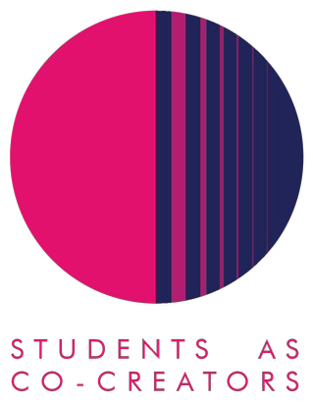

**Spanish Course for Migrants/Refugees Evaluation Report**

1. Where did the inspiration to do the project come from?

This Co-Creators project came about as a result of an idea within Humanities to create a clinic to help local refugees or migrants acquire skills including learning languages. As an extension of this, the idea to create a textbook for the purposes of running these classes for Spanish came about. The original scope was modified to include a textbook for both beginners and intermediate learners of Spanish.

1. What did you set out to achieve?

The objective of the project was to create learning materials appropriate to be used in a Spanish language class (in person) intended for migrants/refugees as part of any future clinic organized by the School of Humanities.

1. How did students and staff work together on this project?

Our primary medium for collaboration was Microsoft Teams which we used for regular team meetings and the presentation and sharing of content. At the beginning of the project, as some of the student partners were not that used to interacting via Teams, this proved a little tricky combined with the non-attendance of certain team members. The advantage of Teams was that it allowed us to hold regular meetings online from our different locations and it proved very helpful for quick interactions, queries and feedback between team members however we found some of the partners failed to attend the Teams calls or were unresponsive in interactions. The convening of the meetings was administered by the academic partner.

Participants worked in small groups to fulfil a number of research tasks that involved reviewing existing language learning materials and putting forward their own proposals and approaches for going about our task whilst the academic staff partner provided regular feedback and guidance.

1. What kind of impact do you anticipate that your work may have on learning and teaching going forward (specific to your course/module or in a broader context)?

As detailed previously, the intention here is that the resources that are created by this project team can be used by teachers who may lead Spanish language classes for migrants/refugees as part of the wider clinic project.

1. Any lessons learned from working in partnership?

Once again, this Students as Co-Creators partnership project has proved to be rewarding. It has been a useful yet at times somewhat challenging experience to get the necessary traction on this project. One aspect that requires further considerations for future projects is that students are not necessarily au-fait with MS Teams and some basic training in this regard may be useful.

The other issue that greatly affected this project was the difficulty to get all the student partners to join the meetings and contribute properly with the project. We also suffered from partners not engaging at all early on and failing to communicate with the staff partner. Perhaps some form of mechanism to guarantee the level of commitment of the student partners to the project is required.