**Year Abroad Toolkit**

Student Partners: Carmela Borrelli, Dawn Cuthbert, Pietro Bonessa and Andrea Salinas

Staff Partners: Owain Evans and Radka Bartoskova

Academic Partner: Olga Núñez Piñeiro

**School of Humanities**

**Academic Year 2022-2023**

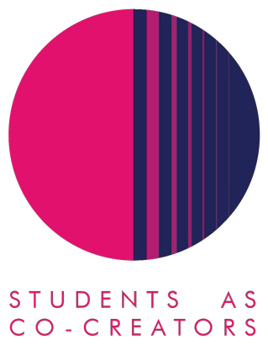

**Year Abroad Toolkit Evaluation Report**

1. Where did the inspiration to do the project come from?

This Co-Creators project came about as a result of an internal discussion about whether the creation of a Year Abroad toolkit would contribute to increased interest and ultimately greater uptake on the Year Abroad opportunities offered by the University.

At the same time, the hope was that the same toolkit could serve as a valuable support mechanism for those students who are already overseas on their year abroad.

In both instances, the expectation was that our Year Abroad Toolkit could help us in a positive way to reduce the number of students who drop out prior to leaving for their overseas placement or whilst already abroad as this is increasingly an issue we are facing.

A Students as Co-creators project seemed like the perfect instrument to look to create such a resource as the shared experiences of students who had already participated in a Year abroad would be absolutely invaluable in shaping the final output.

1. What did you set out to achieve?

As mentioned in the previous section the idea was to produce the content for the Year Abroad toolkit calling upon the expertise of the staff partners in international mobility alongside the experience of the student participants to create genuinely useful content to act as a “one stop shop” for future applicants and those embarking on the Year Abroad.

International mobility is an ever more important component of a degree and something which greatly enhances the employability of our students, and it is hoped that the toolkit will allow us to better support students who embark upon this element of our course offering.

1. How did students and staff work together on this project?

Our principal channel for collaboration was Microsoft Teams which we used for regular team meetings and the presentation of content which was shared as it was updated. At the beginning of the project as some of the student partners were not that used to interacting via Teams, this proved a little tricky. The advantage of Teams was it allowed us to hold periodic follow-up meetings online from various locations and it proved very helpful for quick interactions, queries and feedback between team members. The convening of the meetings was administered by one of the staff partners.

Participants worked in small groups to fulfil a number of research tasks that involved reviewing website content and putting forwards their own ideas about what information could be presented in the toolkit and in which format. All the students who participated in the project, submitted photos and videos for possible inclusion in the toolkit. On the other hand, we invited all of those currently abroad to send in photos, videos and testimonials with the incentive of Amazon vouchers being awarded to the best contributions.

1. What kind of impact do you anticipate that your work may have on learning and teaching going forward (specific to your course/module or in a broader context)?

As the Academic Exchange Coordinator of Humanities, I have a personal interest in encouraging our students to give serious consideration to studying abroad as this is such a valuable opportunity for them to broaden their horizons and gain useful life skills. We do suffer increasingly from students getting "cold feet" before actually setting foot on foreign soil and it will be interesting to monitor whether as a result of this project and the toolkit that has been consequently produced as part of it to see whether this will have a positive impact in the future on the number of students who go through with their application to study/work abroad. We should also be able to gauge the success of our toolkit project by the number of queries received both by Academic Coordinators and the Student Mobility team as we receive significant amounts of queries and requests via email from students, many of which now should be covered in the toolkit.

1. Any lessons learned from working in partnership?

Once again, this Students as Co-Creators partnership project has proved to be a very enriching experience. It has been most helpful to work with students in a slightly different role to the usual lecturer/student classroom relationship and be able to take advantage of their experiences to shape the toolkit. One thing to be considered for future projects is that students are not necessarily familiar with MS Teams and some basic coaching in this at the outset may be useful.

The other issue encountered at the beginning was that it was very difficult to get all the student partners to join the meetings and contribute properly with the project. Perhaps we need some mechanism to verify the level of commitment of the student partners to the project (some had work commitments etc. and were unable to engage).