A Curriculum Design Collaboration

Co-designing an HR symposium with students

Student Partners: Low Tech Shen, Federico Francesco Alberto, Noorisha Gafoo

Academic Partners: Dr. Carla Gibbes, Dr. Koko Kondo, Nwe Zin Shaung

School of Management and Marketing

Academic Year 2024-2025

Where the inspiration to do the project came from

The event had been started due to negative feedback from January (2023) starters who felt left out and found difficulty in interacting with their September cohort members. In addition, the PTES in 2023 had reported that 54% of the 22/23 cohort reported that it was difficult to interact with other postgraduate students and therefore ta sense of community was lacking.
The first co-creators’ event was held in February 2024. This not only saw an increase in the overall score for community on the PTES for the 23/24 cohort (75%) but also led to positive qualitative student feedback. It was, therefore, important to continue to include students in such events and to make them available to a wider audience where possible. The event has thus far been embedded in one of the core modules of the programme Human Resource Management (HRM). This year it was also linked to the second authentic assessment on the module. A social was held afterwards which allowed students to network and talk to the HR professional in attendance. Thus brining the students from both September and January together in a relaxed environment and hopefully building a sense of belonging and community within the programme.

What kind of impact your work may have on learning and teaching going forward (specific to your course/module you worked on or in a broader context)

As stated above, we wanted to continue to improve the student’s sense of community in the programme. We were also aware of the positive impact of involving students in the curriculum design of such events. We had seen how this could enhance student learning on the module and found that students who have previously participated as co-creators have performed better academically than their counterparts.
What you set out to achieve (aims)

One of the key objectives is to enhance students’ engagement by encouraging a student-focused learning and teaching approach. Moreover, we also aimed to create an experience for students where they can interact with UK HR professionals and gain knowledge of HR practices in the UK business sectors and potentially their employability after graduating.

The symposium took place on the 12th March 2024. We collected qualitative feedback via the student co-creators. We received a 20% response from the cohort. When asked what was most valuable about the event we received the following comments.

Entire session
The whole session, specially the interactive part
The importance of culture in the company’s environment
Group activity - which helped us experience the real life hr situation and act in that that situation
Understanding the Influence of culture in HR decisions clearly explained by HR Coach.
everything
Affect of culture on HR

We also asked students whether they had any suggestions for improving future events. The comments were:-

No suggestions, it was very well executed.
They should not relent rather continue the good work, it was Very helpful.
nope, you're perfect

From the feedback we received it can be seen that the event was positive received.

How students and staff worked together – what the roles entailed

An initial meeting was arranged in December 2024 with students’ co-creators. We discussed the aims and objectives of the event. Students created a WhatsApp group where they could discuss and share important information, documents and answer queries/questions.

The second meeting was held via MS teams in January 2025, staff confirmed on supporting students with event arrangements especially for dealing with the university catering requests. Tasks were allocated among students such as, creating a poster (see below), and arranging the catering. In the last meeting in February 2025, the event details were confirmed, and staff checked and supported students with last minutes ad hoc task as required.

As stated earlier the HRM event took place on the 12th March 20205. During the event, led by students, staff worked in partnership in dealing with event management activities such as IT set up, time keeping, meet and greet HR Professional and catering. All students’ partners were involved during the events supporting each other as required.

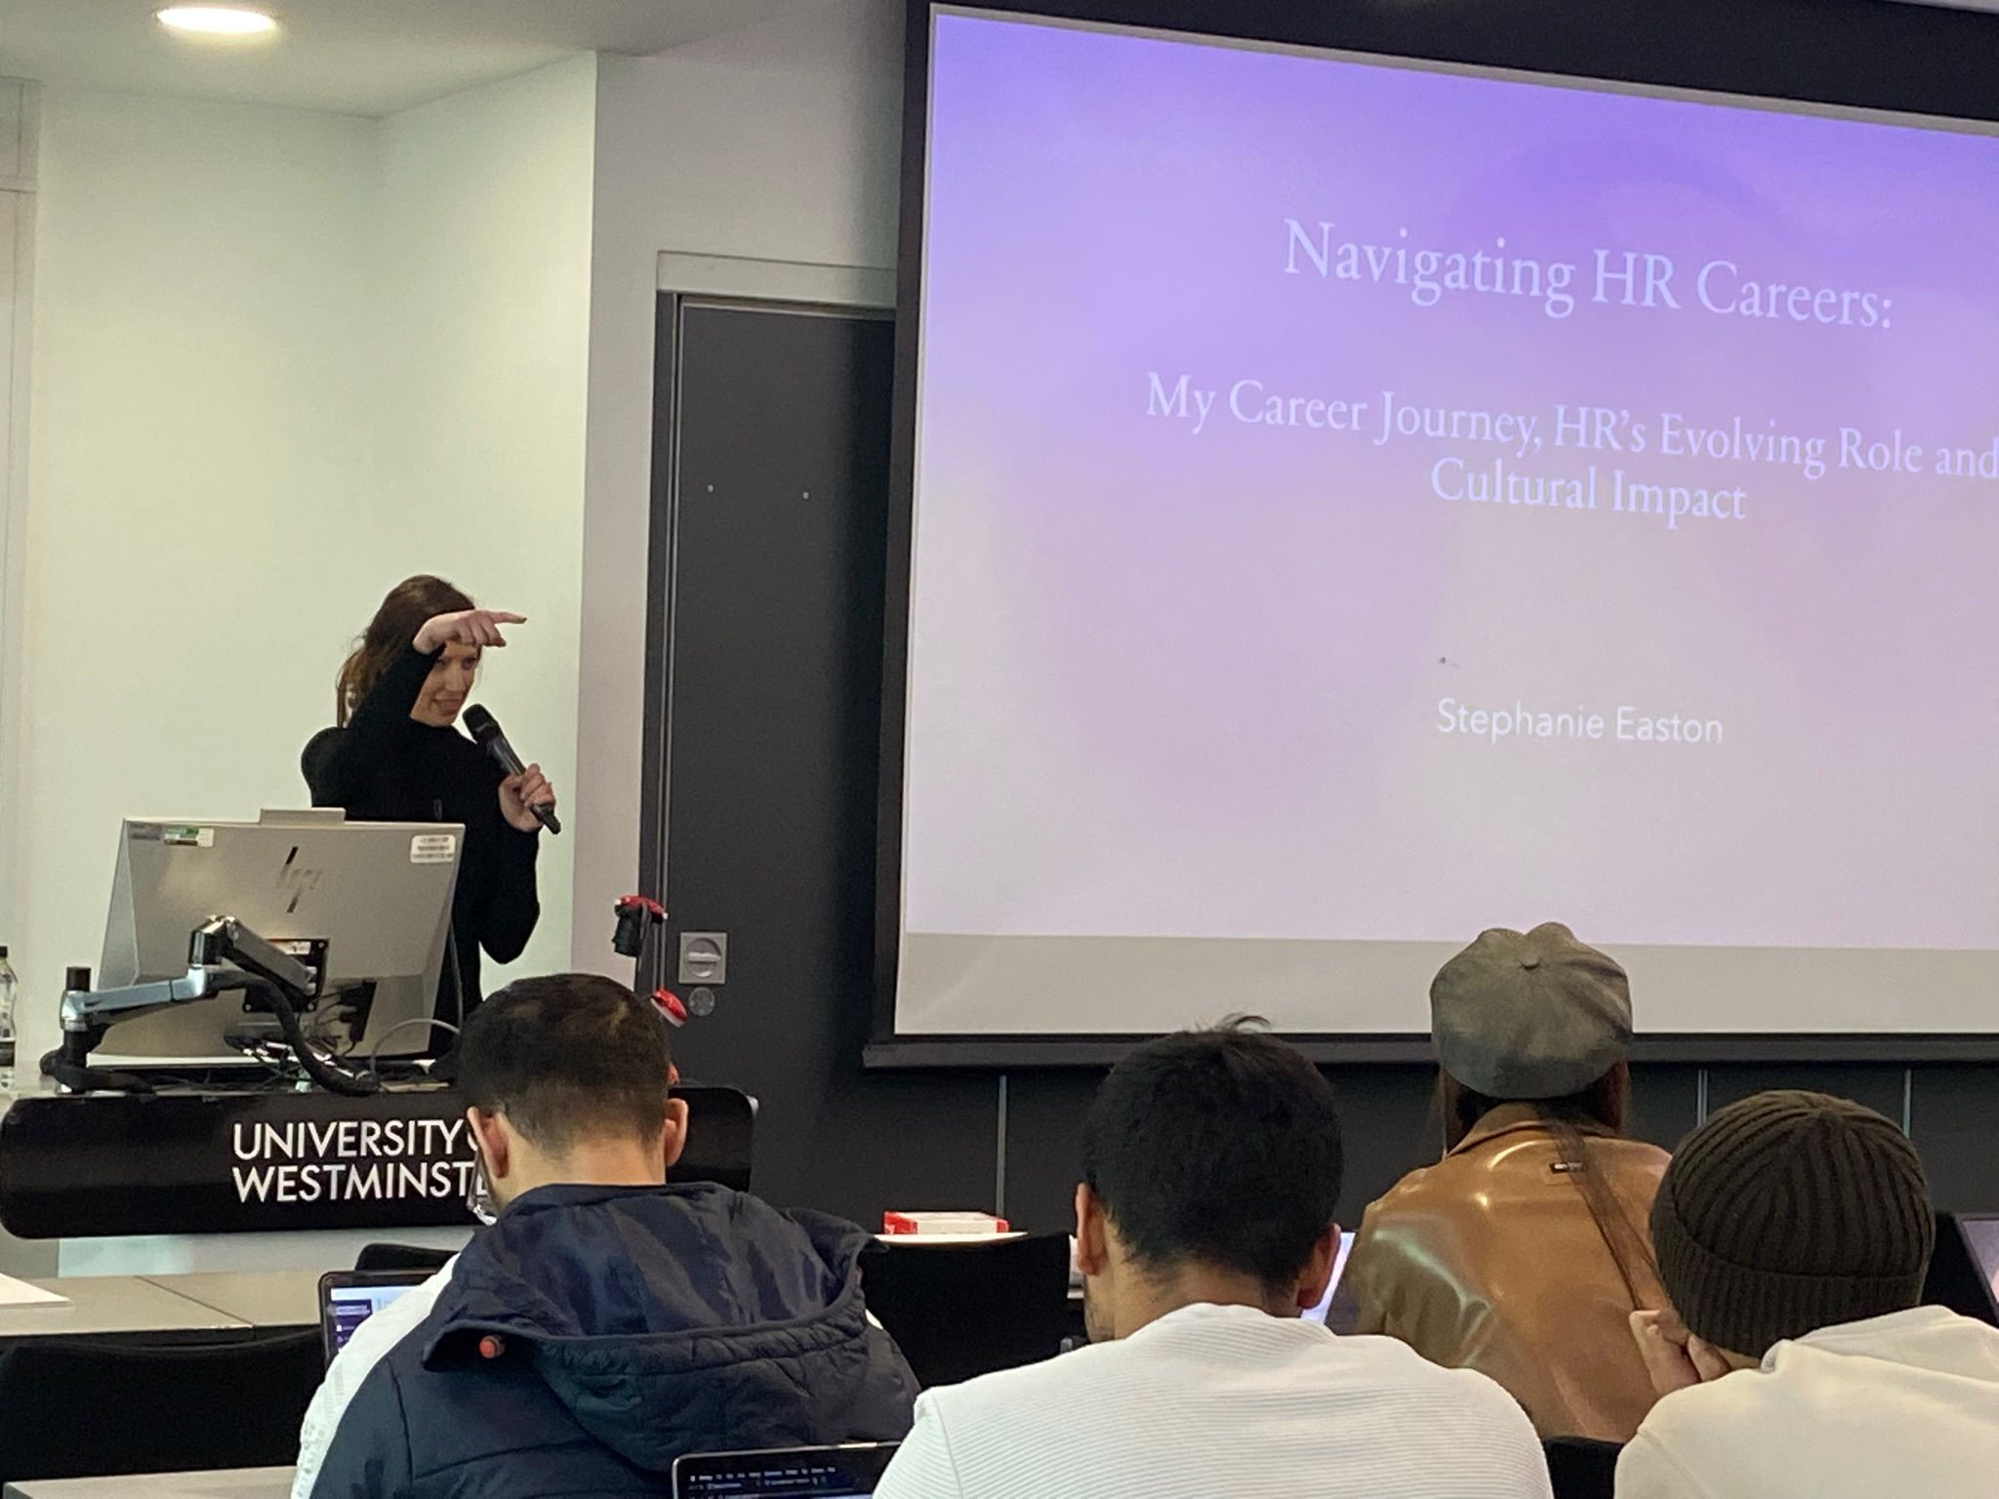
Any lessons from working in partnership.

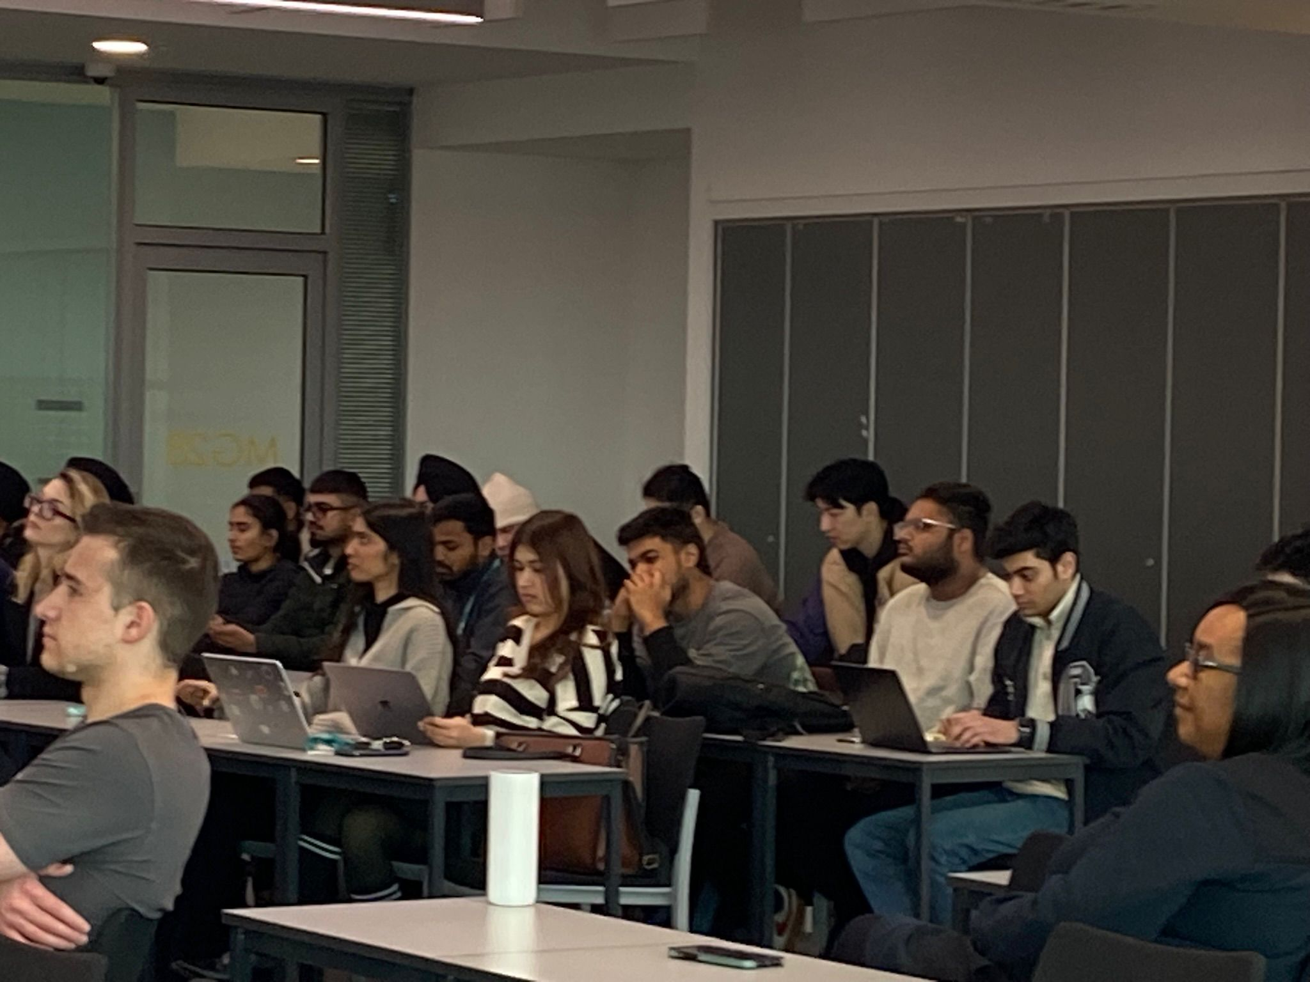
Initially when we put out the request a couple students who initially volunteered dropped out very early on. Subsequently the remining co-creators were a small group of three students. They worked extremely well with each other and were highly motivated. Interestingly these three students all gained a distinction for this module and have continued to work well across the programme. Ideally, we would have liked to include more student co-creators, so this is the challenge as we move forward. There is no doubt that bringing the students together has a positive impact on the student cohort. Using projects such as these can only be beneficial and its hoped to continue to do so.

