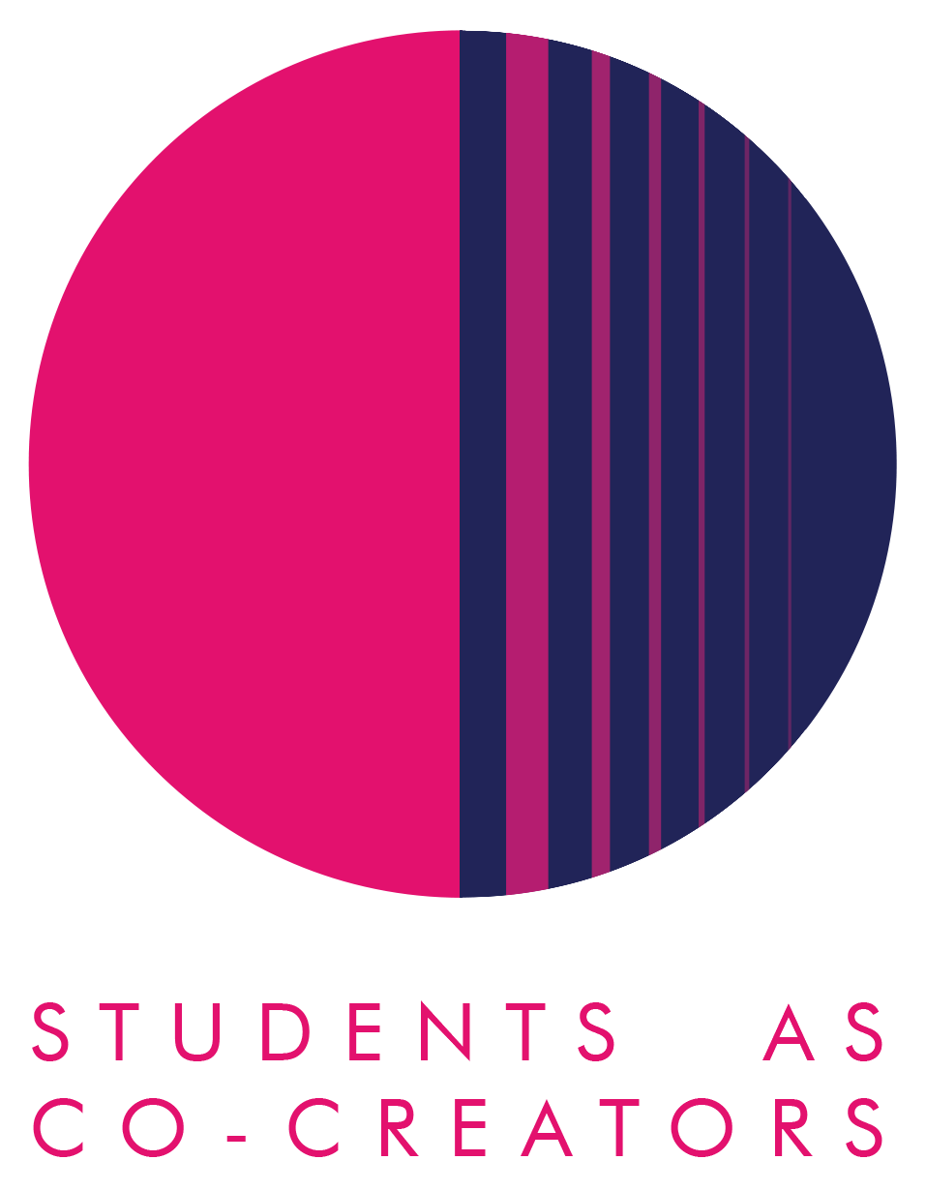

A Curriculum Design Collaboration

Peer Mentoring Toolkit

Student partners: Iga Karczmarz, Gioia Otuniyi
Parthi Patel and Camila Tanquina Olivo
Academic partner: Olga Núñez Piñeiro

School of Humanities

Academic Year 2024-2025

- Where did the inspiration to do the project come from?

The idea came from L6 Spanish student Parthi Patel, who felt that she would have personally benefited from having had a more experienced student acting as a mentor to ease her transition into university life and provide ongoing support during her degree.

Many higher education providers have formal peer-mentoring schemes and research indicates that they have a positive impact on both mentors and mentees alike as well as the institutions themselves.

2. What did you set out to achieve?

The objective of the project was to develop a peer mentoring toolkit / guidance for next year’s second and final year student mentors within the School of Humanities.

3. How did students and staff work together on this project?

We decided that as a first step we would read the guidance published by Advance HE on peer mentoring and we then decided to contact Advance HE and ask them if they could facilitate a tailored workshop that would prepare us with a grounding in effective student-led peer support in order to help us produce a toolkit / guidance for next year’s student mentors.

Advance HE designed and delivered a half-day, online workshop to help us produce a toolkit / resources for next year's second and final year students on how to be a good peer mentor. The session was delivered online on 27th June by Mark O’Hara and was funded by the Student as Co-Creators team for which we are incredibly grateful as it was a very useful exercise.

Mark is a Principal Fellow of the Higher Education Academy (PFHEA) and is a Senior Consultant (Education) at Advance-HE. He has over 30 years’ experience in Higher Education and is both a National Teaching Fellow (NTF) and a winner of the UK’s Collaborative Award for Teaching Excellence (CATE).

Mark has worked as an Associate PVC for Education, as Associate Dean for Learning Teaching and Quality Enhancement, and as Head of Student Experience. Mark has extensive experience of governance and academic quality assurance in HE as well as academic staff development and support relating to learning and teaching. His academic interests include student enablement and recognition, teaching enhancement, widening participation, more inclusive educational practices and global engagement. He has acted as institutional lead for multi-national Erasmus+ projects on equality, diversity and inclusion as well as on student transitions. Mark is currently Vice Chair of the European Association of Institutional Research (EAIR).

The outline of the session schedule was as follows:
- 10 mins - Welcome & icebreaker
- 30 mins - Why peer learning matters & benefits for the leaders and the led
- 30 mins - Principles of effective peer learning & support - think-pair-share activity
- 10 mins - Interim plenary / Q&A
- 15 mins - Break
- 1 hr 10 mins - Developing toolkit / resources (mentoring frameworks; scaffold for toolkit; identifying supporting resources; personal action planning)
- 15 mins - Wrap-up & next steps

Following the completion of the workshop, we held an internal meeting between all the team members to agree a way forward on how the work should be distributed amongst us and to discuss the strategy on how to execute the project and produce the final output. It was agreed that we would create two Project Managers, and both of these should be drawn from the student participants. Parthi Patel and Iga Karczmarz put their names forward. Throughout the project, we relied primarily on Microsoft Teams to communicate with each other as well as some communication via email. We also asked the LIDE team to set up a specific Blackboard site for this Mentoring Scheme.

4. What kind of impact do you anticipate that your work may have on learning and teaching going forward (specific to your course/module or in a broader context)?

We hope that we will be able to recruit a number of mentors next academic year, who will help improve the self-esteem, confidence, sense of belonging, attendance, engagement, academic achievement of new students as well as develop friendships in a positive environment. Mentors themselves will develop critical skills in coaching.
It is hoped that any volunteers from L5 and L6 who are willing to assist with a mentoring scheme will feel some sort of personal fulfilment and in particular satisfaction from seeing how they are able to help L4 students settle in and progress

5. Any lessons learned from working in partnership?

It was a pleasure to get to work with the four L6 students who took part in this project. It is quite unusual to have L6 students participating in Students as Co-Creators projects as they are often focused on their final year of study, but these students gave their time selflessly to this project and were highly committed to something which had no direct benefit to them personally. I hope that we can build on the framework that has been established to take the mentoring scheme forward next year.

It was also extremely helpful to count on the guidance of Advance HE through the training session. Once again, I am most grateful to the Students as Co-Creators Team for agreeing to finance this consultancy which all of the participants found enormously valuable.

