Bridging the gap: exploring dimensions and dynamics of ethical consumer literacy in responding to SDG 12 – the second phase from last year’s SCC project
Dr Nattida Srisaracam, School of Organisations, Economy and Society
and Dr Koko Kondo, School of Marketing and Management
Westminster Business School, University of Westminster
In collaboration with Students as Co-Creators grant by CETI.

Introduction
The United Nations’ Sustainable Development Goal (SDG) 12, Responsible Consumption and Production, highlights the urgent need to transform consumption patterns to reduce ecological degradation and promote sustainable futures (United Nations, 2015). A critical dimension underpinning this transformation is ethical consumer literacy, understood as the knowledge, skills, and motivation consumers require to make purchasing decisions aligned with environmental stewardship, social justice, and sustainable practices (McGregor, 2013; Hassan et al., 2016; Papaoikonomou et al., 2023). While awareness of sustainable consumption has risen globally, consumers often face persistent barriers, such as price sensitivity, convenience, and limited access to credible information, that prevent them from translating values into practice (Carrington et al., 2014; Johnstone & Tan, 2015). More recent studies reinforce this persistent ‘value–action gap’, showing that price premiums continue to deter ethical purchases (Gomes et al., 2023), while convenience and availability constraints undermine sustainable choices (Syed et al., 2024; Schiaroli et al., 2024; Barbu et al., 2022). Limited access to reliable information and rising concerns over greenwashing have eroded consumer trust, making it difficult to act on sustainability values even when awareness is high (Fella et al., 2024; Lopes et al., 2023).

Existing research on ethical consumption has tended to focus on consumer behaviour outcomes or the role of businesses in providing sustainable alternatives (Bray et al., 2011; White et al., 2019). However, there remains a notable gap in examining how ethical consumer literacy develops and interacts with broader socio-cultural influences, particularly among younger generations whose consumption patterns will shape future markets. Gen Z, in particular, has been positioned as a sustainability-conscious cohort, yet evidence suggests a gap between their pro-sustainability attitudes and their actual purchasing behaviours (Francis & Hoefel, 2018; Bapat, 2020). Moreover, while many frameworks call for multi-stakeholder collaboration – involving consumers, businesses, governments, and advocacy groups – promote ethical literacy (OECD, 2021), empirical research often struggles to capture these dynamics in practice, due to access and scope limitations.

This research project, Bridging the Gap: Exploring Dimensions and Dynamics of Ethical Consumer Literacy (ECL) in Responding to SDG 12, represents the second phase of our ECL study, delivered through the ‘Students as Co-Creators’ initiative and funded by CETI. The project was led by Dr Nattida Srisaracam and Dr Koko Kondo, in collaboration with six student partners who contributed as co-creators to key research elements, including research workshops and activities, as well as project posters and marketing. Our student partners are Trisha Shetty, Dia Durgesh Wagle, Vinayak Batra, Thomas John Hadfield, Iman Khalid, and Christos Taladianos. Building on our first-phase findings, which established a conceptual foundation for ethical consumer literacy, this phase narrows its focus to Gen Z consumers as a starting point for deeper inquiry. Although our initial aim was to include perspectives from multiple stakeholders i.e., consumers, businesses, and advocacy groups, the restricted timeframe and access barriers necessitated prioritising Gen Z consumer perspectives in this stage. This pragmatic adjustment provides both a scholarly rationale and a methodological advantage: focusing on this cohort offers an opportunity to capture rich insights from a generational group that is both vocal about sustainability and poised to become influential market actors. The inclusion of wider stakeholders will remain a key focus for the next project phase.
Accordingly, this phase reframes the overarching research question to:
How do Generation Z consumers understand and engage with ethical consumer literacy in the context of responsible consumption (SDG 12), and what barriers and enablers shape their practices?
By centering Gen Z voices, this study makes two contributions. First, it addresses an underexplored gap in the literature by examining not only what young consumers know about ethical consumption, but also how they actively engage with sustainability practices in everyday life. Second, through its participatory and co-creative methodology, it demonstrates innovative ways of embedding action-based learning into research design to strengthen ethical literacy and capture behavioural insights.

Methodology and co-created research fieldwork
This study adopted a participatory action research (PAR) design (Kemmis and McTaggart, 2005; Reason and Bradbury, 2008), integrating student partners as co-organisers and engaging participants in experiential, action-oriented activities. Such approaches are particularly suited to exploring ethical consumer literacy, as they move beyond self-reported attitudes to encourage active engagement and reflection (Stringer, 2014; Bradbury, 2015). The co-creation model aligns with the Students as Co-Creators framework (Healey et al., 2016), enabling collaboration between faculty, students, and research participants to enhance the relevance, inclusivity, and impact of the research process.

The project centred around a research workshop that combined an upcycling eco-fashion activity with a subsequent focus group discussion on 26th March 2025 (3:00 - 5:00 PM) at WBS Marylebone campus (See Figure 1.1). In the workshop, nine Gen Z consumers (i.e., research participants) worked in small groups to repurpose unused materials into wearable “eco-fashion” designs, which they then presented in a catwalk-style showcase (See Figure 1.2 and 1.3). Designed by student partners, this activity served as an action-based intervention to immerse participants in sustainable decision-making, thereby encouraging reflection on resource use, creativity, and the meanings of ethical consumption. Such experiential methods are supported in the methodological literature as effective in enhancing sustainability awareness and encouraging critical reflection (Kolb, 1984; Wiek et al., 2011).

Figure 1.1: Promotional poster created by our student partners, Iman Khalid and Thomas John Hadfield, who also led the marketing activities for this project.
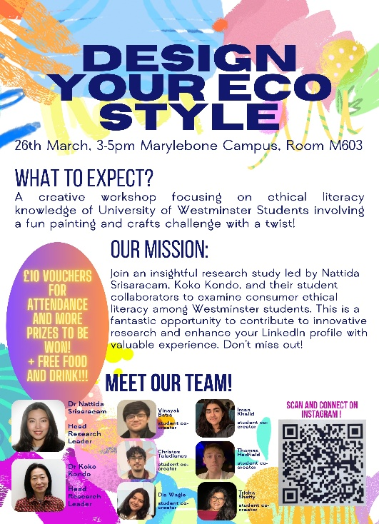
Figure 1.2: Upcycling Workshop – Design your Econ Style competition, organised by our student partners.
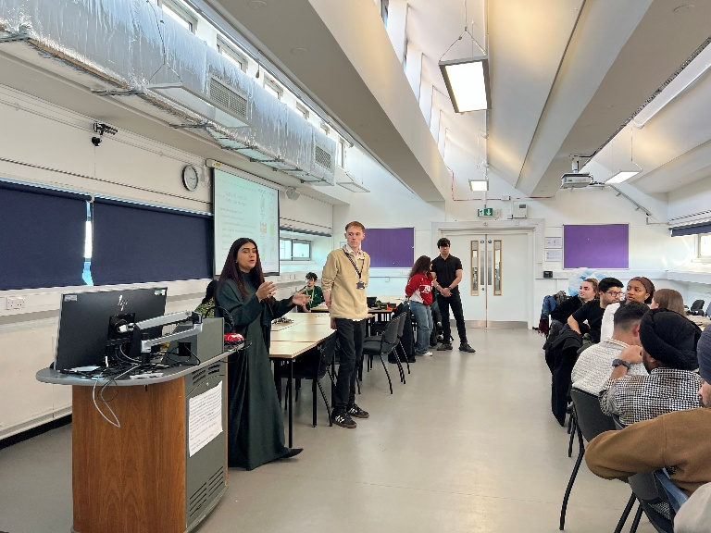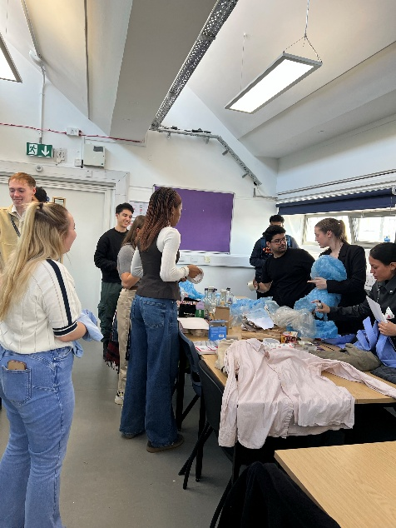
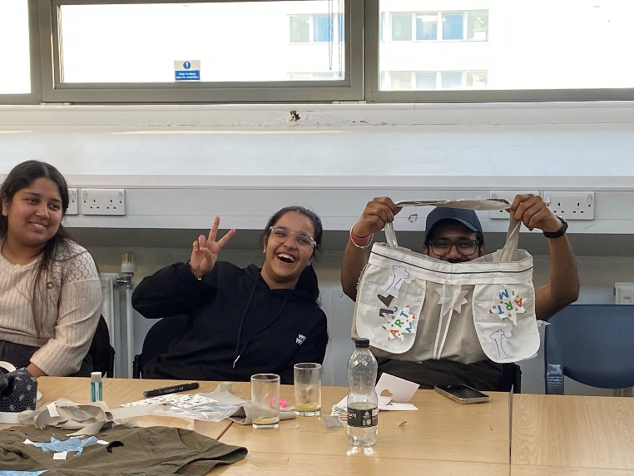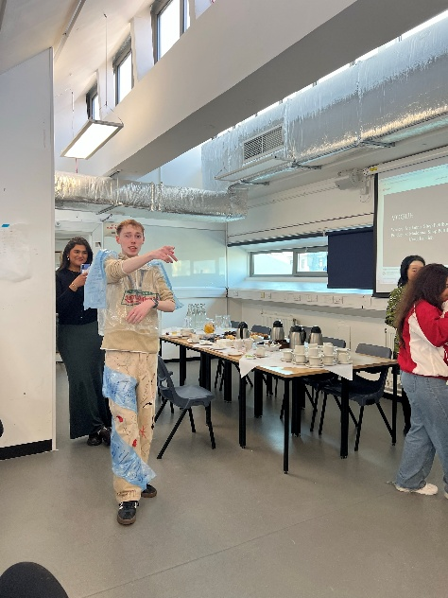
Figure 1.3: We concluded the first half of the research workshop activity.
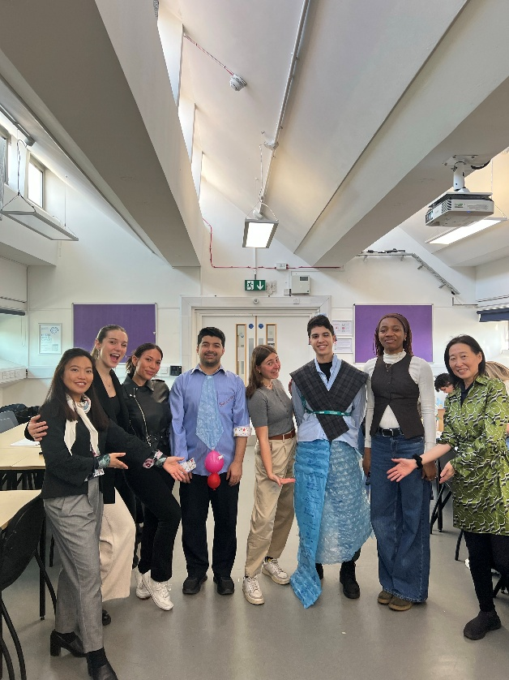

Following the workshop, a 90-minute focus group was conducted to elicit participants’ perceptions of ethical consumerism (See Figure 2.1 and 2.2). The focus group format was chosen for its ability to generate interactive dialogue, capture collective meanings, and explore diverse viewpoints in a socially situated context (Morgan, 1997; Bryman, 2016). The session began with a visual recognition exercise, in which participants identified familiar ethical association logos from a pre-selected list, to stimulate awareness and discussion. The group then explored themes such as definitions of ethical consumption, perceived barriers to action, and enabling factors. The session concluded with a participatory word-clouding activity in which participants wrote personal definitions of “ethical consumption.”
Figure 2.1: A 90-minute focus group was conducted to explore the multifaceted context of ethical consumer literacy.
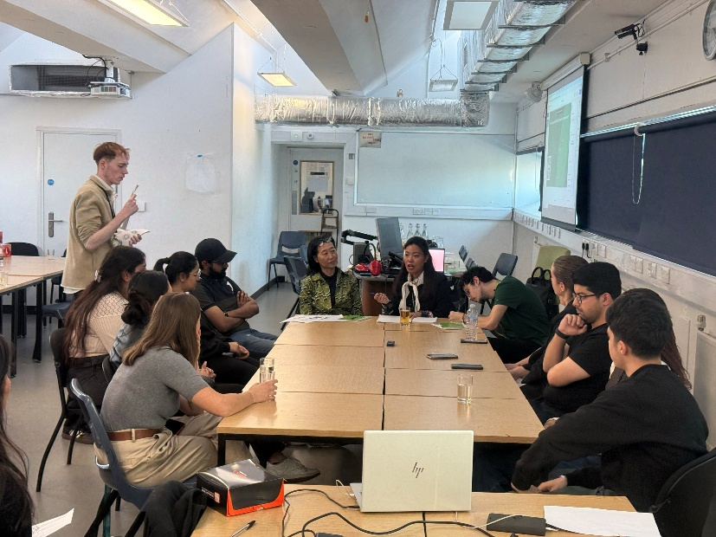
Figure 2.2: The research workshop and focus group were completed collaboratively with our SCC student partners.
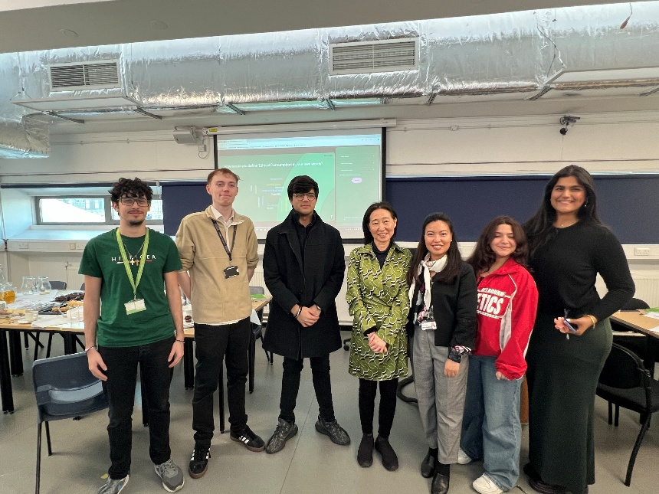
Data were collected from the workshop outcomes (group presentations and reflective notes) and the focus group transcripts. This ‘multi-modal’ design provided a richer, triangulated understanding of ethical consumer literacy by combining observed practices with expressed attitudes and reflections. Employing multiple modes of data collection not only enhances validity through methodological triangulation (Denzin, 1978; Flick, 2018), but also captures different dimensions of a complex phenomenon. The upcycling workshop foregrounded embodied and enacted practices, allowing researchers to observe how participants made sustainability decisions in action rather than merely reporting intentions i.e., an approach aligned with calls for more experiential and practice-based methods in sustainability research (Wiek et al., 2011; Evans, 2019). In contrast, the focus group discussions provided access to narratives, attitudes, and meaning-making processes, highlighting how participants articulate ethical concerns, confront barriers, and negotiate trade-offs in consumption (Morgan, 1997; Bryman, 2016). In the context of ethical consumer literacy, these discussions were particularly valuable in uncovering how Gen Z consumers interpret sustainability information, evaluate competing ethical priorities, and translate abstract knowledge into practical decision-making. This provides insight into the cognitive and motivational dimensions of ethical literacy, complementing the behavioural evidence generated through the workshop. Finally, the word-clouding exercise offered a creative, participatory mode of data generation that surfaced individual definitions and associations in a visually synthesised form, complementing both the observed and dialogic data. Taken together, this multi-modal approach moves beyond reliance on self-report surveys, enabling a more holistic exploration of ethical consumer literacy as both a cognitive and performative practice.
The focus group was structured around three thematic clusters designed to explore different dimensions of ethical consumer literacy:
- Section 1: Information searching and management – Participants were asked about their familiarity with ethical product standards and associations, how they access and evaluate information, and what types of information would support ethical decision-making.
- Section 2: Defining and engaging in ethical consumption – Questions focused on participants’ experiences with ethical consumption, challenges and barriers they face, and the skills or competencies they see as important for strengthening consumer literacy.
- Section 3: Reflection and future directions – Participants were invited to define “ethical consumption” in their own words, self-assess their practices, and suggest how businesses might better support consumers in making ethical choices.
This design enabled the exploration of knowledge, skills, and motivational aspects of ethical consumer literacy while allowing space for reflection on personal practices and systemic expectations.

Preliminary findings
Based on the 90-minute focus group with nine Gen X participants who completed the upcycling workshop, several thematic patterns emerge across the three clusters of inquiry: 1) Information Literacy, 2) Engagement & Competencies, and 3) Identity & Expectations.
1. Information literacy: awareness, accessibility, and trust
Theme 1: Recognition of standards is fragmented
Several participants recognised only well-known certifications (e.g., Fairtrade, “those with the green leaf symbol”), while lesser-known associations drew blank looks. As one participant commented:
“I know Fairtrade and maybe the recycled logo… but others, I’ve never heard of them.”
This aligns with earlier studies noting uneven awareness of ethical standards among young consumers (Carrington et al., 2014; Johnstone & Tan, 2015). Recent surveys confirm that even in eras with increasing sustainability discourse, recognition remains concentrated on a few dominant labels (Gomes et al., 2023; Lopes et al., 2023).
Theme 2: Information sources and barriers
Participants reported relying on social media (especially Instagram and TikTok), brand websites, and peer recommendations for information, but several voiced doubts about credibility:
“I check Insta stories or TikTok influencers, it's fast, but I’m never sure if brands are just pretending to be green.”
“I spend maybe ten minutes looking up product claims, mostly on the site… but honestly, some is just marketing.”
This reflects well-documented challenges in accessing credible, trustworthy sustainability information; and the rise of greenwashing among influencers, especially for Gen Z (Fella et al., 2024; Syed et al., 2024).
Theme 3: Time constraints and information overload
Most participants said they spent only a few minutes researching before making a purchase, citing time pressure and information overload:
“I usually compare two or three brands […] takes maybe five minutes max. I can’t keep digging.”
This highlights the convenience barrier: even strong ethical intentions are undermined by limited time and decision fatigue (Syed et al., 2024; Schiaroli et al., 2024). The literature on bounded rationality in sustainable consumption further reflects this trade-off between depth of scrutiny and practical convenience (Barbu et al., 2022).
2. Engagement and competencies: practice and obstacles
Theme 4: Creativity meets value evident by action tension
Participants engaged enthusiastically in the upcycling task, demonstrating creativity and environmental awareness:
“Designing a dress out of old T-shirts made me think twice before throwing things away.”
But they also expressed tension between values and actual purchasing behaviour:
“I want to buy fair clothes, but they cost more […] I’m still tempted by cheaper fast-fashion.”
This reflects the persistent value–action gap—where participants feel obliged to align with ethical choices but are constrained by price. This echoes both classic findings (Carrington et al., 2014) and more recent studies highlighting how price premiums limit green purchases (Gomes et al., 2023).
Theme 5: Activism is uneven
Some participants had participated in activism e.g., via online campaigns, boycotts, or petitions, while others felt disengaged:
“I signed an online petition about palm oil but don’t go further; it’s time and emotional energy.”
This pinpoints to partial engagement and highlights the need for both motivational and structural support for sustained ethical action, aligning with the concept of ethical consumer literacy as encompassing not just knowledge, but also behavioural capability (McGregor, 2013) – this also links to recently formalised frameworks on consumer empowerment. For instance, a recent study on digital-age consumption underlines that agency is not innate but must be intentionally cultivated through systemic interventions and consumer education (Nokhiz & Ruwanpathirana, 2025).
Moreover, these findings suggest that without reinforcing infrastructure, such as transparent sustainability standards, reliable information channels, and enabling tools, ethical awareness among consumers may fall short of translating into consistent action. The literature on consumer empowerment now argues for shifting the burden away from individuals alone toward a model where the broader system supports them, through regulatory frameworks, accessible data, and business practices that anticipate and facilitate ethical choices (Nokhiz & Ruwanpathirana, 2025).
Participants also suggested that useful skills would include critical evaluation (e.g., reading labels), budgeting for sustainable options, and knowing where to find reliable recommendations:
“It’d help if we learned how to spot real claims, what to trust, and maybe how to shop on a budget ethically.”
Such competencies resonate with literature emphasising that ethical literacy entails skills, not just awareness, especially financial literacy for sustainable purchases (Wiek et al., 2011; Evans, 2019; recent 2024 educational research).
3. Identity and expectation: definitions and business role
Theme 6: Defining ethical consumption
Despite variation in participants’ responses, the word-cloud data from our study showed that common definitions of ethical consumption clustered around “consciousness,” “awareness,” and “health.” This reflects broader understandings in the literature, where ethical consumption is often framed as a heightened state of awareness in decision-making, involving reflection on both personal values and broader societal consequences (Harrison, Newholm, and Shaw, 2005; Crane et al., 2019). Consciousness and awareness in this context signal the consumer’s role in making informed and responsible choices, rather than acting purely on habit or convenience.
The association with “health” indicates a tendency for consumers to merge ethical considerations with personal well-being, echoing findings that ethical choices are often intertwined with lifestyle and identity (Johnston, Szabo, and Rodney, 2011). This resonates with research suggesting that for many individuals, “doing good” is inseparable from “feeling good,” where ethical consumption is practiced not only as a social responsibility but also as an expression of self-care and personal integrity (Spaargaren & Oosterveer, 2010).
Taken together, the emphasis on consciousness, awareness, and health underscores the dual dimension of ethical consumption: it is simultaneously a moral orientation towards the external world and a reflective practice embedded in individual everyday life. This suggests that definitions of ethical consumption remain fluid, contingent on the negotiation between social ethics and personal benefits.
Theme 7: Self-assessment reflects value-action tension
Self-ratings ranged from 3 to 9 out of 10, accompanied by comments such as:
“I’d say 6 – I try, but sometimes convenience beats values.”
This mirrors prior findings about the gap between ethical identity and behaviour, especially under structural pressures (Johnstone & Tan, 2015; Bapat, 2020).
Theme 8: Expectation for business action
Participants strongly believed businesses should make ethical consumption easier and help consumers to make better ethical decision-making:
“Brands should label clearly and make it more accessible; help us be better consumers.”
This underlines that Gen Z sees ethical consumer literacy as a two-way path: consumer effort must meet systemic support, consistent with recent scholarship supporting corporate responsibility for transparent and accessible ethical options (OECD, 2021; 2024 corporate sustainability reports).

Next steps
Next phases will focus on including stakeholder engagement with businesses and advocacy groups – we will test whether the barriers and expectations voiced by Gen Z align with organisational perspectives and feasibility. We also aim to build on from our preliminary findings to develop a measured scale for ELC.
Conclusion
Based on the preliminary findings, this study converges on one central insight: while Gen Z participants demonstrate strong ethical awareness and motivation towards ethical consumption, but the ethical literacy levels remain their challenges to encounter persistent informational, financial, and structural barriers. These obstacles constrain the translation of intentions into sustained ethical action and deeper understanding. Developing critical thinking competencies, particularly in evaluating ethical and questionable consumption choices, emerges as a key priority for fostering more consistent and informed decision-making among Gen Z consumers.

References
Barbu, C. M., Dinu, V. and Constantin, T. (2022). Bounded rationality in sustainable consumer behavior: Trade-offs and decision-making. Journal of Consumer Behaviour, 21(4), pp.512-526.
Bapat, D. (2020). Sustainability attitudes and behavior among Gen Z consumers. Journal of Sustainable Marketing, 5(2), pp.45-61.
Bradbury, H. (2015). The Sage handbook of action research (3rd ed.). Sage.
Bray, J., Johns, N. and Kilburn, D. (2011). An exploratory study into the factors impeding ethical consumption. Journal of Business Ethics, 98, pp.597-608.
Bryman, A. (2016). Social research methods (5th ed.). Oxford University Press.
Carrington, M. J., Neville, B. A. and Whitwell, G. J. (2014). Why ethical consumers don’t walk their talk: Towards a framework for understanding the gap between ethical intention and actual purchase behavior. Journal of Business Ethics, 124, pp.1-17.
Crane, A., Matten, D., Glozer, S. and Spence, L. J. (2019). Business ethics: Managing corporate citizenship and sustainability in the age of globalization (5th ed.). Oxford University Press.
Denzin, N. K. (1978). The research act: A theoretical introduction to sociological methods (2nd ed.). McGraw-Hill.
Evans, D. (2019). Consumer behavior and sustainability: Engaging practices for ethical living. Routledge.
Fella, A., Zhan, Y., & McGuire, T. (2024). Digital influence and greenwashing: Ethical consumerism in the social media era. Journal of Business Research, 184, 115–130.
Francis, T. and Hoefel, F. (2018). ‘True Gen’: Generation Z and its implications for companies. McKinsey & Company.
Gomes, A., Silva, R. and Fernandes, P. (2023). Price sensitivity and green consumption: Evidence from European youth. Sustainability, 15(4), pp.3210.
Harrison, R., Newholm, T. and Shaw, D. (2005). The ethical consumer. Sage.
Hassan, L. M., Shiu, E. and Parry, S. (2016). Ethical consumption: The case of Gen Y. Journal of Consumer Behaviour, 15, pp.149-159.
Healey, M., Flint, A. and Harrington, K. (2016). Engagement through partnership: Students as co-creators of learning. In Innovations in Education and Teaching International, 53(5), pp.1-12.
Johnstone, M. L. and Tan, L. P. (2015). Exploring the gap between ethical consumption and ethical consumerism. Journal of Business Ethics, 136, pp.321-334.
Johnston, J., Szabo, M. and Rodney, A. (2011). Good food, good people: Understanding the ethical consumer. Journal of Consumer Behaviour, 10, pp.7-18.
Kemmis, S. and McTaggart, R. (2005). Participatory action research: Communicative action and the public sphere. In N. K. Denzin and Y. S. Lincoln (Eds.), The Sage handbook of qualitative research (3rd ed., pp. 559-603). Sage.
Kolb, D. A. (1984). Experiential learning: Experience as the source of learning and development. Prentice Hall.
Lopes, P., Costa, F. and Marques, C. (2023). Ethical label recognition and consumer trust: A Gen Z perspective. Journal of Consumer Policy, 46, pp.789-810.
McGregor, S. L. T. (2013). Developing ethical literacy for sustainable consumer behavior. Journal of Business Ethics, 117, pp.123-137.
Morgan, D. L. (1997). Focus groups as qualitative research (2nd ed.). Sage.
Nokhiz, S. and Ruwanpathirana, T. (2025). Consumer empowerment and agency in the digital age: Fostering ethical decision-making. Journal of Consumer Policy, 48(2), pp.145-167.
OECD. (2021). Policy guidance on responsible business conduct and consumer engagement. Organisation for Economic Co-operation and Development.
Papaoikonomou, E., Rokka, J. and Serafeim, G. (2023). Ethical consumer literacy: Integrating knowledge, motivation, and practice. Journal of Business Ethics, 182, pp.543-563.
Reason, P. and Bradbury, H. (2008). The Sage handbook of action research: Participative inquiry and practice (2nd ed.). Sage.
Schiaroli, L., Rossi, A. and Bianchi, M. (2024). Constraints on sustainable consumption: Time pressure and convenience. Sustainability, 16(2), pp.1012.
Spaargaren, G. and Oosterveer, P. (2010). Citizen-consumers as agents of change in globalizing modernity: The case of sustainable lifestyles. Sustainability, 2, pp.1887-1908.
Stringer, E. (2014). Action research (4th ed.). Sage.
Syed, K., Ahmed, R. and Li, M. (2024). Influencer marketing and greenwashing: Challenges for Gen Z ethical consumption. Journal of Business Research, 195, pp.112-128.
United Nations. (2015). Transforming our world: The 2030 agenda for sustainable development. United Nations.
Wiek, A., Withycombe, L. and Redman, C. L. (2011). Key competencies in sustainability: A reference framework for academic program development. Sustainability Science, 6, pp.203-218.
White, K., Habib, R. and Hardisty, D. J. (2019). How to SHIFT consumer behaviors to be more sustainable: A literature review and guiding framework. Journal of Marketing, 83(3), pp.22-49.

