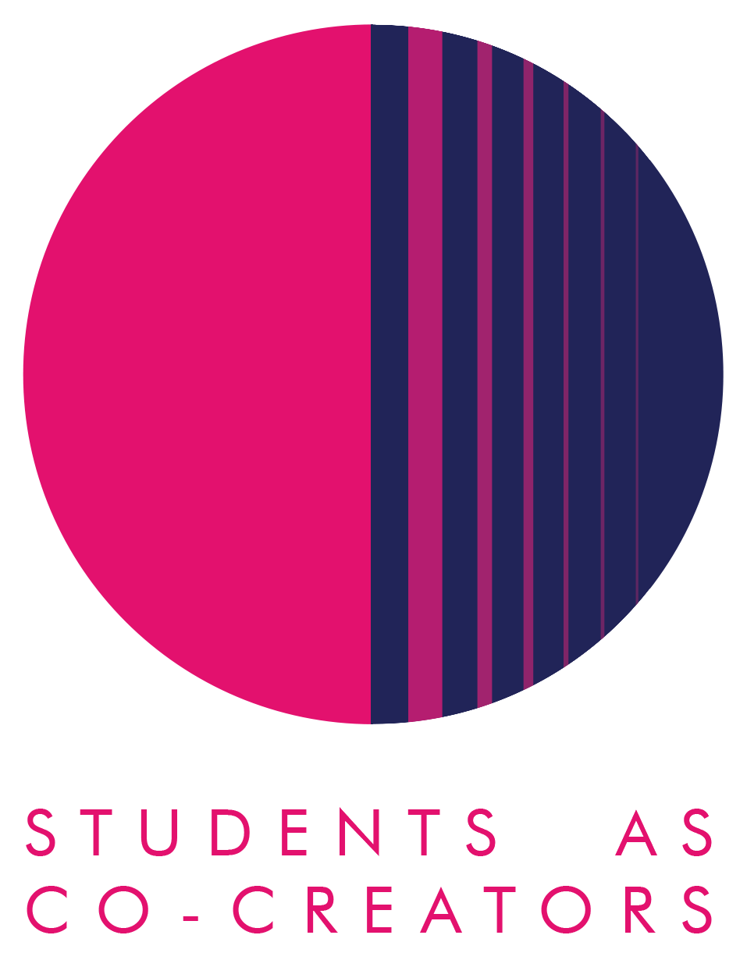

A Learning & Teaching Research Collaboration

Student perceptions of UDL effectiveness in enhancing learning and engagement at WBS

Student Partners:
Noor Ghumran
Marta Dermaku Hajdini
Pattarika Sae Wang
Alejandro Noriega

Academic Partner
Dr. Gustavo R. Espinoza-Ramos

School of Management and Marketing – WBS Academic Year 2024-2025

Table of Contents
Section 1. Executive Summary 3
Section 2. Background and Aims 4
Background 4
UDL 4
Research aims 4
Importance 4
Section 3. Methods 5
Section 4. Results 6
UDL Principle 1: Multiple means of representation 6
UDL Principle 2: Multiple means of action and expression 7
UDL Principle 3: Multiple means of engagement 9
Section 5. Discussion 11
UDL Principle 1: Multiple means of representation 11
UDL Principle 2: Multiple means of action and expression 11
UDL Principle 3: Multiple means of Engagement 11
Section 6. Conclusions and Recommendations 13
Conclusions 13
Recommendations 13
Section 7. Dissemination 14
Section 8. Reflection 15
References 16
Appendix 1 - Participant Information Sheet 19
Appendix 2 - Consent form 21

Table of tables

Table 4.1: Preferred learning tool in the classroom 6
Table 4.2: Way to express understanding of concepts 7
Table 4.3: Importance of motivational factors to engage in learning activities 9
Table 4.4: Importance of motivational factors to engage in assessment 9

Table of Figures

Figure 4.1: Preferred mode of learning in module design 7
Figure 4.2: Preferred summative assessment methods to express learning 8
Figure 4.3: Preferred summative assessment methods to express learning 8

A Learning & Teaching Research Collaboration

Section 1. Executive Summary

In recent years, Higher Education (HE) institutions have been increasingly challenged by declining student engagement and attendance, issues exacerbated by the COVID-19 pandemic. A 2022 survey highlighted that class attendance had dropped to just 25% (Grove, 2024), pushing institutions to reimagine course and assessment design. This research project, conducted at Westminster Business School (WBS), explores how the implementation of Universal Design for Learning (UDL) principles can enhance student learning experiences by accommodating diverse needs, increasing engagement, and supporting progression.

UDL, a framework developed to promote inclusive education, is built on three core principles: multiple means of representation, multiple means of action and expression, and multiple means of engagement. This study applied these principles to investigate students’ preferences in learning materials, assessment methods, and engagement strategies. Using a mixed-methods approach, including a 71-response survey and 11 semi-structured interviews, the study gathered both quantitative trends and in-depth qualitative insights into how students experience and value UDL-informed practices.

- Multiple means of representation, the findings revealed that students strongly prefer interactive, digital learning tools, such as short videos (22%), quizzes (17%), and collaborative productive tools (17%), which offer flexibility and accessibility. While on-campus learning remains the most popular mode (45%), students appreciate blended formats that allow for both in-person off-campus activities (18%) and online classes (12%).

- Multiple means of action and expression, regarding summative assessment, most students favoured individual written assignments (30%) but also valued presentations (19%) and posters (18%) that allowed diverse expression of understanding. The preference for individual work (59%) was primarily attributed to perceived fairness and control over outcomes, although students acknowledged the importance of group assessments, but they prefer that there is an individual grade (26%).

- Multiple means of engagement, students engage more in learning activities due to the lecturer’s support (63.9%) and approachability (59.7%). Meanwhile, student engagement in assessment is due to clear assessment criteria (70.8%) and the lecturer’s support (59.7%). While factors such as cultural exposure were rated lower in importance (30.6%), the research suggests this may reflect a gap in students’ awareness of its long-term professional benefits rather than a lack of value. The study highlights that motivation for assessment is closely tied to relevance, structure, and support.

Ultimately, the research underscores the potential of UDL to address declining student engagement by aligning educational practices with student preferences and learning variability. Recommendations include embedding blended learning strategies, diversifying assessment formats, and enhancing lecturer-student interactions. This work provides valuable insights for course designers and educators at Westminster Business School and beyond, with the potential to inform institutional strategies for inclusive, student-centred learning.

Section 2. Background and Aims

Background
Over the past decade, Higher Education (HE) institutions have been facing different challenges, including rising costs, changes in regulation, and mental health issues that have caused a decline in student enrolment and engagement. For example, a 2022 survey highlights a class attendance falling to 25% (Grove, 2024). For that reason, Higher education institutions have been facing increasing pressures to adopt strategies to improve course design to accommodate students' preferences, improve progression and therefore enhance the student learning experience (Calabrese et al., 2022).

UDL
Universal Design for Learning (UDL) is an educational framework that can support HE institutions to address these pressures. UDL has gained prominence since the 1990s, promoting inclusive, transformative learning for students of all abilities who will be able to engage in meaningful learning (CAST, 2023a). UDL views learners as unique individuals with diverse needs, challenging the notion that all students learn similarly, highlighting that education often targets an 'ideal' student profile (Cumming & Rose, 2022; Meyer et al., 2014). Consequently, it provides educators with a framework to differentiate teaching, addressing diverse learner needs (Kieran & Anderson, 2019). The UDL framework comprises three core principles, nine guidelines and 31 checkpoints that support the design of inclusive learning environments (Rao, 2021).

Multiple means of representation
- This principle focuses on developing course materials in various formats (visual, auditory and written), allowing learners to access, process, and understand content in different ways (CAST, 2023b). For instance, videos, audio recordings, text, graphs, and other multimedia options help students link new information to their prior knowledge; meanwhile, assistive technology helps in developing flexible and accessible learning materials.

Multiple means of action and expression
- This principle focuses on creating various methods for students to express their understanding and opinions about the learning material. This includes writing, speaking, social interactions, individual or group work, and the use of digital tools. Assessment methods can include interviews, podcasts, quizzes/tests, posters, graphs, presentations, and reports/essays (Al-Azawei et al., 2016).

Multiple means of engagement:
- This principle involves offering learning environments and activities that capture different student motivations and therefore enhance student engagement. Instructors can tailor learning to students’ interests, using real-world applications (Luke, 2021) and create interactive experiences. Additionally, this engagement can be fostered through social interactions with peers or self-reflection.

Research aims
This research explores students' preferences regarding applying Universal Design for Learning (UDL) principles at the Westminster Business School, focusing on their impact on learning material, activities, and assessment. This study seeks to assess UDL’s effectiveness in creating inclusive and transformative learning experiences that support diverse abilities and backgrounds, and ways that students can demonstrate knowledge.

Importance
Westminster Business School is developing different initiatives to improve student engagement, progression and outcomes. Therefore, the findings from this students-as-co-creators (SCC) project will guide educational leaders in the course/module design by identifying and evaluating different learning modes. Moreover, despite the extensive literature on UDL implementation, its practical application remains unclear (Smith et al., 2019), particularly in the business studies context. This SCC will expand the research on UDL implementation at the university level (Hills, Overend, & Hildebrandt, 2022) and understand students’ perspectives on UDL application in their courses and its impact on their learning (Kennette & Andrew Wilson, 2019a).

Section 3. Methods

This exploratory study employs a mixed-methods research design to complement the strengths of both qualitative and quantitative approaches when understanding students’ preferences in the application of UDL principles in modules at the Westminster Business School. By combining qualitative and quantitative approaches, this research offers a more comprehensive view of the phenomenon studied (Creswell, 2008). Quantitative data provides structured insight through statistics and numerical analysis (Malina et al., 2011), while qualitative data explores the social context, addressing the ‘why’ and ‘how’ of student behaviour (Berg & Lune, 2012). Therefore, employing both approaches strengthens the research outcomes (Nikolopoulou & Zacharis, 2023).

Ethical approval was granted by the CETI ethics committee (Application No. CETI-LTRC-2425-03, Class 1). Participants received an information sheet (Appendix 1) explaining their rights and the study’s aims. Data was collected voluntarily and anonymously, with signed consent forms (Appendix 2) confirming participants’ agreement and ensuring ethical compliance (Sieber & Tolich, 2013).

A quantitative approach was employed to identify patterns and trends about students' perceptions of effective learning environment, material and assessment design. This was conducted through a 33-question survey that was distributed via the University of Westminster student email list from 27 January to 21 March 2025. To encourage participation, students were entered into a draw to win one of three £15 Amazon vouchers. The survey was created in MS Forms as all data is stored securely in the Microsoft 365 cloud environment, which uses enterprise-level encryption, which prevents unauthorised access to participants' responses and therefore complies with data protection regulations.

The survey had four sections, the first one gathered socio-demographic information such as age and level of study; the next three sections focused on each UDL principle. The survey questionnaire included a combination of closed and open-ended questions, such as Likert scales, multiple-choice, and ranking items, to quantify respondents' preferences for module design. A total of 72 responses were received, but one response was duplicated. Therefore, 71 valid responses remained.

Qualitative research was carried out as it allows a deeper understanding of students' preferences for an effective learning environment, material and assessment design. This qualitative study was gathered through 30-minute semi-structured interviews carried out between March 3rd and May 1st, 2025. To encourage participation, interviewees were entered into a prize draw to win a £25 Amazon voucher, with four winners selected. All interviews were recorded and securely stored on Panopto, as it offers a secure and efficient platform for recording, storing, and encrypting interview recordings.

The semi-structured interviews had three sections based on each UDL principle: multiple means of representation, action and expression, and engagement. Open-ended questions were used to allow participants to express themselves freely without being limited by predefined options. Out of the 22 students who originally volunteered to be interviewed, only 11 interviews were carried out.

Key socio-demographic information from all 71 respondents of the survey questionnaire is: 81.7% (58) are undergraduate students and 18.3% (13) are postgraduates. Third-year undergraduates represented the largest group with 39.44% (28). Meanwhile, the distribution based on gender is: 64.79% (46) of respondents identify themselves as female and 35.21% (25) as male.

Section 4. Results

This section outlines some of the key findings, both qualitative and quantitative, derived from both the survey questionnaire and the early findings from the semi-structured interviews. Together, these results will provide a deeper understanding and analysis of students’ perspectives on UDL application within their courses, thus creating a more holistic view of the effectiveness of the UDL framework.

UDL Principle 1: Multiple means of representation
This principle refers to creating educational content in a variety of formats, allowing learners to access, process, and understand the material in ways that suit their individual needs (CAST, 2023b). For instance, incorporating visual, auditory, and textual elements can enhance the learning experience (Almumen, 2020)

Table 4.1: Preferred learning tool in the classroom

Preferred learning tool in the classroom | %
Short videos (YouTube, LinkedIn Learning videos, etc) | 22%
Hardcopy book / case study | 9%
Podcasts | 6%
Whiteboard / smartboard | 11%
Online whiteboard (e.g. padlet, miro, etc) | 9%
Flipchart paper / acrylic walls | 1%
Quizzes/polls (Kahoot, Poll Everywhere, etc) | 17%
Collaborative / shared productivity tools (e.g MS office 365 – Ms Word, excel, etc ) | 17%
Virtual / augmented reality | 7%
Other | 1%
TOTAL | 100%

Table 4.1 depicts the findings about students’ preferences on tools used during learning activities in the classroom. The students could select all the options applicable. The most preferred classroom learning tool are short videos (22%), followed closely by Quizzes/Polls and Collaborative/Share Productivity Tools (both at 17%). However, other tools such as podcasts, virtual/augmented reality and traditional tools such as books and whiteboards were not as popular. These preferences suggest although there are a wide range of learning tools, there is a higher preference towards digital, collaborative and interactive materials. This preference is due to the increased use of technological resources during COVID-19 in which students were able to navigate and enhance their digital skillset to improve learning (Pozo et al., 2024), causing a shift in students’ learning preferences towards digital technologies. Consequently, Higher Education is undergoing a significant digital transformation in both teaching and learning, driven by rapid technological advancements and evolving student expectations; more importantly, offering learning content in multiple formats ensures that each student can engage with learning material and tools according to their learning preferences.

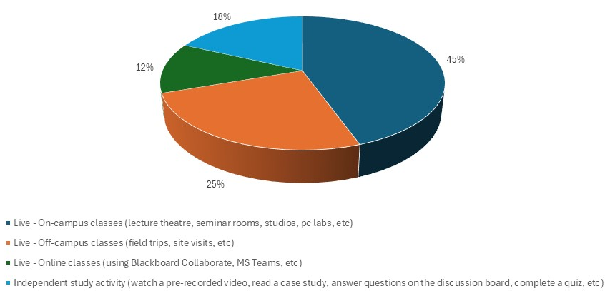

Figure 4.1: Preferred mode of learning in module design

In addition to the preferred learning tools used in the classroom, it is important to identify the students’ preferences in the learning environment. Figure 4.1 shows the preferred learning modes, highlighting live on-campus classes with 45% (69), followed by live off-campus classes with 25% (39). This is aligned with some comments in the semi-structured interviews and other studies that suggest students prefer in-person classes as they are more interactive, support peer engagement, enhance performance and their overall satisfaction with learning (Kortemeyer et al., 2023). Furthermore, online classes (12%) and independent studies (18%) were the least popular amongst students, a finding that is supported by other studies that suggest the lack of face-to-face interaction and inability to build interpersonal relationships with teachers and fellow students can reduce motivation and engagement (Chowkase et al., 2022). In addition, students may choose online classes or independent study when it is convenient for them if they are unable to attend classes in person (Christensen, 2021).

UDL Principle 2: Multiple means of action and expression
Students acknowledged the importance of incorporating traditional and non-traditional assessment methods, as this allows them to demonstrate knowledge according to their learning preferences. There are two different types of assessment methods, formative and summative. The former are not graded and are embedded within instructional activities on which students reflect on their understanding and improve continuously (Carless & Boud, 2018), and therefore, monitor their learning progress. The latter measures student achievement against learning outcomes, which are usually carried out at the end of the instructional period and are used for grading performance (JISC, 2020).

Table 4.2: Way to express understanding of concepts

Ways to express understanding of concepts in class | %
Writing | 20%
Reading | 16%
Watching / listening (videos / case study videos, podcast) | 22%
Verbally (team / plenary discussion and group presentation) | 16%
Verbally (Individual Presentation) | 9%
Practical experiences (field trips, exhibitions, simulation games) | 17%
TOTAL | 100%

Table 4.2 shows that students prefer a variety of formative assessment methods during lectures and seminars on which they can express understanding in different ways, among these, watching or listening to multimedia content (e.g., videos and podcasts) was identified by 22% of respondents (47) as the most effective method for demonstrating understanding of concepts; followed by writing methods with 20% (42), practical experiences such as field trips, exhibitions with 17% (37), reading with 16% (35) the same as verbal methods (team and individual presentation / discussion). This finding is aligned with a study involving nearly 200 undergraduates that point outs podcasts as the most effective revision tool than textbooks or even personal notes (Evans, 2008). It is important to note that students value the use of life experiences that can be used to reflect and demonstrate knowledge. Moreover, one of the interviewees also mentioned enjoying practical experiences, such as playing simulation games in one of their modules, as it provided hands-on learning and the opportunity to learn through trial and error.
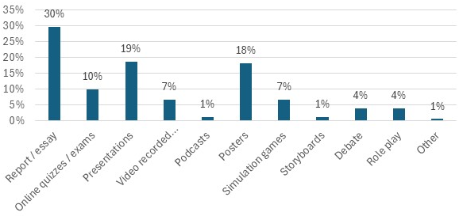

Figure 4.2: Preferred summative assessment methods to express learning

Figure 4.2 shows students’ preferences for summative assessment types. According to the survey, the three most popular types of assessment are report/essay with 30% (24), followed by live presentations with 19% (24) and posters with 18% (33). The preference for written assessments, such as essays and reports, is because it allows students to explore topics in depth, organise their ideas clearly, demonstrate critical thinking and express their own perspectives (Lincoln University, 2025). The two least favourite assessment methods were podcasts and storyboards, with 1% (2) each. This can be explained due to storyboard creation can be time-consuming and challenging for students who are unfamiliar with visual or creative tasks (University of Illinois Springfield, 2025).
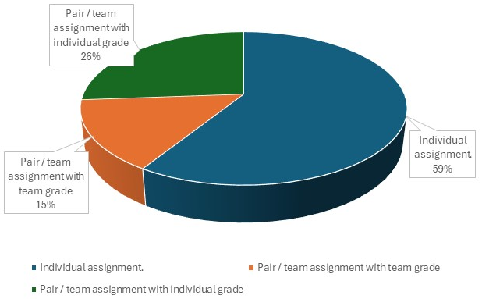

Figure 4.3: Preferred summative assessment methods to express learning

The preferred summative assessment types can be classified according to two distinctive modes: individual and team (group-based), which are associated with individual and shared grades, respectively. While individual assessments remain the dominant mode, team-based assessments are increasingly valued for their ability to foster employability skills (Allen et al., 2024). The survey indicates that individual assessment was the most preferred method for expressing learning, with 59% (63), a finding that is supported by the interviews’ responses and other studies. For example, students favour individual assignments because they allow them to work at their own pace, and it is fair as it rewards their own effort (Zheng, 2022). Nevertheless, some students prefer group work because it fosters the development of valuable employability skills such as teamwork, communication, and problem-solving (Carnegie Mellon University, 2025).

UDL Principle 3: Multiple means of engagement
This principle refers to providing students with varied ways to motivate, challenge, and sustain their interest in learning. For example, some students thrive with choice and autonomy, others need clear structure, while some may require emotional safety or peer collaboration to stay focused.

Table 4.3: Importance of motivational factors to engage in learning activities

Motivational factors to engage with learning activities | Very Important | Fairly Important | Important | Slightly Important | Not important
Level of difficulty in completing the module | 31.9% | 34.7% | 29.2% | 1.4% | 2.8%
Lecturer's preparation and approachability | 59.7% | 26.4% | 12.5% | 1.4%
Sense of community | 27.8% | 34.7% | 26.4% | 11.1%
Interactive learning material | 50.0% | 29.2% | 18.1% | 1.4% | 1.3%
Connecting to real-life contexts and applications | 48.6% | 34.7% | 13.9% | 2.8%
Support provided by the lecturers | 63.9% | 23.6% | 12.5%
Exposure to other perspectives and cultures | 34.7% | 34.7% | 26.4% | 4.2%
Enhance career prospects | 58.3% | 20.8% | 18.1% | 2.8%

The student motivation varies when engaging in learning activities and when completing summative assessments. In Table 4.3, students were asked to rank, based on importance, the factors that motivate engagement in learning activities. The top three factors included support provided by lectures at 63.9%, lecture preparation and approachability at 59.7% and lastly, enhancing career prospects at 58.3%. These results can be supported by previous studies. For example, lectures’ preparation and approachability can help make students feel that they are in a safe and friendly environment, which enhances engagement and assessment completion (Karnita et al., 2017). In addition, according to Otte (2025), the current job market is extremely competitive, and for that reason, highly trained graduates struggle to find well-paid work. Therefore, tailoring learning activities to enhance career prospects is highly desirable. ‘Interactive learning material’ was the fourth most important factor in the questionnaire, with 50%. The interviewees provided some examples of interactive activities during lectures and seminars that enhance student engagement. For example, providing exercises such as quizzes and poll tools, which not only test the students’ understanding but also ensure they stay on track (University of Oxford, 2024).

Table 4.4: Importance of motivational factors to engage in assessment

Motivational factors to engage with assessment |  | Very Important | Fairly Important | Important | Slightly Important |  | Not important
Level of difficulty in completing the assessment | 36.1% |  | 30.6% | 27.8% | 2.8% | 2.7%
Connecting to real-life contexts and applications | 40.3% |  | 38.9% | 20.8%
Support provided by the lecturers | 59.7% |  | 23.6% | 16.7%
Clear assessment criteria | 70.8% |  | 18.1% | 11.1%
Opportunities for creativity and self-expression | 40.3% |  | 40.3% | 16.7% | 2.7%
Exposure to other perspectives and cultures | 30.6% |  | 31.9% | 27.9% | 8.4% | 1.2%
Flexibility in deadlines or submission formats | 52.8% |  | 29.2% | 11.1% | 2.8% | 4.1%
Enhance career prospects | 48.6% |  | 36.1% | 12.5% | 1.4% | 1.4%

The student motivational factors when completing the summative assessment are seen in Table 4.4. The highest-rated factor deemed ‘very important’ was ‘clear assessment criteria’, with 70.8% as students can enhance their performance in assessments due to the clear expectations and guidance of the effective application of knowledge (Watson, 2024). The second highest motivational factor is the ‘support provided by lecturers’ at 59.7%, which has similar importance for students when engaging in learning activities. Moreover, Chen, Bian and Zhu (2023) argue that lecturers’ support in learning activities and when giving feedback to students will motivate the latter to engage and perform better in assessments. The third highest motivational factor is the ‘flexibility in deadlines or submission formats’. Having more flexibility in submission formats can help students be more creative, demonstrate their strengths and develop agency, skills that are necessary in their professional careers (Irwin & Hepplestone, 2012). However, despite students wanting more flexibility in assessment deadlines, most students allow over 90% of the opportunity window to elapse before completing an assignment; therefore, it is still questionable how effective providing a flexible deadline is (Conner, 2024).

One of the factors that scored the least important is ‘exposure to other perspectives and cultures’. This is because students mainly focus on what will help them succeed academically; therefore, unless there is a specific value of different perspectives and cultures needed for an assessment, students will not see its importance. This finding contradicts some studies that point out that assessments connected with students' cultural backgrounds foster motivation and deeper engagement, rather than causing disinterest (Anyichie & Butler, 2023).

Section 5. Discussion

UDL Principle 1: Multiple means of representation
In this study, the application of the UDL principle of multiple means of representation focused on the students’ preferences about a range of teaching modes and different formats of learning material. Through primary data gathered in this research project, WBS students prefer various modes of learning that include on-campus, off-campus, online classes and independent study. There is a high preference for on-campus classes (45%) as students appreciate the social interaction with peers and lecturers. More importantly, on-campus classes enhance students’ engagement, comprehension, and communication (Photopoulos et al., 2023). In addition, it is important to develop blended learning modules as they will enhance the students’ learning experience. For example, a well-designed blended learning strategy can improve module retention and coursework completion (Hughes, 2007).

In addition, this UDL principle is applied when offering content in varied formats as it accommodates different learner needs, both inside and outside of the classroom. Thus, highlighting that one single teaching mode and format of learning material will only be satisfactory for certain learners but not all, meaning that flexibility is necessary (Hall et al., 2004). Moreover, research has found that by providing students with different forms of content, they were able to enhance their engagement, critical thinking skills, deeper understanding of their learning, and motivation to succeed in their studies (Kennette & Andrew Wilson, 2019b).

Furthermore, the use of digital technology can significantly improve the development of learning material content by making it more accessible and inclusive for students with disabilities and different learning preferences (Fernández-Batanero et al., 2022). Some examples of Assistive Technologies (AT) include screen readers, speech-to-text apps, transcripts and text-to-speech (TTS) tools. Moreover, students can share and exchange notes created on their laptops, and customise their learning material (Baroni & Lazzari, 2022).

UDL Principle 2: Multiple means of action and expression
The UDL principle of multiple means of action and expression advocates for students to demonstrate their knowledge that is aligned with their individual strengths (Biggs & Tang, 2011). Our findings suggest that many students show a slight preference for written assignments (30%). But something to evaluate is whether technological advancements, particularly AI tools, contribute to these preferences. AI-assisted writing tools enable students to produce essays more efficiently by helping generate ideas, summarise information, and structure arguments effectively (Black & Tomlinson, 2025). If used ethically, AI can reduce the time and cognitive load associated with essay writing, making this form of assessment more accessible and appealing.

The second most preferred assessment type was presentations. Although there were two different results: live presentations (19%) and video-recorded presentations (7%). Research suggests that the former helps students enhance communication, critical thinking, and confidence, which are useful for both academic success and future careers (Murray, 2024). By combining both types of presentations, universities can help students develop a variety of key skills while meeting different learning needs.

In addition to the different assessment methods, it is important to evaluate the two distinctive modes: individual and team assessment. Our results indicate a significant inclination towards individual assignments (59%), yet teamworking skills remain a crucial skill demanded by employers. Universities could address this tension by encouraging collaborative activities within assessments, assigning clear roles in group projects to ensure accountability and reduce “free rider” issues, which are common reasons students prefer individual work (Yadin, 2014).

Regardless of the assessment type and mode, working with real companies provides business students with hands-on experience that bridges theoretical knowledge and professional practice. Such real-world engagement promotes critical thinking, teamwork, and adaptability, competencies that are highly valued by employers but may be underdeveloped when assessments focus solely on individual work.

UDL Principle 3: Multiple means of Engagement
The UDL principle of multiple means of engagement focuses on developing ways to stimulate student interest and motivation in the learning process. For that reason, this section focuses on the analysis of the students’ motivational factors in the learning activities and assessment.

Regarding student motivation in learning activities, providing only a lecture format may negatively affect learners’ engagement, and thus, other strategies may be used to help sustain students’ motivation, such as open discussions and peer-tutoring (Al-Azawei et al., 2016). Throughout our interviews, we have found that business students seem to be more motivated by the level of support provided by lectures and the development of employability skills. In contrast, factors such as a sense of community and exposure to other perspectives and cultures were perceived as not important. This is because many students enrol in university primarily to enhance their career prospects; therefore, they are often more motivated to engage in learning activities that directly contribute to their employability rather than those that foster a sense of community (Tomlinson, 2017).

Regarding student motivation in assessment, students are more motivated to engage with assessments when there is more guidance provided by their lecturers. This support enhances students' confidence when completing assessments, as students will believe they can succeed and therefore are motivated to engage in assessments (De Hollander et al., 2018).

The UDL literature instils community and cultural understanding as essential elements as part of multiple means of engagement (Meyer et al., 2014). The results from our research imply that students who are more concerned with career success might not instantly value such aspects. This, in turn, may indicate a lack of understanding among students regarding the long-term worth of cultural awareness, but it does not necessarily mean that they are unimportant. If students keep neglecting these abilities, it could put them at risk for lacking intercultural awareness in the future, as it is becoming more and more important in globalised companies (Deardorff, 2006). Therefore, it is important that if universities want to make sure their students come out with exposure to other perspectives and cultures, they find a way to incorporate such views through engaging learning activities and in assessments.

Section 6. Conclusions and Recommendations

Conclusions
This research highlights the relevance and growing need for the practical implementation of Universal Design for Learning (UDL) principles in higher education (HE), particularly in business studies. Faced with declining attendance and engagement, HE institutions should rethink how courses are designed to meet evolving student needs. Our findings at Westminster Business School confirm that students value inclusive, flexible, and engaging learning environments shaped by UDL’s three core principles: multiple means of representation, action and expression, and engagement.

Students preferred on-campus learning supported by digital and interactive tools, such as short videos, quizzes, and collaborative platforms. They also expressed a strong desire for varied assessment types, with a slight preference for written formats, while also appreciating practical experiences and presentations that cater to different learning preferences. Importantly, students were more motivated to engage in assessments when provided with clear criteria, timely support from lecturers, and connections to real-world applications. Engagement was further enhanced by structured, interactive sessions and activities linked to career development, indicating a pragmatic focus among students on employability and academic support.

However, the data also revealed limited perceived value in cultural or community-based engagement, suggesting a gap in student understanding of intercultural competencies, which are increasingly vital in globalised workplaces.

Recommendations
By adopting the following recommendations, HE institutions can build more inclusive, engaging, and future-ready learning environments that reflect students’ preferences and prepare them for academic and professional success.

- Diversify learning materials: Embed multimedia resources and digital tools to support multiple learning preferences. This includes visual, auditory, and text-based formats, as well as the use of assistive technologies to make more accessible learning material.

- Blend delivery modes: Prioritise blended learning formats that combine in-person teaching (on-campus and off-campus) with flexible online components, ensuring accessibility without sacrificing student interaction.

- Broaden assessment methods: Incorporate a balanced mix of individual and group assessments. Offer alternative assessment formats like presentations, posters, and practical experiences to support student strengths and develop a broader skill set.

- Enhance lecturer support: Invest in staff development to ensure lecturers are approachable, responsive, and equipped to deliver clear assessment guidance and inclusive teaching practices.

- Align learning with career outcomes: Integrate employability-focused content and real-world case studies to enhance relevance and motivation.

- Promote cultural awareness: Design activities and assessments that embed intercultural perspectives and encourage students to value diverse viewpoints.

Section 7. Dissemination

We hope to maximise the impact of our research and foster improvements in the application of Universal Design for Learning (UDL) principles in course and module design at the Westminster Business School to improve student engagement and progression. For that reason, we will disseminate the findings of this in the following practical and impactful methods:

We will communicate the project’s results to different stakeholders, including the University of Westminster’s Students as Co-Creators team, course / module leaders and the Director of Teaching and Learning. We also plan to write a blog that serves as a guide for the application of UDL principles that can be posted on the CETI website or well-known platforms like SEDA, WonkHe, or Times Higher Education. Additionally, share our findings using our social media platforms, such as LinkedIn, to research educators and academic experts.

In the medium term, we will collaborate with CETI to give a webinar to our UoW academics to showcase the findings about UDL practices in module design. In addition, we would like to record this webinar and share it on our social media platforms, including X, LinkedIn and YouTube, in order to reach a wider audience and have indicators of its impact (number of views and downloads).

Since our research project included conducting semi-structured interviews and a survey questionnaire, our long-term goal is to publish an academic paper to showcase the research findings regarding UDL application in business studies. The article may appear in journals like SEDA - Educational Developments and the International Journal for Students as Partners.

Section 8. Reflection

This section presents the reflection of three out of four student partners and their experience in the research process. There is a common trend in the challenges that they face when arranging and carrying out the interviews. This experience helped them to build resilience that can be applied in other projects and contexts.

Pattarika
Through this UDL research and process, I have learned that different students have varied learning preferences. I understand that it is difficult for universities to fully accommodate every student’s unique needs. However, I believe it is important for universities to prioritise the preferences of the majority while still incorporating a mix of other learning styles to create a balanced and inclusive learning environment. One key recommendation I would make is for universities to regularly conduct surveys to stay updated on students’ preferences, as these can change over time. This will help ensure that teaching methods and assessment styles remain relevant and effective.

One positive experience I had during this process was discovering that 45% of students still prefer on-campus classes over online ones. This finding resonated with me personally, as I also find that learning face-to-face helps me concentrate better and engage more actively with lecturers and classmates.

However, there were also some challenges during the research process. One of the biggest difficulties I faced was finding enough people willing to be interviewed. Many students declined to participate due to personal reasons, which limited the number of interviewees. Despite this, I managed to conduct enough interviews to gather meaningful data.
In the future, I suggest that universities use these findings to develop more flexible learning options that adapt to changing student needs by combining online and in-person elements, thereby improving both engagement and accessibility.

Noor
Being part of this research project has taught me that there is so much more to consider when teaching and learning in higher education. By understanding UDL principles and what it means to integrate this in teaching practices, universities can then create an inclusive and accessible environment for their students. I truly enjoyed conducting interviews, during which I was able to collect qualitative data by directly talking to participants. I was able to gain valuable insights into individual experiences and how varying learning needs must be catered for by educators. There needs to be a shift from traditional learning methods, instead promoting flexibility to empower students and support their strengths.

Part of this process involved finding participants for the interviews; however, some participants were unfamiliar with UDL and its principles, which proved to be a challenge. In order to gain meaningful insights, I made sure to explain and clarify any questions, ensuring that I avoided suggestions that could have biased their response. Despite these challenges, the data collected shows the potential of UDL implementation and how it can transform higher education institutions in their approach to better supporting students. Going forward, I believe that this research can be used to train university staff to not only create awareness but so that they can foster a diverse and collaborative environment within their classrooms, thus enhancing students’ motivation and engagement.

Marta
Being able to participate in the UDL research project has been very fulfilling. One of my main roles was to help conduct interviews with students, which provided me with a chance to hear a variety of viewpoints regarding multiple means of representation, action and expressions and engagement. By listening to different students speak about their viewpoints, I became aware of how varied learning approaches are when it comes to what inspires students to pursue their education. Some shared personal stress about what inspired them, which made me realise how important it is to create different learning environments that can support different motivations and strengths.

One challenge I had during the research process was finding students who would be willing to engage in interviews. Although it was difficult at first, those who did agree to share their experiences were enthusiastic enough to help make the process continue smoothly. This allowed me to better understand each individual's perspective on learning approaches, which ultimately strengthened the depth and quality of our analysis.

In the future, I believe interviews like these are essential for universities. By listening to students directly, universities can build a more welcoming and encouraging culture for students by understanding what works and what does not. This would then help students develop and succeed throughout their academic journeys through a more tailored support system formulated by the university.

References

Al-Azawei, A., Serenelli, F., & Lundqvist, K. (2016). Universal Design for Learning (UDL): A Content Analysis of Peer Reviewed Journals from 2012 to 2015. Journal of the Scholarship of Teaching and Learning, 16(3), 39–56. https://doi.org/10.14434/josotl.v16i3.19295
Allen, L., Warburton, A., & Adeoye, J. M. (2024). Exploring staff and student experiences of group-work assessment in higher education. Developing Academic Practice, 2024(10), 1–16. https://doi.org/10.3828/dap.2024.17
Almumen, H. A. (2020). Universal Design for Learning (UDL) Across Cultures: The Application of UDL in Kuwaiti Inclusive Classrooms. SAGE Open, 10(4), 1–14. https://doi.org/10.1177/2158244020969674
Anyichie, A. C., & Butler, D. L. (2023). Examining culturally diverse learners’ motivation and engagement processes as situated in the context of a complex task. Frontiers in Education, 8, 1–17. https://doi.org/10.3389/feduc.2023.1041946
Baroni, F., & Lazzari, M. (2022). Universal Design for Learning at University: Technologies, Blended Learning and Teaching Methods. Studies in Health Technology and Informatics, 297, 541–548. https://doi.org/10.3233/SHTI220885
Berg, B. L., & Lune, H. (2012). Qualitative research methods for the social sciences (8th ed.). Pearson Education Inc.
Biggs, J. B., & Tang, C. S. (2011). Teaching for quality learning at university what the student does (4th ed.). Open University Press.
Black, R. W., & Tomlinson, B. (2025). University students describe how they adopt AI for writing and research in a general education course. In Scientific Reports (Vol. 15, Issue 1). Nature Research. https://doi.org/10.1038/s41598-025-92937-2
Calabrese, G., Leadbitter, D. L. M., Trindade, N. D. S. M. Da, Jeyabalan, A., Dolton, D., & ElShaer, A. (2022). Personal Tutoring Scheme: Expectations, Perceptions and Factors Affecting Students’ Engagement. Frontiers in Education, 6. https://doi.org/10.3389/feduc.2021.727410
Carless, D., & Boud, D. (2018). The development of student feedback literacy: enabling uptake of feedback. Assessment and Evaluation in Higher Education, 43(8), 1315–1325. https://doi.org/10.1080/02602938.2018.1463354
Carnegie Mellon University. (2025). What are the benefits of group work? Eberly Center. https://www.cmu.edu/teaching/designteach/teach/instructionalstrategies/groupprojects/benefits.html
CAST. (2023a). Frequently Asked Questions. https://udlguidelines.cast.org/more/frequently-asked-questions#goal
CAST. (2023b). Provide multiple means of Representation. https://udlguidelines.cast.org/representation/?utm_source=castsite&utm_medium=web&utm_campaign=none&utm_content=aboutudl&_gl=1*3gn5rj*_ga*NDkzOTk0NzgzLjE3MDE3ODE3MTg.*_ga_C7LXP5M74W*MTcwMjg0MTA3Ni4xMy4xLjE3MDI4NDE2OTMuMC4wLjA.
Chen, C., Bian, F., & Zhu, Y. (2023). The relationship between social support and academic engagement among university students: the chain mediating effects of life satisfaction and academic motivation. BMC Public Health, 23(1). https://doi.org/10.1186/s12889-023-17301-3
Chowkase, A. A., Datar, K., Deshpande, A., Khasnis, S., Keskar, A., & Godbole, S. (2022). Online learning, classroom quality, and student motivation: Perspectives from students, teachers, parents, and program staff. Gifted Education International, 38(1), 74–94. https://doi.org/10.1177/02614294211060401
Christensen, J. M. (2021). Student Preferences and Decisions for Online or In-Person Class Sessions in Blended Learning [Brigham Young University]. https://scholarsarchive.byu.edu/etd
Conner, S. (2024). How students leverage assignment submission flexibility: A case study. Heliyon, 10(21). https://doi.org/10.1016/j.heliyon.2024.e39937
Creswell, J. W. (2008). Research Design: Qualitative, Quantitative, and Mixed Methods Approaches (3rd ed.). SAGE Publication.
Cumming, T. M., & Rose, M. C. (2022). Exploring universal design for learning as an accessibility tool in higher education: a review of the current literature. Australian Educational Researcher, 49(5), 1025–1043. https://doi.org/10.1007/s13384-021-00471-7
De Hollander, C., McGuckin, T., Sinclair, K., Barnett, F., & Sealey, R. (2018). Front loading the curriculum: early placement experiences enhance career awareness and motivation. Student Success, 9(2), 39–47. https://doi.org/10.5204/ssj.v9i2.419
Deardorff, D. K. (2006). Identification and assessment of intercultural competence as a student outcome of internationalization. Journal of Studies in International Education, 10(3), 241–266. https://doi.org/10.1177/1028315306287002
Evans, C. (2008). The effectiveness of m-learning in the form of podcast revision lectures in higher education. Computers and Education, 50(2), 491–498. https://doi.org/10.1016/j.compedu.2007.09.016
Fernández-Batanero, J. M., Montenegro-Rueda, M., Fernández-Cerero, J., & García-Martínez, I. (2022). Assistive technology for the inclusion of students with disabilities: a systematic review. Educational Technology Research and Development, 70(5), 1911–1930. https://doi.org/10.1007/s11423-022-10127-7
Grove, J. (2024, March 14). Lectures in question as paid work pushes attendance even lower. Times Higher Education. https://www.timeshighereducation.com/news/lectures-question-paid-work-pushes-attendance-even-lower
Hall, T., Vue, G., Strangman, N., & Meyer, A. (2004). Differentiated Instruction and Implications for UDL Implementation. http://aem.cast.org/about/publications/2003/ncac-differentiated-instruction-udl.html
Hills, M., Overend, A., & Hildebrandt, S. (2022). Faculty Perspectives on UDL: Exploring Bridges and Barriers for Broader Adoption in Higher Education. The Canadian Journal for the Scholarship of Teaching and Learning, 13(1). https://doi.org/10.5206/cjsotlrcacea.2022.1.13588
Irwin, B., & Hepplestone, S. (2012). Examining increased flexibility in assessment formats. Assessment and Evaluation in Higher Education, 37(7), 773–785. https://doi.org/10.1080/02602938.2011.573842
JISC. (2020). The future of assessment: five principles, five targets for 2025. https://repository.jisc.ac.uk/7733/1/the-future-of-assessment-report.pdf
Karnita, R., Woodcock, A., Bell, S., & Super, K. (2017). Approachability as a Prerequisite of Student Reflection. Advances in Human Factors, Business Management, Training and Education, 498, 493–502. https://doi.org/10.1007/978-3-319-42070-7_45
Kennette, L. N., & Andrew Wilson, N. (2019a). Universal Design for Learning (UDL): Student and Faculty Perceptions. Journal of Effective Teaching in Higher Education, 2(1), 1–26.
Kennette, L. N., & Andrew Wilson, N. (2019b). Universal Design for Learning (UDL): Student and Faculty Perceptions. Journal of Effective Teaching in Higher Education, 1(2). https://doi.org/https://doi.org/10.36021/jethe.v2i1.17.g7
Kieran, L., & Anderson, C. (2019). Connecting Universal Design for Learning With Culturally Responsive Teaching. Education and Urban Society, 51(9), 1202–1216. https://doi.org/10.1177/0013124518785012
Kortemeyer, G., Dittmann-Domenichini, N., Schlienger, C., Spilling, E., Yaroshchuk, A., & Dissertori, G. (2023). Attending lectures in person, hybrid or online—how do students choose, and what about the outcome? International Journal of Educational Technology in Higher Education, 20(19), 1–24. https://doi.org/10.1186/s41239-023-00387-5
Lincoln University. (2025). Essays, reports and more. https://ltl.lincoln.ac.nz/learning-and-research-skills/writing-and-referencing/types-of-assessments/
Luke, K. (2021). Twelve tips for designing an inclusive curriculum in medical education using Universal Design for Learning (UDL) principles. MedEdPublish, 10(1). https://doi.org/10.15694/mep.2021.000118.1
Malina, M. A., Nrreklit, H. S. O., & Selto, F. H. (2011). Lessons learned: Advantages and disadvantages of mixed method research. Qualitative Research in Accounting and Management, 8(1), 59–71. https://doi.org/10.1108/11766091111124702
Meyer, A., Rose, D. H., & Gordon, D. (2014). Universal design for learning: Theory and Practice (1st ed.). CAST Professional Publishing.
Murray, T. (2024, March 18). Importance of Presentations in Academia. Enago Academy. https://www.enago.com/academy/guestposts/tatianamurray/importance-of-presentations-in-academia/
Nikolopoulou, K., & Zacharis, G. (2023). Blended Learning in a Higher Education Context: Exploring University Students’ Learning Behavior. Education Sciences, 13(5). https://doi.org/10.3390/educsci13050514
Otte, J. (2025, February 10). ‘It’s nightmarish’: why 1.5m Britons are still hunting for a job. The Guardian. https://www.theguardian.com/money/2025/feb/10/britons-hunting-for-a-job-uk-jobseekers-pay
Photopoulos, P., Tsonos, C., Stavrakas, I., & Triantis, D. (2023). Remote and In-Person Learning: Utility Versus Social Experience. SN Computer Science, 4(2). https://doi.org/10.1007/s42979-022-01539-6
Pozo, J. I., Cabellos, B., & del Puy Pérez Echeverría, M. (2024). Has the educational use of digital technologies changed after the pandemic? A longitudinal study. PLoS ONE, 19(12). https://doi.org/10.1371/journal.pone.0311695
Rao, K. (2021). Inclusive Instructional Design: Applying UDL to Online Learning. The Journal of Applied Instructional Design, 10(1), 1–10. https://doi.org/10.59668/223.3753
Sieber, J., & Tolich, M. (2013). Planning Ethically Responsible Research. In Planning Ethically Responsible Research. SAGE Publications, Inc. https://doi.org/10.4135/9781506335162
Smith, S. J., Rao, K., Lowrey, K. A., Gardner, J. E., Moore, E., Coy, K., Marino, M., & Wojcik, B. (2019). Recommendations for a National Research Agenda in UDL: Outcomes From the UDL-IRN Preconference on Research. Journal of Disability Policy Studies, 30(3), 174–185. https://doi.org/10.1177/1044207319826219
Tomlinson, M. (2017). Forms of graduate capital and their relationship to graduate employability. Education and Training, 59(4), 338–352. https://doi.org/10.1108/ET-05-2016-0090
University of Illinois Springfield. (2025). Why Use Storyboards. https://www.uis.edu/ion/resources/tutorials/instructional-design/why-storyboards
University of Oxford. (2024). Making lectures inclusive. Centre for Teaching and Learning. https://www.ctl.ox.ac.uk/inclusive-lectures
Watson, S. (2024, October 16). Clarifying assessment expectations for inclusivity. University of Essex. https://blogs.sussex.ac.uk/learning-matters/2024/10/16/clarifying-assessment-expectations-for-inclusivity/
Yadin, A. (2014, April). Individualted assignments for imposing better learning habits. The 10th International Scientific Conference Elearning and Software for Education.
Zheng, Y. F. (2022, November 11). I’m a Student. Here’s Why Group Work Feels So Unfair. Education Week. https://www.edweek.org/teaching-learning/opinion-im-a-student-heres-why-group-work-feels-so-unfair/2022/11

Appendix 1 - Participant Information Sheet

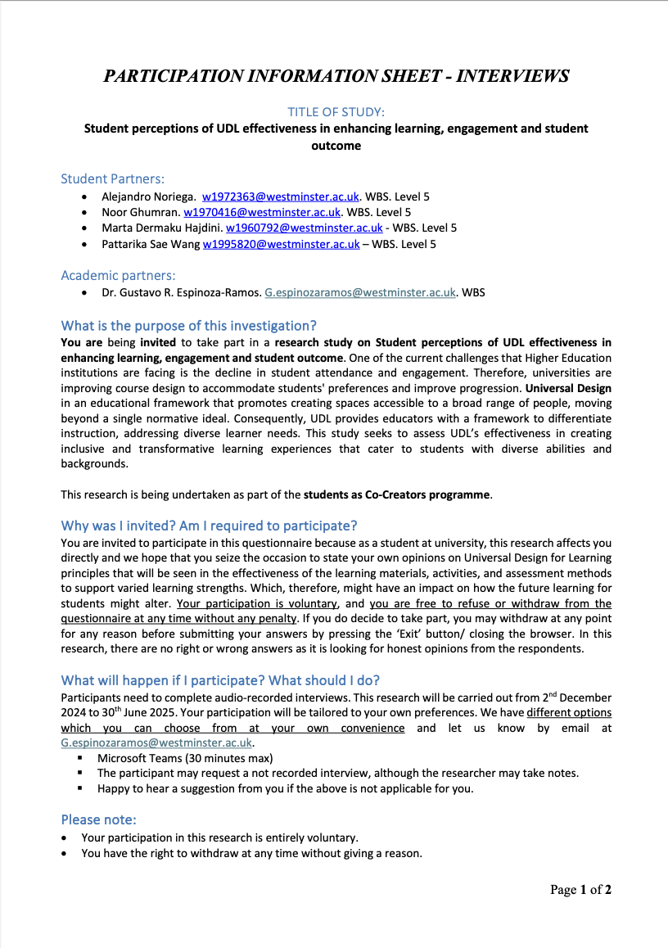

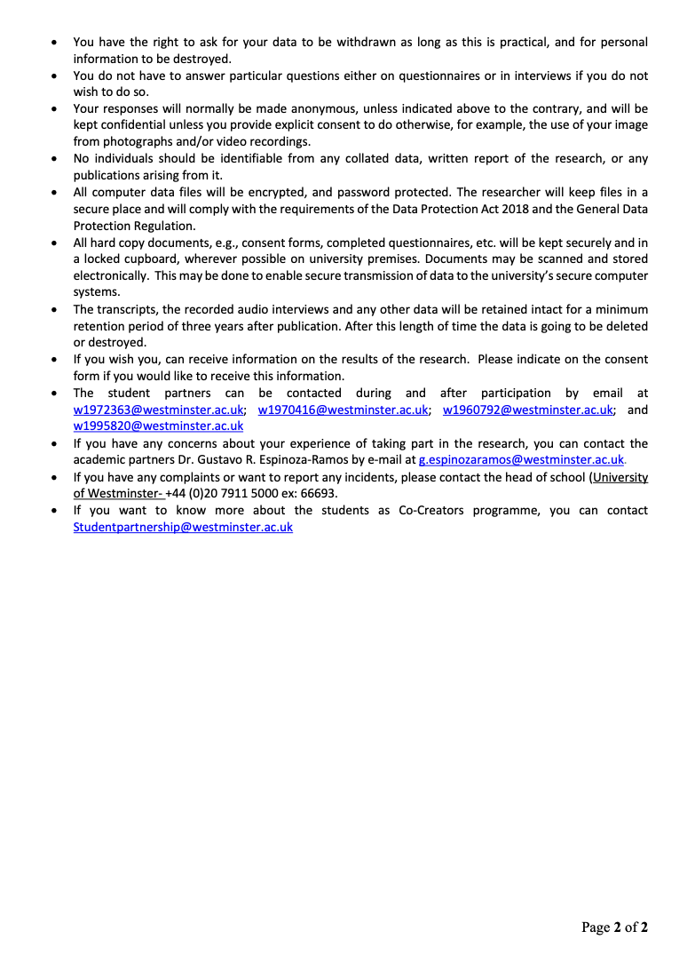

Appendix 2 - Consent form

