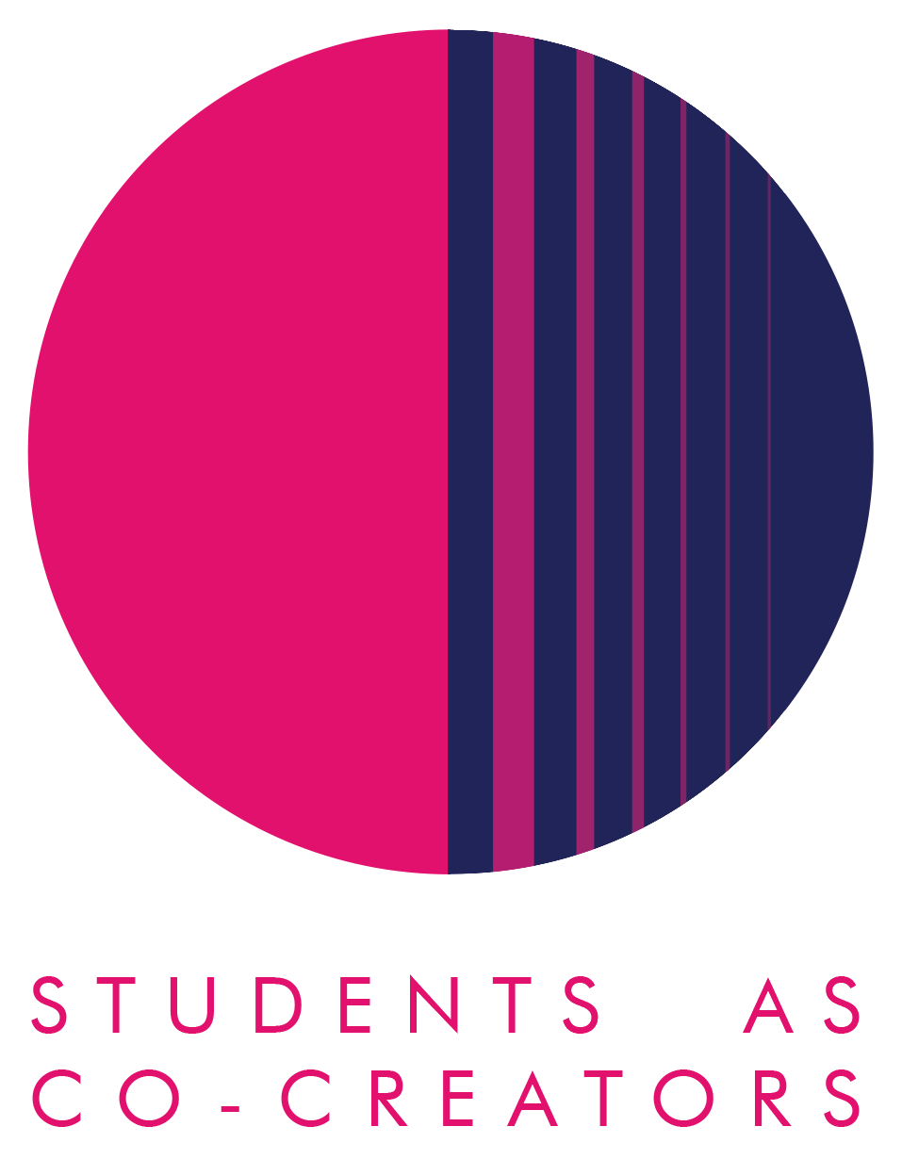

A Curriculum Design Collaboration

5 Minute Methods

Mariia Horobets (BA Digital Media and Communication), Jack Let (BA Digital Media, Public Relations and Advertising), Millie Thomson (BA Digital Media Production)

Dr Efthimia Bilissi, Dr Carl W. Jones

Westminster School of Media and Communication

Academic Year 2025-2026

Students as Co-Creators Evaluation Report – 5 Minute Methods

Introduction

The ‘5-minute Methods’ project was co-created with three third-year BA Digital Media students. The grant from the ‘Students as Co-Creators’ extended the list of research methods videos available to students via an existing YouTube Channel, building on an earlier Students as Co-Creators project.
Two new research methods videos were co-created, adding the ‘Online Surveys’ and ‘Semiotics’ methods to content provided on the existing YouTube channel “5 Minute Methods” (https://www.youtube.com/@5minutemethods203). The project involved content creation from script development on the chosen research methods to video production. This aligned with the skills students develop throughout their BA Digital Media courses. The design of the project focused on developing short, student-friendly resources on ‘online surveys’ and ‘semiotics’. These videos are provided as resources to support dissertation and final year project modules in the School of Media and Communication UG programme.

Where did the inspiration to do the project come from?

The inspiration came from previous Students as Co-Creators projects in 2020/21, where students produced five-minute videos explaining different research methods used in media & communication studies that could be applied to their final dissertations and other final-year projects, forming the original “5 Minute Methods” channel. Feedback from students and staff indicated that these focussed 5 minutes videos made research methods more accessible and engaging, especially for dissertation and individual practice project work.
Both Dr Efthimia Bilissi and Dr Carl W. Jones recognised that the curriculum would benefit from a wider range of methods presented in this format, especially those methods used in the study of media and communication, such as online surveys and semiotics. The Students as Co-Creators programme offered a structured way to work in partnership with students to expand and update these useful resources. Also preparing final-year students for jobs such as research and content production in digital media.

What did you set out to achieve?

Our project was aligned with the University of Westminster’s Education Strategy for authentic and transformative education. Research suggests that working in partnership benefits both staff and students by enhancing awareness, motivation and learning, and improving teaching and classroom experiences (Cook-Sather, 2014).
We aimed to co-create two additional five-minute research methods videos to extend the range and quality of the 5 Minute Methods channel created in 2021. Specifically, the objectives were to:
- Develop clear, concise video explanations of online survey and semiotic analysis as research methods, including definitions, strengths/limitations and practical tips for student projects.

- Give participating students structured opportunities to deepen their understanding of research methods while building transferable skills in scripting, presenting, filming and editing. Transferable skills acquired during student partnership projects benefit students beyond the completion of their studies (Carle et al., 2021). Basically, giving students the opportunity to apply what they had learned throughout their 3 years in Digital Media BA into practice and develop their portfolio offerings.

- Embed student‑generated resources directly into dissertation and project modules, so future cohorts can learn research methods through the perspectives and language of peers guided by staff.

Overall, the project set out to enhance the research methods curriculum through co‑created digital artefacts that are reusable across modules and cohorts, along with allowing the students to put theory into practice.

How did students and staff work together on this project?

The project team involved three final-year student partners from the BA Digital Media and Communication, BA Digital Media, Public Relations and Advertising, and BA Digital Media Production courses, and two academic partners.
The work was organised during on-campus meetings, where ideas and progress were discussed and planned in stages. Flexibility in planning work around course commitments and availability was part of our team’s discussions and decisions during meetings, as research has shown that time can be a barrier to student partnership projects. This is because students have to juggle these projects alongside their work for their courses (Carle et al. 2021).
Students and staff collaborated across distinct but overlapping roles: research; scripting; presentation; copyright (visual & music); and production (filming, editing, broadcasting). Millie Thomson and Mariia Horobets each selected a research method (online surveys and semiotics) and worked with academic staff to research the topic, draft scripts, and refine the content for accuracy and clarity, ready for filming.
Scripts were reviewed by the academic partners (Dr Efthimia Bilissi and Dr Carl W. Jones), with iterative feedback on structure; key concepts; key visuals examples, all before filming. Millie and Mariia focused on their videos theme, researching and writing the scripts. Jack took responsibility for filming, audio, directing, editing both videos, lighting, framing, sound and post‑production, working in consultation with the academic team. Dr Carl W. Jones was more involved in the actual production including: location, lighting, cinematography, wardrobe, directing, and editing. Dr Efthimia Billissi was more involved in pre-production: script writing, fact checking and copyright approvals.
Overall, the decision‑making about content, tone and visual style was shared: students proposed creative approaches to explaining the methods, while staff ensured alignment with research methods, teaching and ethical guidance. Communication was maintained through meetings, shared documents and review sessions, with the final artefacts uploaded to the 5 Minute Methods YouTube channel as co‑created curriculum resources: https://www.youtube.com/@5minutemethods203.
The individual videos can be accessed directly via the links below:
Millie Thompson ‘Online Survey as a Research Method’ : https://www.youtube.com/watch?v=n8OsCNJrGBY
Mariia Horberts ‘Semiotics as a Research Method’: https://www.youtube.com/watch?v=7o4-RYPPVHo

What kind of impact do you anticipate that your work may have on learning and teaching going forward (specific to your course/module or in a broader context)?

At the module level, the new videos provide concrete, student‑friendly resources that lecturers can embed into dissertation, individual practice project and digital media project teaching, to introduce or reinforce research methods. They offer focused explanations that students can revisit independently when designing their own dissertation projects, improving understanding of method choice, strengths and limitations, and ethical considerations (especially for online surveys).
More broadly, the project demonstrates students as partners in curriculum design by showcasing student‑created materials that become part of the formal learning environment. It supports peer‑to‑peer learning, clearly explains research methods for diverse modules offered in the School of Media and Communication, and contributes to ongoing work at Westminster around enhancing research skills; diversifying and decolonising the curriculum through a digital student voice.
The accessible online nature of the videos means the impact extends beyond one group of students, forming a growing repository of research methods content focused on media and communication that can be updated and expanded in future co‑creator cycles.

Any lessons learned from working in partnership?

The ‘5 Minute Methods’ Students as Co-Creators project has been a positive experience. We saw how separating roles such as: ‘researcher/presenter/scripter’ and ‘videographer/editor’ allowed students to play to their strengths, while still collaborating closely with each other and staff on the ‘content’ final product.
As the project work was conducted in Semester 2, organising and planning around the course team’s and other commitments was an important part of the process, particularly since student partners were final-year students completing Projects or Dissertations.

References
- Carle, M. S., Deng, J. M., Huang, D., Lapierre, K. R., Mesnic, N., Bodé, N. E., Featherstone, R. B., Ingram, Q., O’Connor, E. K., Roberge, S., Roy, K., Veilleux-Deschênes, J., Znotinas, A., & Flynn, A. B. (2021). Engaging students as co-creators of course resources and learning experiences. New Directions for Teaching and Learning, 2021, 63–76. https://doi.org/10.1002/tl.20460

- Cook-Sather, A., Bovill, C. and Felten, P. (2014). Engaging students as partners in learning and teaching : a guide for faculty. Jossey-Bass.

